Lesson 2 Practice Problems
- The dot plot displays the number of bushes in the yards for houses in a neighborhood. What is the median?
- 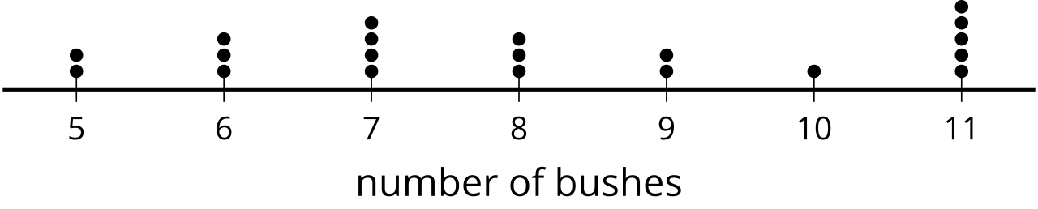

- The data set represents the shoe sizes of 19 students in a fifth grade physical education class.
- 4, 5, 5, 5, 6, 6, 6, 6, 7, 7, 7, 7, 7.5, 7.5, 8, 8, 8.5, 8.5, 9
- Create a box plot to represent the distribution of the data.
- The data set represents the number of pages in the last book read by each of 20 students over the summer.
- 163, 170, 171, 173, 175, 205, 220, 220, 220, 253, 267, 281, 305, 305, 305, 355, 371, 388, 402, 431
- Create a histogram to represent the distribution of the data.
- Each set of data was collected from surveys to answer statistical questions. Select all of the data sets that represent numerical data.
  - {1, 1.2, 1.4, 1.4, 1.5, 1.6, 1.8, 1.9, 2, 2, 2.1, 2.5}
  - {Red, Red, Yellow, Yellow, Blue, Blue, Blue}
  - {45, 60, 60, 70, 75, 80, 85, 90, 90, 100, 100, 100}
  - {-7, -5, -3, -1, -1, -1, 0}
  - {98.2, 98.4, 98.4, 98.6, 98.6, 98.6, 98.6, 98.7, 98.8, 98.8}
  - {Yes, Yes, Yes, Yes, Maybe, Maybe, No, No, No}
  - {A, A, A, B, B, B, C, C, C}
- (From Unit 1, Lesson 1.)
- Is “What is the typical distance a moped can be driven on a single tank of gas?” a statistical question? Explain your reasoning.
- (From Unit 1, Lesson 1.)
© CC BY 2019 by Illustrative Mathematics®

