Lesson 6: Subtracting Rational Numbers
Let's bring addition and subtraction together.

6.1: Number Talk: Missing Addend
Solve each equation mentally. Rewrite each addition equation as a subtraction equation.
$247+c=458$
$c+43.87=58.92$
$\frac{15}{8}+c=\frac{51}{8}$

6.2: Expressions with Altitude
A mountaineer is changing elevations. Write an expression that represents the difference between the final elevation and beginning elevation. Then write the value of the change. The first one is done for you.
beginning  elevation  (feet) | final  elevation  (feet) | difference  between final  and beginning | change
+400 | +900 | $900−400$ | +500
+400 | +50
+400 | -120
-200 | +610
-200 | -50
-200 | -500
-200 | 0

Are you ready for more?
Fill in the table so that every row and every column sums to 0. Can you find another way to solve this puzzle?
 | -12 | 0 |  | 5
0 |  |  | -18 | 25
25 |  | -18 | 5 | -12
-12 |  |  |  | -18
 | -18 | 25 | -12

 | -12 | 0 |  | 5
0 |  |  | -18 | 25
25 |  | -18 | 5 | -12
-12 |  |  |  | -18
 | -18 | 25 | -12

6.3: Does the Order Matter?
- Find the value of each subtraction expression.
- A
- $3−2$
- $5−\left(\text{-}9\right)$
- $\left(\text{-}11\right)−2$
- $\left(\text{-}6\right)−\left(\text{-}3\right)$
- $\left(\text{-}1.2\right)−\left(−3.6\right)$
- $\left(\text{-}2\frac{1}{2}\right)−\left(\text{-}3\frac{1}{2}\right)$

- B
- $2−3$
- $\left(\text{-}9\right)−5$
- $2−\left(\text{-}11\right)$
- $\left(\text{-}3\right)−\left(\text{-}6\right)$
- $\left(\text{-}3.6\right)−\left(\text{-}1.2\right)$
- $\left(\text{-}3\frac{1}{2}\right)−\left(\text{-}2\frac{1}{2}\right)$
- What do you notice about the expressions in Column A compared to Column B?
- What do you notice about their values?

Lesson 6 Summary
When we talk about the difference of two numbers, we mean, “subtract them.” Usually, we subtract them in the order they are named. For example, the difference of +8 and $\text{-}6$ is $8−\left(\text{-}6\right)$.
The difference of two numbers tells you how far apart they are on the number line. 8 and -6 are 14 units apart, because $8−\left(\text{-}6\right)=14$:
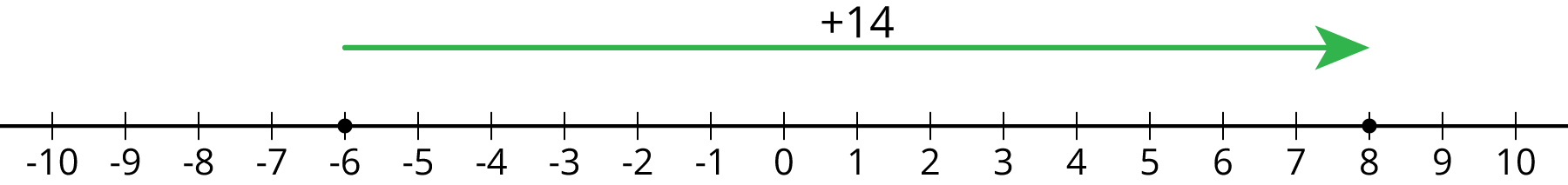
Notice that if you subtract them in the opposite order, you get the opposite number:
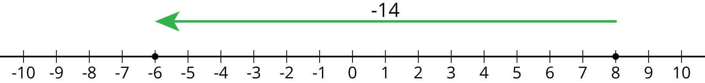
$\left(\text{-}6\right)−8=\text{-}14$
In general, the distance between two numbers $a$ and $b$ on the number line is $\left|a−b\right|$. Note that the distance between two numbers is always positive, no matter the order. But the difference can be positive or negative, depending on the order.
© CC BY Open Up Resources. Adaptations CC BY IM.

