Unit 8 Lesson 17: Using Box Plots

1 Hours of Slumber (Warm up)

Student Task Statement
Ten sixth-grade students were asked how much sleep, in hours, they usually get on a school night. Here is the five-number summary of their responses.
- Minimum: 5 hours
- First quartile: 7 hours
- Median: 7.5 hours
- Third quartile: 8 hours
- Maximum: 9 hours
- On the grid, draw a box plot for this five-number summary.
- 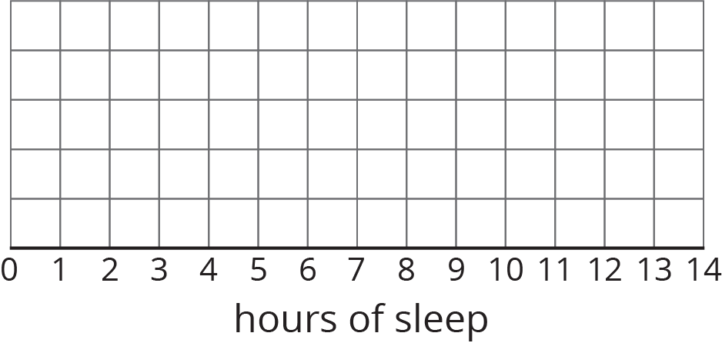
- What questions could be answered by looking at this box plot?

2 Info Gap: Sea Turtles

Student Task Statement
Your teacher will give you either a Problem Card or a Data Card about sea turtles that nest on the Outer Banks of North Carolina. Do not show or read your card to your partner.
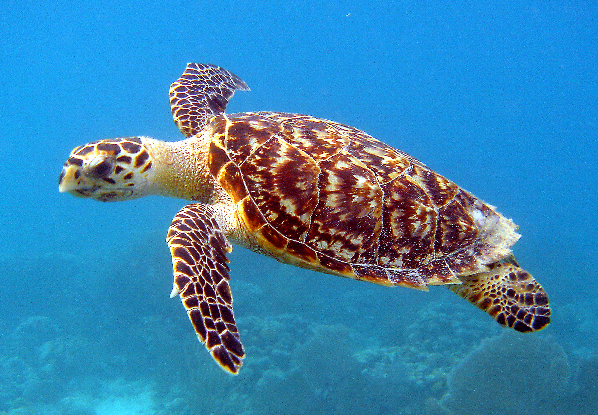
If your teacher gives you the problem card:
- Silently read your card and think about what information you need to be able to answer the question.
- Ask your partner for the specific information that you need.
- Explain how you are using the information to solve the problem.
- Continue to ask questions until you have enough information to solve the problem.
- Share the problem card and solve the problem independently.
- Read the data card and discuss your reasoning.
If your teacher gives you the data card:
- Silently read your card.
- Ask your partner “What specific information do you need?” and wait for them to ask for information.
- If your partner asks for information that is not on the card, do not do the calculations for them. Tell them you don’t have that information.
- Before sharing the information, ask “Why do you need that information?” Listen to your partner’s reasoning and ask clarifying questions.
- Read the problem card and solve the problem independently.
- Share the data card and discuss your reasoning.
Pause here so your teacher can review your work. Ask your teacher for a new set of cards and repeat the activity, trading roles with your partner.

3 Paper Planes

Student Task Statement
Andre, Lin, and Noah each designed and built a paper airplane. They launched each plane several times and recorded the distance of each flight in yards.
Andre

25
26
27
27
27
28
28
28
29
30
30
Lin

20
20
21
24
26
28
28
29
29
30
32
Noah

13
14
15
18
19
20
21
23
23
24
25
Work with your group to summarize the data sets with numbers and box plots.
- Write the five-number summary for the data for each airplane. Then, calculate the interquartile range for each data set.
- min | - Q1 | - median | - Q3 | - max | - IQR
- Draw three box plots, one for each paper airplane. Label the box plots clearly.
- 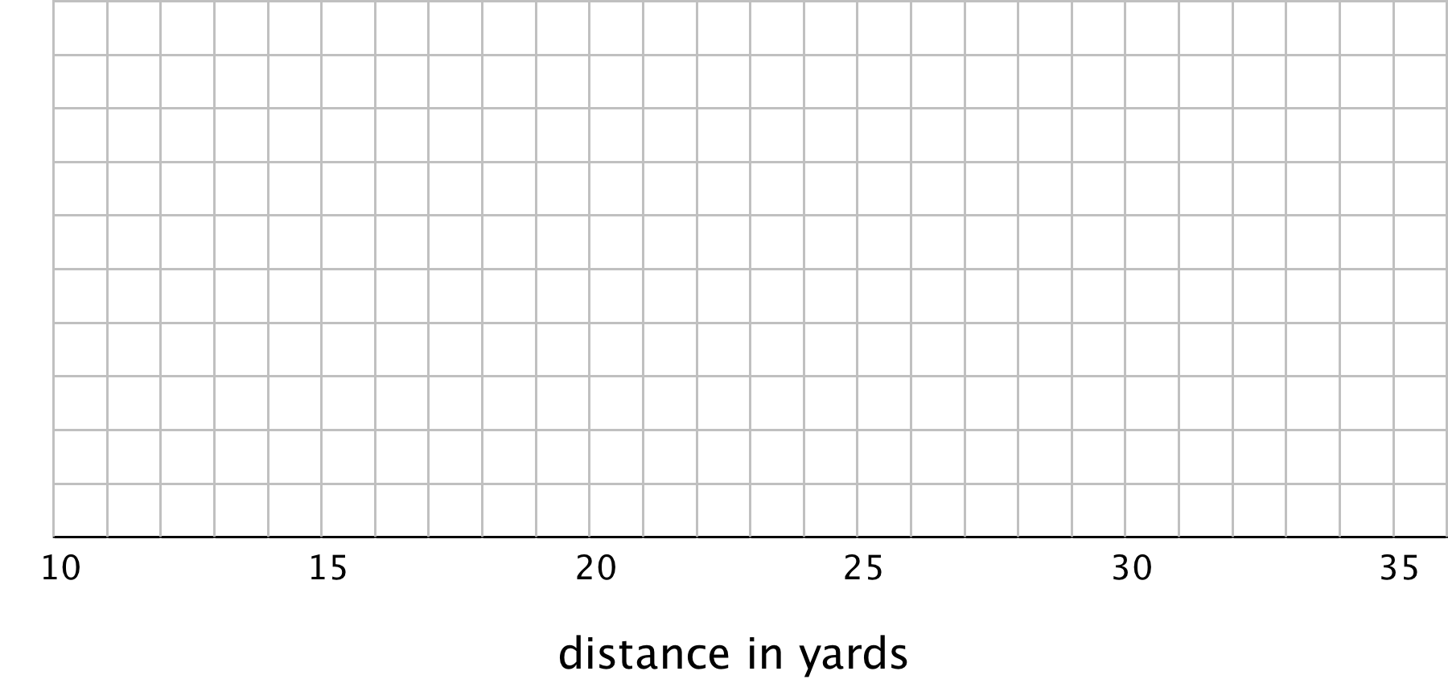
- How are the results for Andre and Lin’s planes the same? How are they different?
- How are the results for Lin and Noah’s planes the same? How are they different?

Activity Synthesis
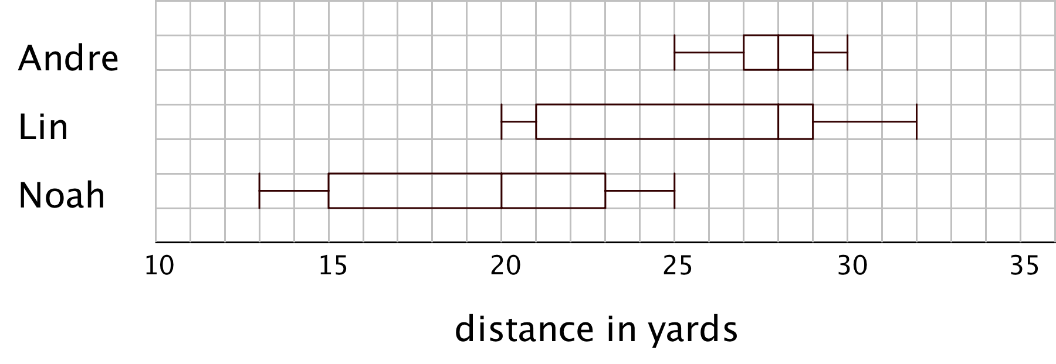
© CC BY Open Up Resources. Adaptations CC BY IM.

