Lesson 6: Rectángulos y cuadrados

Standards Alignments
Addressing | 1.G.A, 1.G.A.1, 1.NBT.C.4

Teacher-facing Learning Goals
- Draw squares and rectangles based on defining attributes.
- Identify defining and non-defining attributes of rectangles and squares.
- Recognize a square as a special rectangle.

Student-facing Learning Goals
- Descubramos qué hace que una figura sea un rectángulo o un cuadrado.

Lesson Purpose
The purpose of this lesson is for students to identify defining and non-defining attributes of squares and rectangles. Students draw rectangles and squares as well as non-examples of rectangles and squares.
Earlier in this section, students sorted shapes and described their attributes. In the previous lesson, students learned the defining attributes of triangles (all triangles are closed, have three straight sides, and three corners).
In this lesson, students continue that work, this time with squares and rectangles. Students learn that a square is a special rectangle because it has the defining attributes of a rectangle (four sides and four square corners), but also has four sides with equal lengths. Students should be able to identify squares as rectangles, but they do not need to articulate a formal definition of a rectangle or a square.

Access for:

Students with Disabilities
- Action and Expression (Activity 2)

English Learners
- MLR7 (Activity 2)

Instructional Routines
Number Talk (Warm-up)

Materials to Gather
- Chart paper: Activity 2
- Materials from a previous activity: Activity 2
- Materials from a previous lesson: Activity 1

Materials to Copy
- Centimeter Dot Paper - Standard (groups of 1): Activity 2

Lesson Timeline
Warm-up | 10 min
Activity 1 | 20 min
Activity 2 | 15 min
Lesson Synthesis | 10 min
Cool-down | 5 min

Teacher Reflection Question
What evidence have students given that they can distinguish between defining and non-defining attributes?

Cool-down
(to be completed at the end of the lesson) 5min
Colorea figuras

Standards Alignments
Addressing | 1.G.A

Student-facing Task Statement
- Colorea los 3 rectángulos.
- 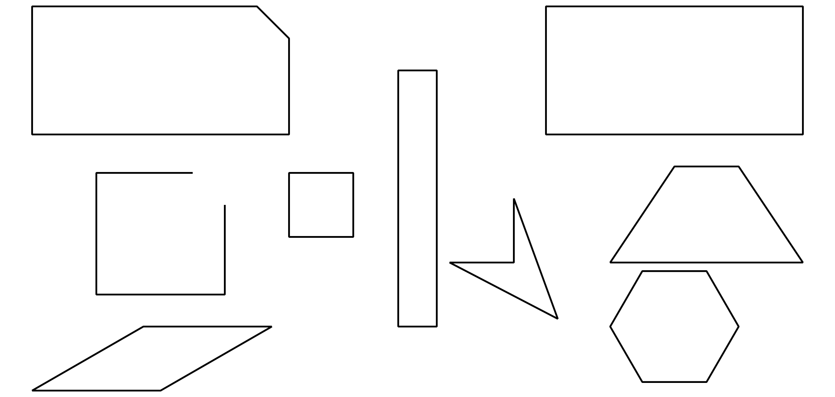
- Escribe 2 cosas que son verdaderas sobre todos los rectángulos.

Student Responses
- Student colors all rectangles (and squares).
- Sample response: They all have four straight sides. They all have four square corners.

