Lesson 1: Solids of Rotation
- Let’s rotate two-dimensional shapes to make three-dimensional shapes.

1.1: Which One Doesn’t Belong: Solids
Which one doesn’t belong?

A
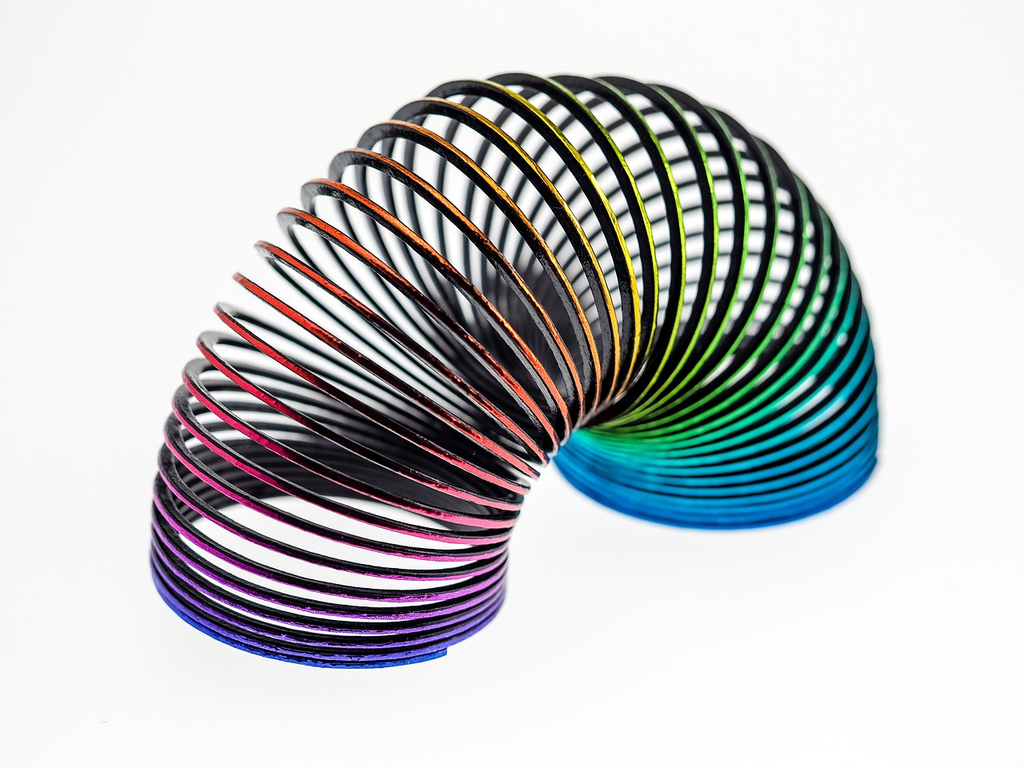

B

C
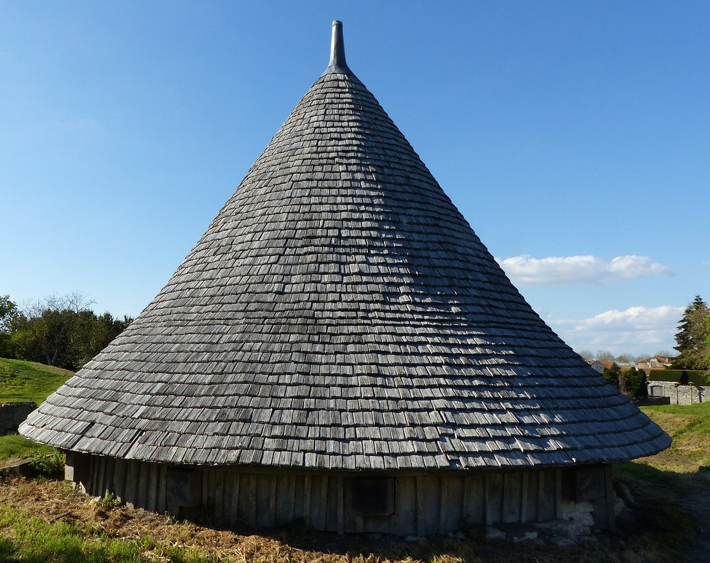

D
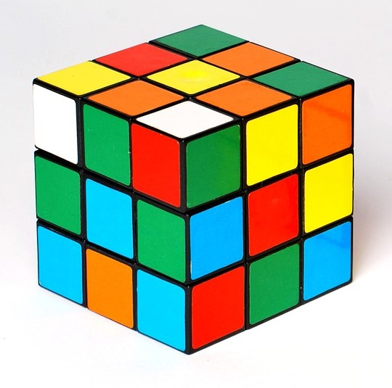

1.2: Axis of Rotation
Your teacher will give you a shape. Tape 1 side of the shape to a pencil.
- Spin the pencil between your hands. What solid is traced out as you rotate the shape? Draw the solid.
- Predict what solids will be formed by the shapes of other members of your group. Confirm by asking them to rotate their shapes.

Are you ready for more?
- Graph $y=\text{-}x+3$ from $x=1$ to $x=3$.
- Sketch the solid of rotation generated by rotating this line using the $y$-axis as the axis of rotation.
- What figure is made?
- The object being rotated here is a line, not a two-dimensional object like in the lesson. How does this affect the result of the rotation?

1.3: From Three Dimensions to Two
Draw the two-dimensional shape that, when rotated using the given axis of rotation, produces each solid of rotation. Ignore any non-symmetric aspects of the solid.
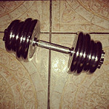
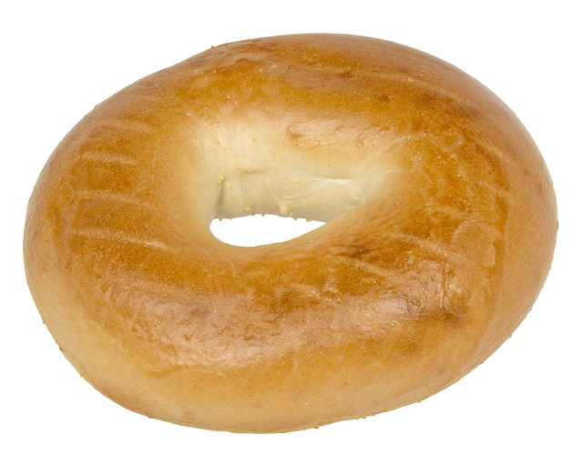

Lesson 1 Summary
Take a coin and spin it on its edge. Give it good speed and make sure it stays vertical. What shape do you see? When you spin the coin, you should see a sphere.
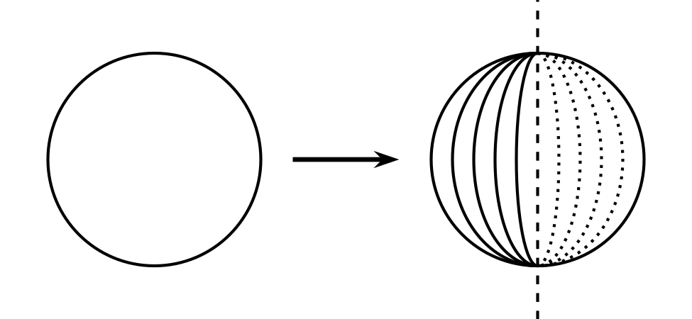
This triangular flag is made of metal. What shape will you see if the pole is spun quickly?
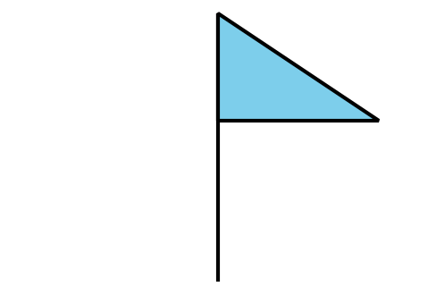
When the flag rotates with the pole, you should see a cone.
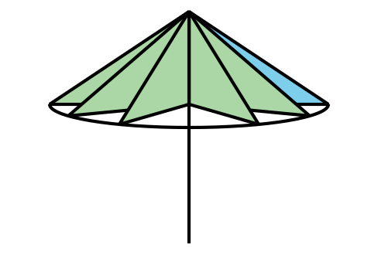
In both pictures, the object spins around a line called the axis of rotation, and the solid created is called the solid of rotation. If you were to spin the flag using a different axis of rotation, you would see a different solid of rotation. This is what it looks like when the flag is rotated using a different axis of rotation.
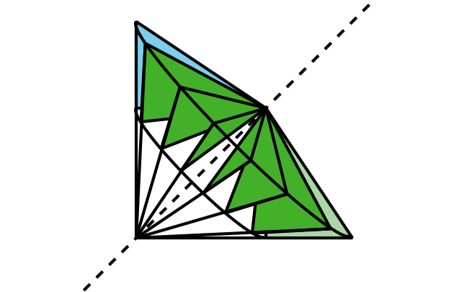
A machine called a lathe cuts away at a rotating block of material. For example, a lathe could be used to make a decorative sculpture shaped like the figure on the right from a block of wood. The image on the left shows the cross-sectional shape that would remain after the lathe carved away part of the spinning block of wood. If we rotate this two-dimensional shape using the vertical axis shown, it produces the sculpture shape.
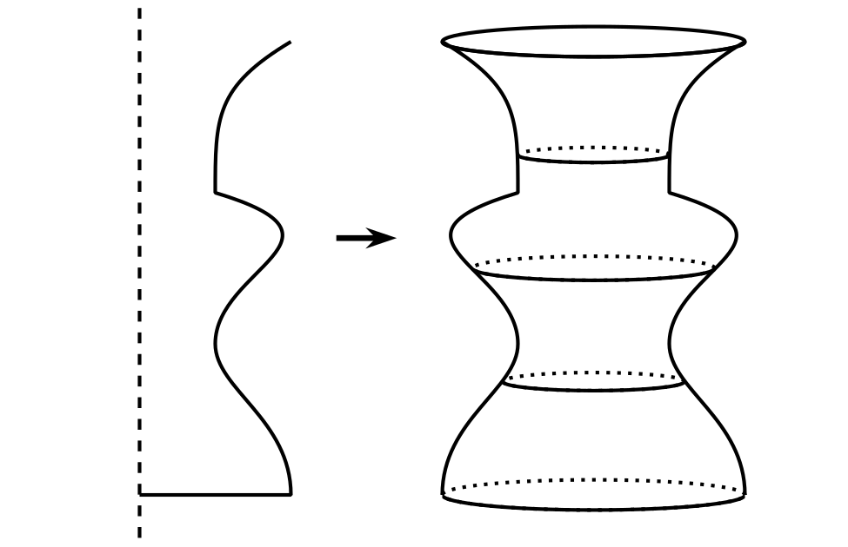
© CC BY 2019 by Illustrative Mathematics®

