Lesson 10: Domain and Range (Part 1)
- Let’s find all possible inputs and outputs for a function.

10.1: Number of Barks
Earlier, you saw a situation where the total number of times a dog has barked was a function of the time, in seconds, after its owner tied its leash to a post and left. Less than 3 minutes after he left, the owner returned, untied the leash, and walked away with the dog.
- Could each value be an input of the function? Be prepared to explain your reasoning.
- 15
- $84\frac{1}{2}$
- 300
- Could each value be an output of the function? Be prepared to explain your reasoning.
- 15
- $84\frac{1}{2}$
- 300

10.2: Card Sort: Possible or Impossible?
Your teacher will give you a set of cards that each contain a number. Decide whether each number is a possible input for the functions described here. Sort the cards into two groups—possible inputs and impossible inputs. Record your sorting decisions.
- The area of a square, in square centimeters, is a function of its side length, $s$, in centimeters. The equation $A\left(s\right)=s^{2}$ defines this function.
  - Possible inputs:
  - Impossible inputs:
- A tennis camp charges $40 per student for a full-day camp. The camp runs only if at least 5 students sign up, and it limits the enrollment to 16 campers a day. The amount of revenue, in dollars, that the tennis camp collects is a function of the number of students that enroll.
- The equation $R\left(n\right)=40n$ defines this function.
  - Possible inputs:
  - Impossible inputs:
- The relationship between temperature in Celsius and the temperature in Kelvin can be represented by a function $k$. The equation $k\left(c\right)=c+273.15$ defines this function, where $c$ is the temperature in Celsius and $k\left(c\right)$ is the temperature in Kelvin.
  - Possible inputs:
  - Impossible inputs:

10.3: What about the Outputs?
In an earlier activity, you saw a function representing the area of a square (function $A$) and another representing the revenue of a tennis camp (function $R$). Refer to the descriptions of those functions to answer these questions.
- Here is a graph that represents function $A$, defined by $A\left(s\right)=s^{2}$, where $s$ is the side length of the square in centimeters.
- 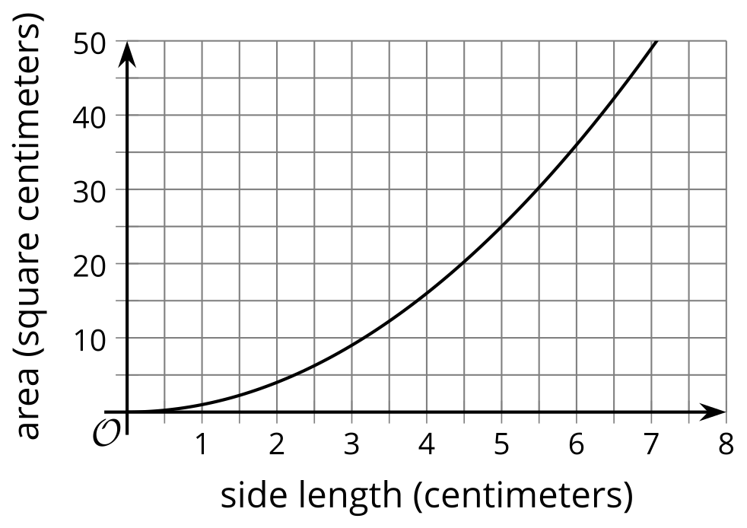
  - Name three possible input-output pairs of this function.
  - Earlier we describe the set of all possible input values of $A$ as “any number greater than or equal to 0.” How would you describe the set of all possible output values of $A$?
- Function $R$ is defined by $R\left(n\right)=40n$, where $n$ is the number of campers.
  - Is 20 a possible output value in this situation? What about 100? Explain your reasoning.
  - Here are two graphs that relate number of students and camp revenue in dollars. Which graph could represent function $R$? Explain why the other one could not represent the function.
  - 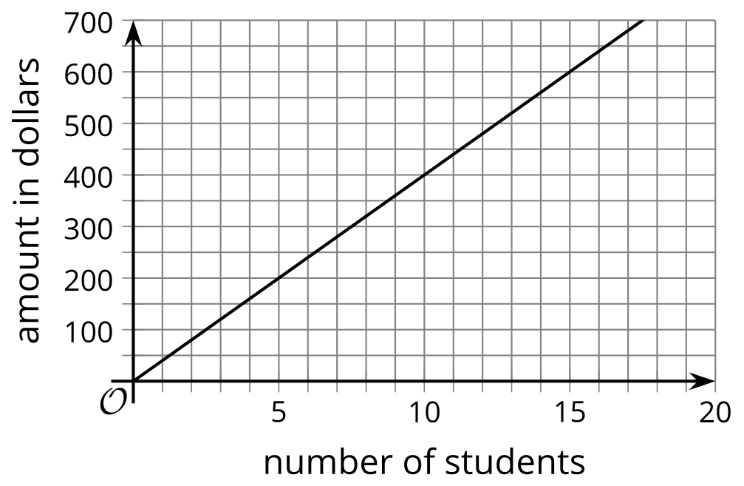
  - 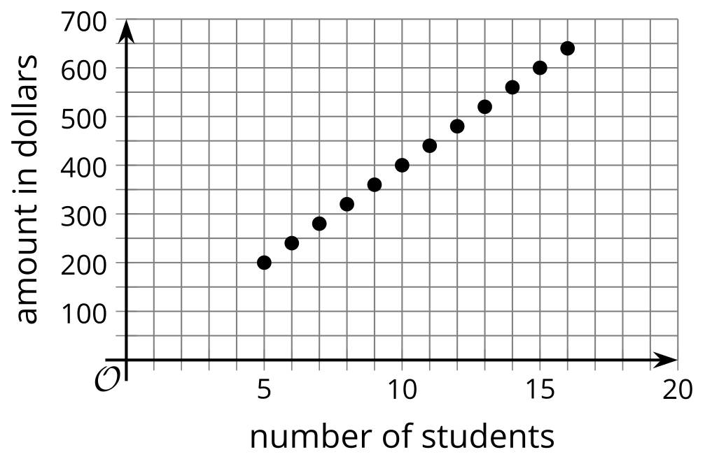
  - Describe the set of all possible output values of $R$.

Are you ready for more?
If the camp wishes to collect at least $500 from the participants, how many students can they have? Explain how this information is shown on the graph.

10.4: What Could Be the Trouble?
Consider the function $f\left(x\right)=\frac{6}{x−2}$.
To find out the sets of possible input and output values of the function, Clare created a table and evaluated $f$ at some values of $x$. Along the way, she ran into some trouble.
- Find $f\left(x\right)$ for each $x$-value Clare listed. Describe what Clare’s trouble might be.
- $x$ | - -10 | - 0 | - $\frac{1}{2}$ | - 2 | - 8
- $f\left(x\right)$
- Use graphing technology to graph function $f$. What do you notice about the graph?
- Use a calculator to compute the value you and Clare had trouble computing. What do you notice about the computation?
- How would you describe the domain of function $f$?

Are you ready for more?
Why do you think the graph of function $f$ looks the way it does? Why are there two parts that split at $x=2$, with one curving down as it approaches $x=2$ from the left and the other curving up as it approaches $x=2$ from the right?
Evaluate function $f$ at different $x$-values that approach 2 but are not exactly 2, such as 1.8, 1.9, 1.95, 1.999, 2.2, 2.1, 2.05, 2.001, and so on. What do you notice about the values of $f\left(x\right)$ as the $x$-values get closer and closer to 2?

Lesson 10 Summary
The domain of a function is the set of all possible input values. Depending on the situation represented, a function may take all numbers as its input or only a limited set of numbers.
- Function $A$ gives the area of a square, in square centimeters, as a function of its side length, $s$, in centimeters.
  - The input of $A$ can be 0 or any positive number, such as 4, 7.5, or $\frac{19}{3}$. It cannot include negative numbers because lengths cannot be negative.
  - The domain of $A$ includes 0 and all positive numbers (or $s≥0$).
- Function $q$ gives the number of buses needed for a school field trip as a function of the number of people, $n$, going on the trip.
  - The input of $q$ can be 0 or positive whole numbers because a negative or fractional number of people doesn’t make sense.
  - The domain of $q$ includes 0 and all positive whole numbers. If the number of people at a school is 120, then the domain is limited to all non-negative whole numbers up to 120 (or $0≤n≤120$).
- Function $v$ gives the total number of visitors to a theme park as a function of days, $d$, since a new attraction was open to the public.
  - The input of $v$ can be positive or negative. A positive input means days since the attraction was open, and a negative input days before the attraction was open.
  - The input can also be whole numbers or fractional. The statement $v\left(17.5\right)$ means 17.5 days after the attraction was open.
  - The domain of $v$ includes all numbers. If the theme park had been opened for exactly one year before the new attraction was open, then the domain would be all numbers greater than or equal to -365 (or $d≥\text{-}365$).
The range of a function is the set of all possible output values. Once we know the domain of a function, we can determine the range that makes sense in the situation.
- The output of function $A$ is the area of a square in square centimeters, which cannot be negative but can be 0 or greater, not limited to whole numbers. The range of $A$ is 0 and all positive numbers.
- The output of $q$ is the number of buses, which can only be 0 or positive whole numbers. If there are 120 people at the school, however, and if each bus could seat 30 people, then only up to 4 buses are needed. The range that makes sense in this situation would be any whole number that is at least 0 and at most 4.
- The output of function $v$ is the number of visitors, which cannot be fractional or negative. The range of $v$ therefore includes 0 and all positive whole numbers.
© CC BY 2019 by Illustrative Mathematics®

