Unit 1 Lesson 6: Construction Techniques 4: Parallel and Perpendicular Lines

1 Math Talk: Transformations (Warm up)

Student Task Statement
Each pair of shapes is congruent. Mentally identify a transformation or sequence of transformations that could take one shape to the other.
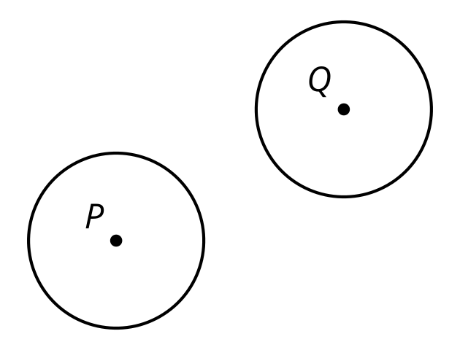
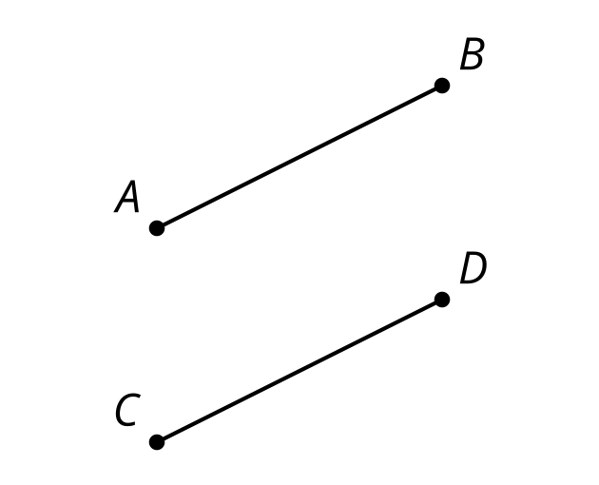
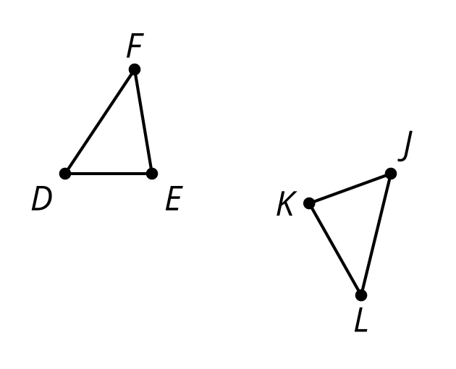
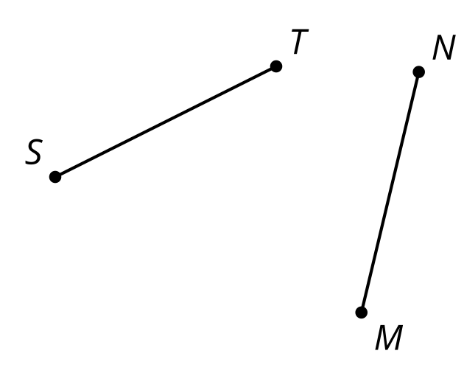

2 Standing on the Shoulders of Giants

Images for Launch
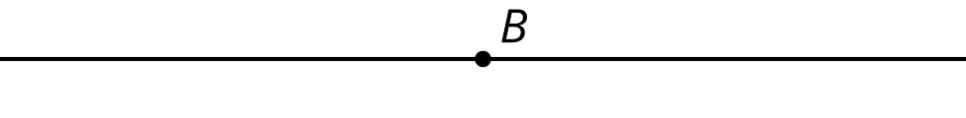
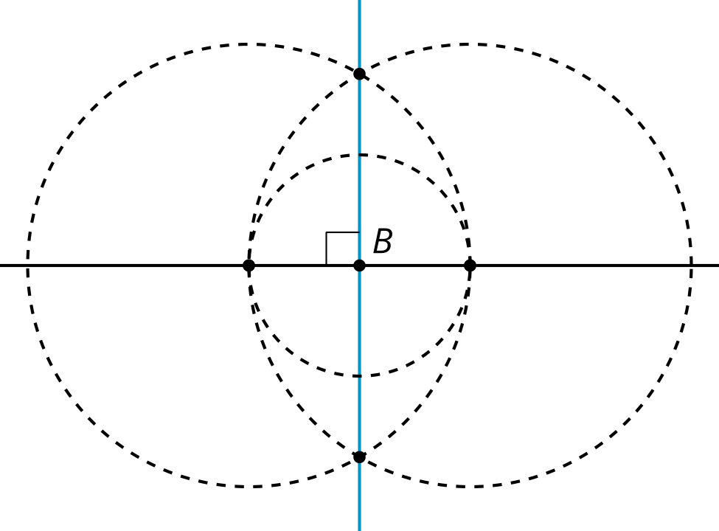

Student Task Statement
Here is a line $m$ and a point $C$ not on the line. Use straightedge and compass moves to construct a line perpendicular to line $m$ that goes through point $C$. Be prepared to share your reasoning.

3 Parallel Constructions Challenge

Student Task Statement
Here is a line $m$ and a point $C$ not on the line. Use straightedge and compass moves to construct a line parallel to line $m$ that goes through point $C$.
© CC BY 2019 by Illustrative Mathematics®

