Unit 1 Lesson 5: Construction Techniques 3: Perpendicular Lines and Angle Bisectors

1 Two Circles (Warm up)

Student Task Statement
Points $A$ and $B$ are each at the centers of circles of radius $AB$.
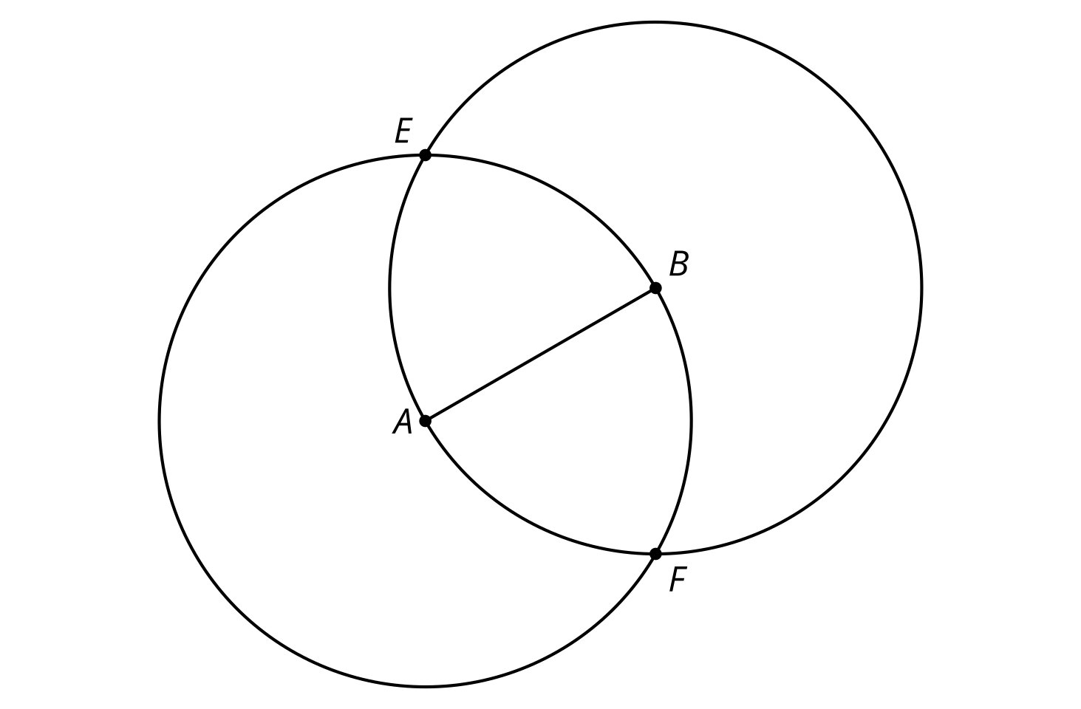
- Compare the distance $EA$ to the distance $EB$. Be prepared to explain your reasoning.
- Compare the distance $FA$ to the distance $FB$. Be prepared to explain your reasoning.
- Draw line $EF$ and write a conjecture about its relationship with segment $AB$.

2 Make It Right

Student Task Statement
Here is a line $ℓ$ with a point labeled $C$. Use straightedge and compass moves to construct a line perpendicular to $ℓ$ that goes through $C$.

3 Bisect This

Student Task Statement
Here is an angle:
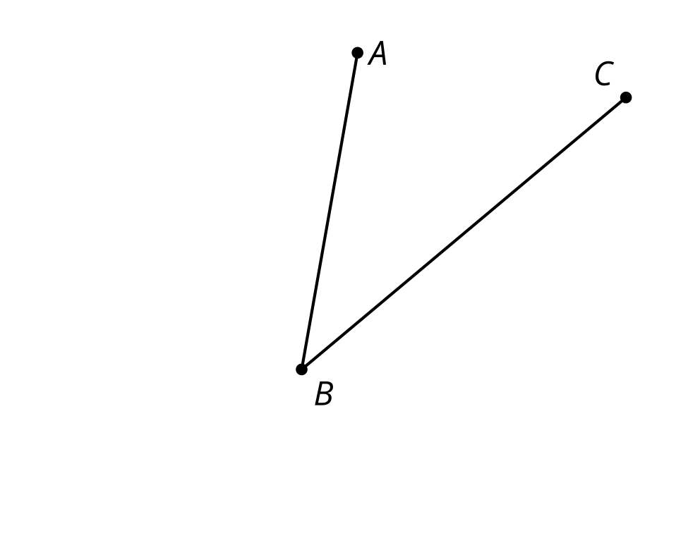
- Estimate the location of a point $D$ so that angle $ABD$ is approximately congruent to angle $CBD$.
- Use compass and straightedge moves to create a ray that divides angle $CBA$ into 2 congruent angles. How close is the ray to going through your point $D$?
- Take turns with your partner, drawing and bisecting other angles.
  - For each angle that you draw, explain to your partner how each straightedge and compass move helps you to bisect it.
  - For each angle that your partner draws, listen carefully to their explanation. If you disagree, discuss your thinking and work to reach an agreement.

Images for Activity Synthesis
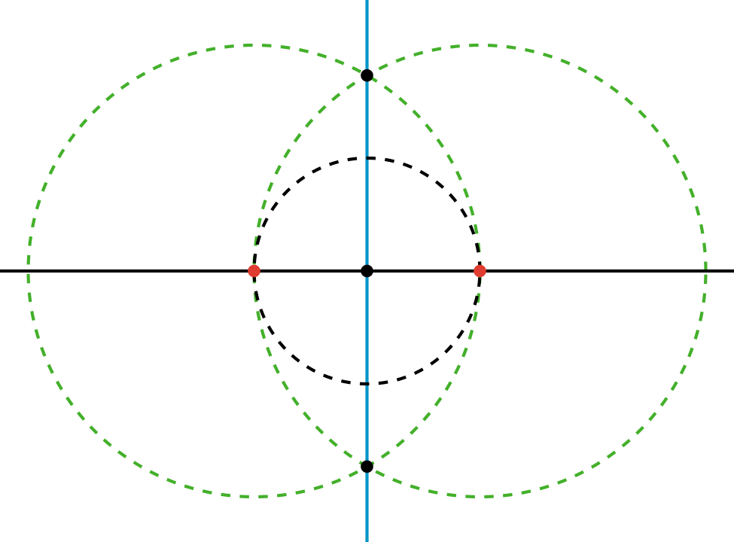
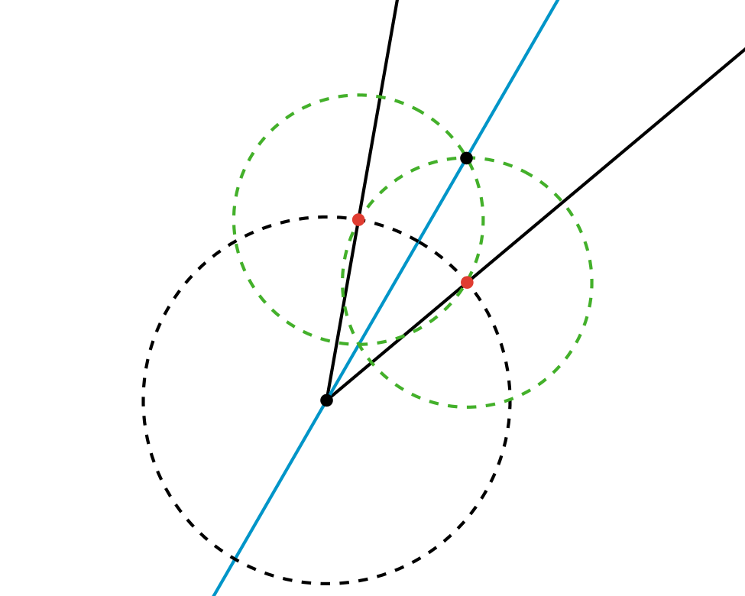
© CC BY 2019 by Illustrative Mathematics®

