Lesson 11 Practice Problems
- In science class, Clare and Lin estimate the mass of eight different objects that actually weigh 2,000 grams each.
- Some summary statistics:
- Clare
  - mean: 2,000 grams
  - MAD: 275 grams
  - median: 2,000 grams
  - IQR: 500 grams
- Lin
  - mean: 2,000 grams
  - MAD: 225 grams
  - median: 1,950 grams
  - IQR: 350 grams
- Which student was better at estimating the mass of the objects? Explain your reasoning.
- A reporter counts the number of times a politician talks about jobs in their campaign speeches. What is the MAD of the data represented in the dot plot?
- 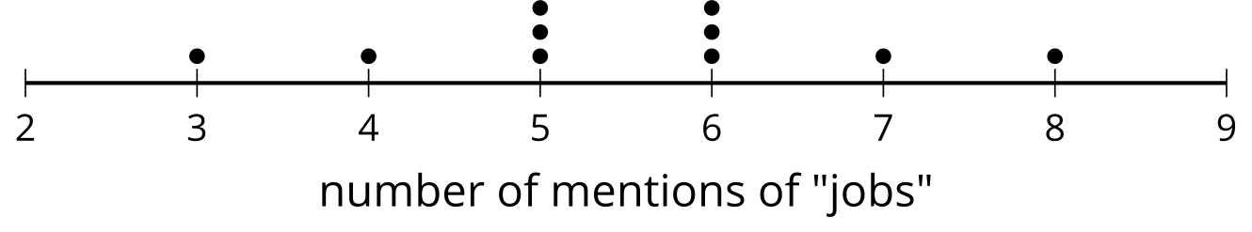
  - 1.1 mentions
  - 2 mentions
  - 2.5 mentions
  - 5.5 mentions
- Four amateur miniature golfers attempt to finish 100 holes under par several times. Each round of 100, the number of holes they successfully complete under par is recorded. Due to the presence of extreme values, box plots were determined to be the best representation for the data. List the four box plots in order of variability from least to greatest.
- player a
- 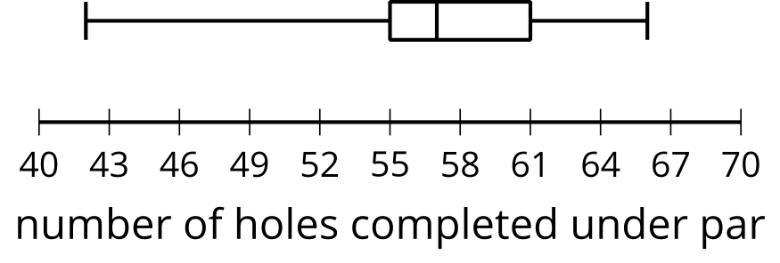
- player b
- 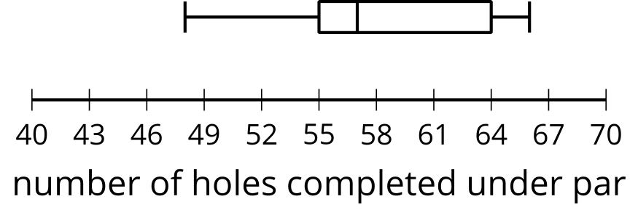
- player c
- 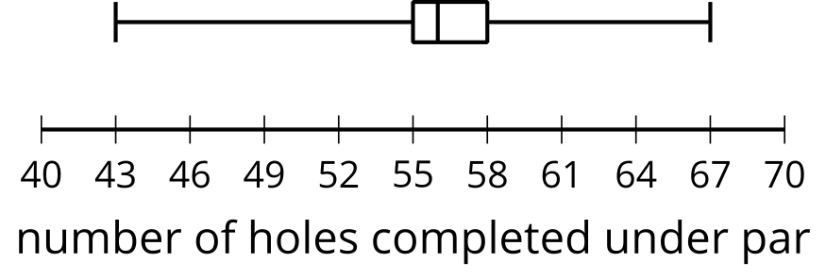
- player d
- 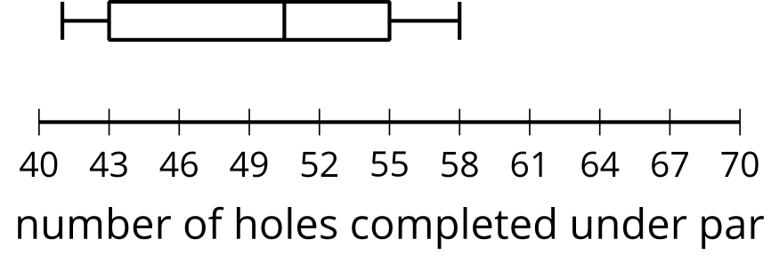
- Select all the distribution shapes for which the median could be much less than the mean.
  - symmetric
  - bell-shaped
  - skewed left
  - skewed right
  - bimodal
- (From Unit 1, Lesson 10.)

  - What is the five-number summary for the data 0, 2, 2, 4, 5, 5, 5, 5, 7, 11?
  - When the minimum, 0, is removed from the data set, what is the five-number summary?
- (From Unit 1, Lesson 9.)
- What effect does eliminating the highest value, 180, from the data set have on the mean and median?
- 25, 50, 50, 60, 70, 85, 85, 90, 90, 180
- (From Unit 1, Lesson 9.)
- The histogram represents the distribution of the number of seconds it took for each of 50 students to find the answer to a trivia question using the internet. Which interval contains the median?
- 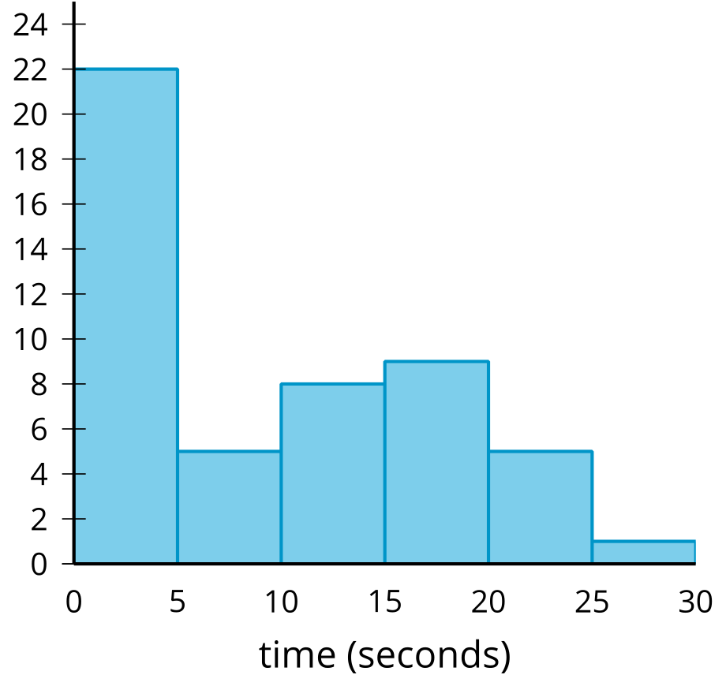
  - 0 to 5 seconds
  - 5 to 10 seconds
  - 10 to 15 seconds
  - 15 to 20 seconds
- (From Unit 1, Lesson 3.)
© CC BY 2019 by Illustrative Mathematics®

