Unit 1 Lesson 12: Units in Scale Drawings

1 Centimeters in a Mile (Warm up)

Student Task Statement
There are 2.54 cm in an inch, 12 inches in a foot, and 5,280 feet in a mile. Which expression gives the number of centimeters in a mile? Explain your reasoning.
- $\frac{2.54}{12⋅5,280}$
- $5,​280⋅12⋅\left(2.54\right)$
- $\frac{1}{5,280⋅12⋅\left(2.54\right)}$
- $5,​280+12+2.54$
- $\frac{5,280⋅12}{2.54}$

2 Card Sort: Scales (Optional)

Student Task Statement
Your teacher will give you some cards with a scale on each card.
- Sort the cards into sets of equivalent scales. Be prepared to explain how you know that the scales in each set are equivalent. Each set should have at least two cards.
- Trade places with another group and check each other’s work. If you disagree about how the scales should be sorted, work to reach an agreement.
- Pause here so your teacher can review your work.
- Next, record one of the sets with three equivalent scales and explain why they are equivalent.

3 The World’s Largest Flag

Images for Launch
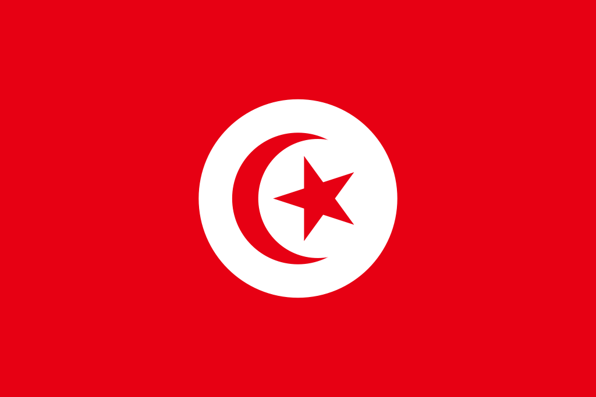

Student Task Statement
As of 2016, Tunisia holds the world record for the largest version of a national flag. It was almost as long as four soccer fields. The flag has a circle in the center, a crescent moon inside the circle, and a star inside the crescent moon.
- Complete the table. Explain or show your reasoning.
 | - flag length | - flag height | - height of  crescent moon
- actual | - 396 m |  | - 99 m
- at 1 to 2,000 scale |  | - 13.2 cm
- Complete each scale with the value that makes it equivalent to the scale of 1 to 2,000. Explain or show your reasoning.
  - 1 cm to ____________ cm
  - 1 cm to ____________ m
  - 1 cm to ____________ km
  - 2 m to _____________ m
  - 5 cm to ___________ m
  - ____________ cm to 1,000 m
  - ____________ mm to 20 m

  - What is the area of the large flag?
  - What is the area of the smaller flag?
  - The area of the large flag is how many times the area of the smaller flag?

4 Pondering Pools (Optional)

Student Task Statement
Your teacher will give you a floor plan of a recreation center.
- What is the scale of the floor plan if the actual side length of the square pool is 15 m? Express your answer both as a scale with units and without units.
- Find the actual area of the large rectangular pool. Show your reasoning.
- The kidney-shaped pool has an area of 3.2 cm² on the drawing. What is its actual area? Explain or show your reasoning.
© CC BY Open Up Resources. Adaptations CC BY IM.

