Lesson 13: Building a Volume Formula for a Pyramid
- Let’s create a formula for the volume of any pyramid or cone.

13.1: Cover Your Bases
Two solids are shown.

A
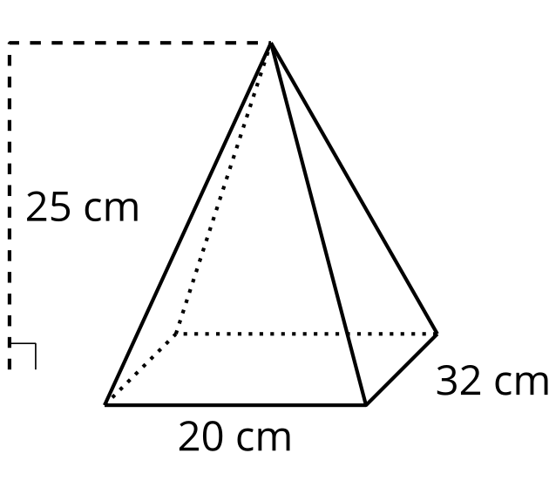

B
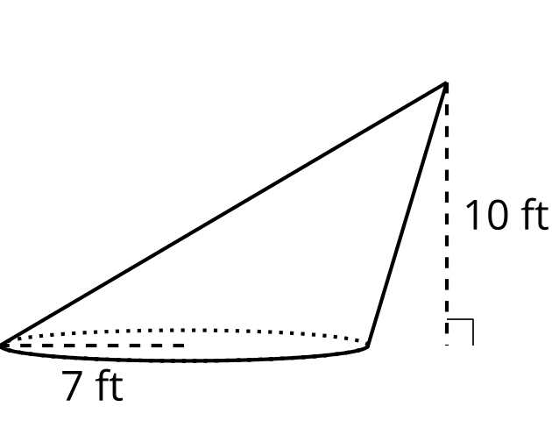
For each solid, draw and label a prism or cylinder that has a base congruent to the solid’s and a height equal to the solid’s.

13.2: Splitting a Prism into Pyramids
Here is a triangular prism.
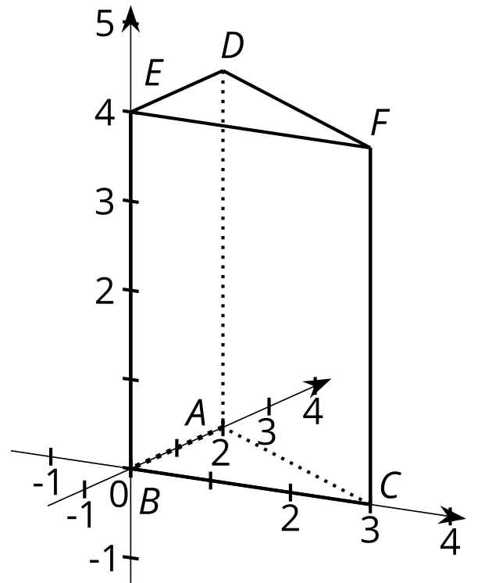
Suppose we split the prism into pyramids like the ones you built earlier. The first pyramid is split off by slicing through points $E$, $D$, and $C$. The remaining part of the prism is sliced through $B$, $C$, and $D$.

P1
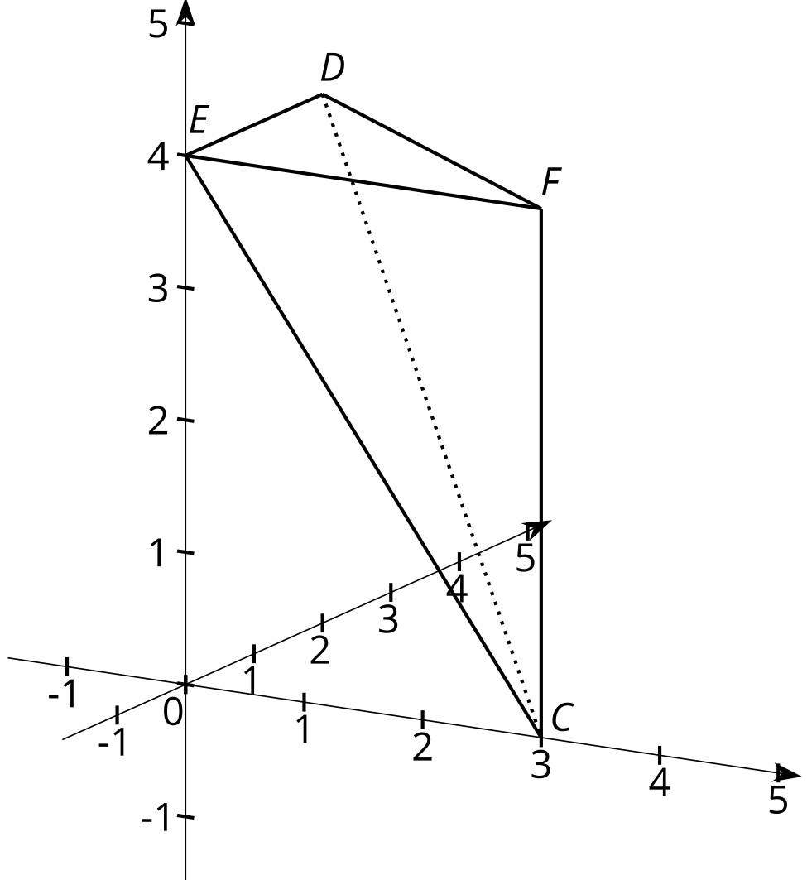

P2
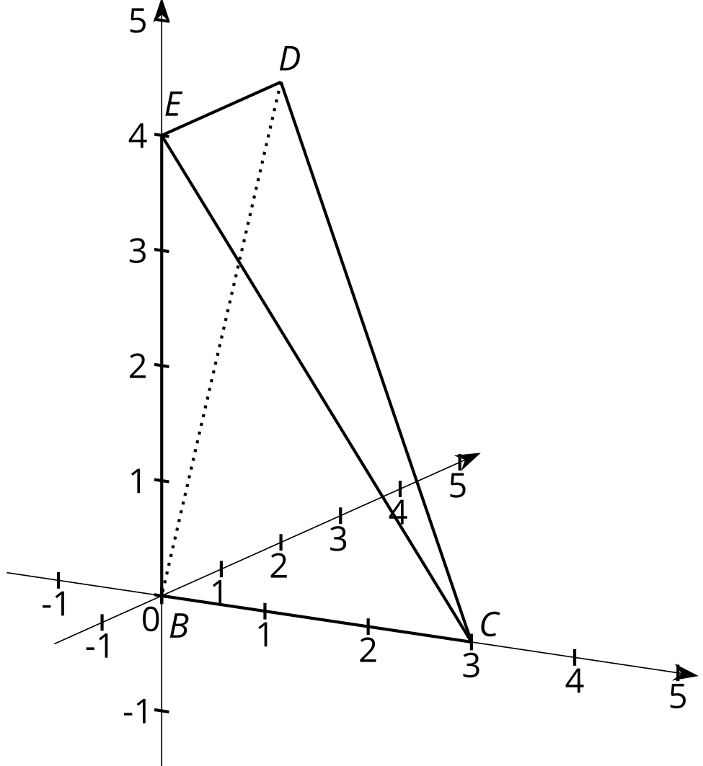

P3
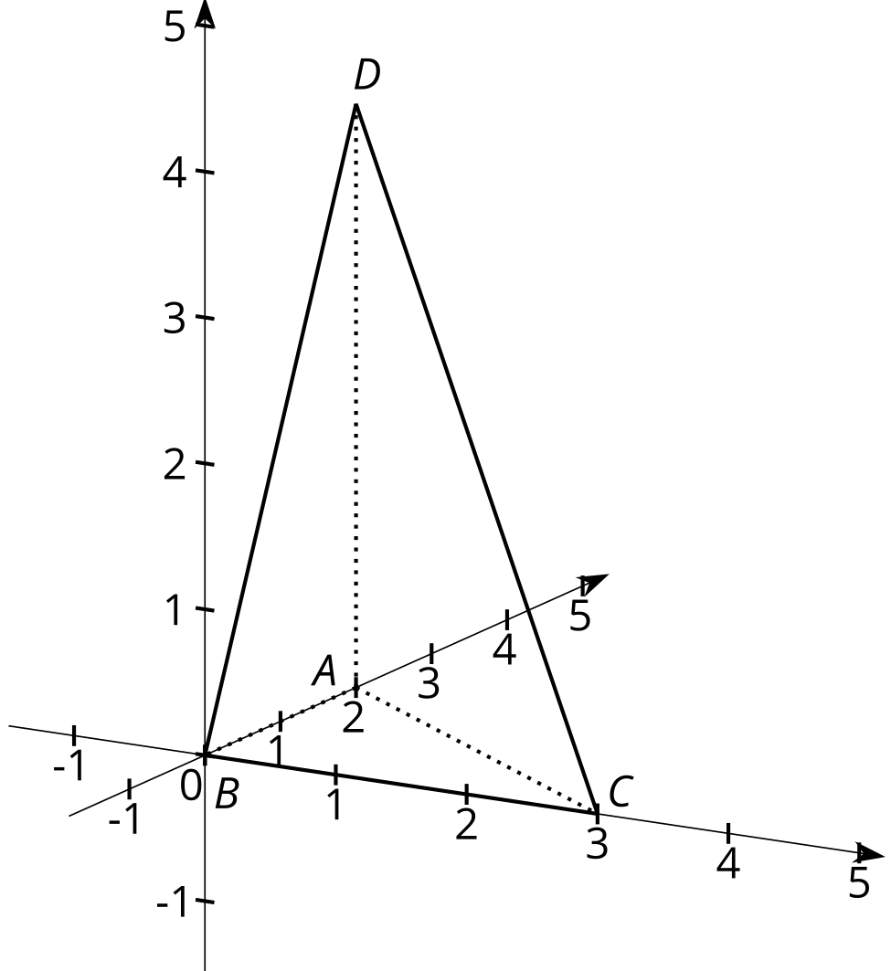
- Using the pyramids you built, compare pyramids P1 and P3.
  - Think of the faces marked P1 and P3 as the bases of the pyramids. These triangles are the two bases of the original prism. How do the areas of these two bases compare?
  - How do the heights of pyramids P1 and P3 compare? Explain your reasoning.
  - How do the volumes of pyramids P1 and P3 compare? Explain your reasoning.
- Using the pyramids you built, compare pyramids P2 and P3.
  - Think of the gray shaded triangles as the bases of the pyramids. These are formed by slicing one of the prism’s rectangular faces down its diagonal. How do the areas of these two bases compare?
  - The heights of pyramids P2 and P3 are equal because when assembled into the prism, the height lines coincide along the length of the prism. How, then, do the volumes of these pyramids compare? Explain your reasoning.
- Based on your answers, how does the volume of each pyramid compare to the volume of the prism?
- How could you use this information to find the volume of one of the pyramids?

13.3: Comparing Cross Sections
Each solid in the image has height 6 units. The area of each solid’s base is 10 square units. A cross section has been created in each by dilating the base using the apex as a center with scale factor $k=0.5$.
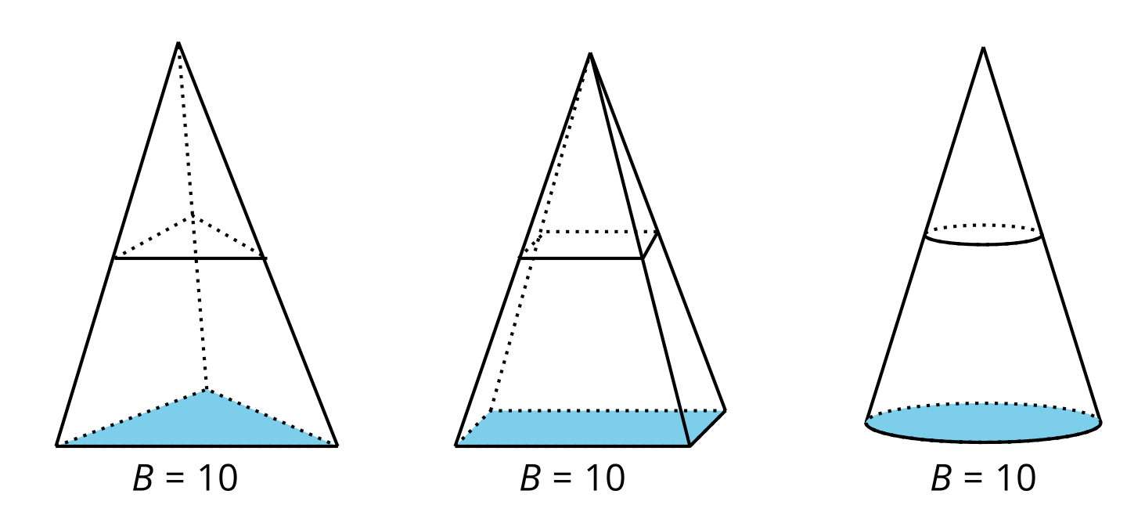
- Calculate the area of each of the 3 cross sections.
- Suppose a new cross section was created in each solid, all at the same height, using some scale factor $k$. How would the areas of these 3 cross sections compare? Explain your reasoning.
- What does this information about cross sections tell you about the volumes of the 3 solids?
- Calculate the volume of each of the solids.

Are you ready for more?
An octahedron is a solid whose faces consist of 8 equilateral triangles. Find the volume of an octahedron with edge length $ℓ$.
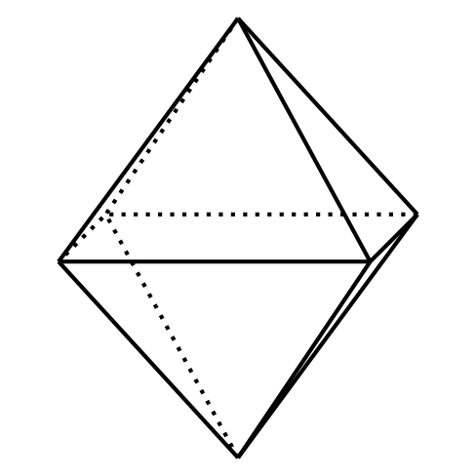

Lesson 13 Summary
In an earlier activity, we conjectured that a triangular pyramid has one-third the volume of the prism that has the same height and a base congruent to the pyramid’s. This turns out to be true.
Suppose we have a pyramid that doesn’t have a triangular base. Call the area of its base $B$ and its height $h$. To understand how to find the volume of such a solid, think about a triangular pyramid that also has an area of $B$ square units and a height of $h$.
Now find a cross section of each solid by dilating the solid’s base using the apex as a center with some scale factor $k$ between 0 and 1. The area of the cross section in both solids will be $Bk^{2}$. This is true for any value of $k$. Since the cross sections at all heights have equal area, the solids have the same volume. The same idea would apply to a cone. This means the expression $\frac{1}{3}Bh$ gives the volume of any pyramid or cone.
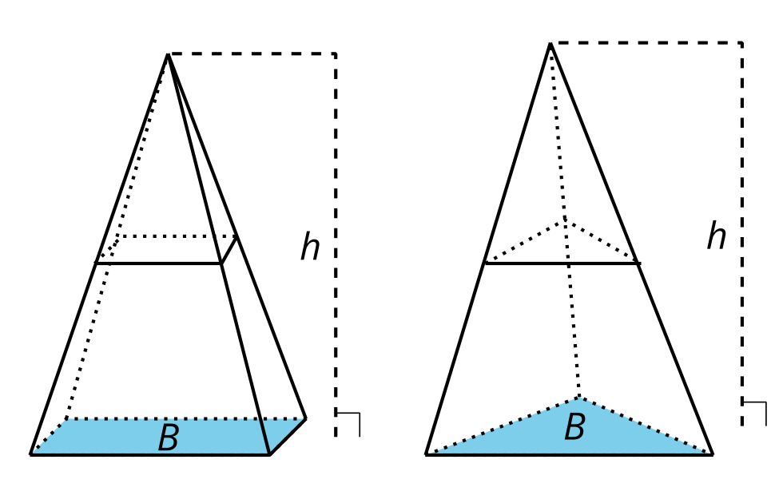
For example, this pyramid’s base has an area of 100 square units. The volume of the pyramid is about 233.3 cubic units, because $\frac{1}{3}⋅100⋅7≈233.3$.
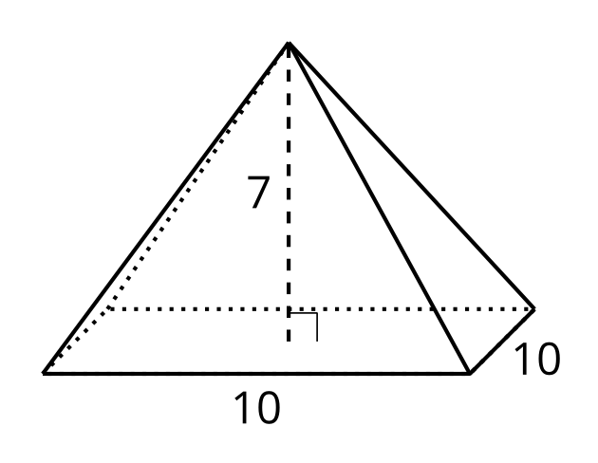
© CC BY 2019 by Illustrative Mathematics®

