Unit 1 Lesson 7: Construction Techniques 5: Squares

1 Which One Doesn’t Belong: Polygons (Warm up)

Student Task Statement
Which one doesn’t belong?

A
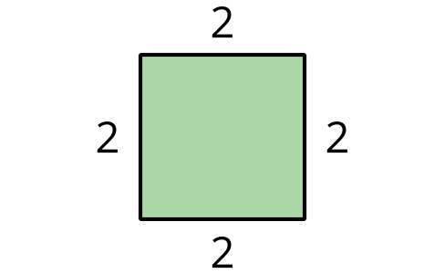

B
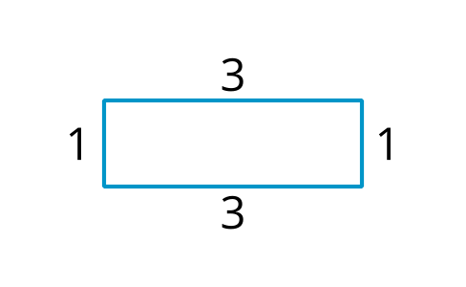

C
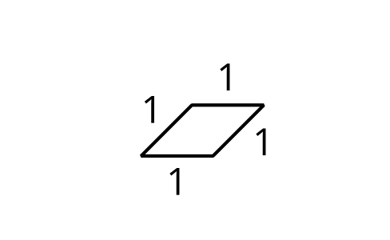

D
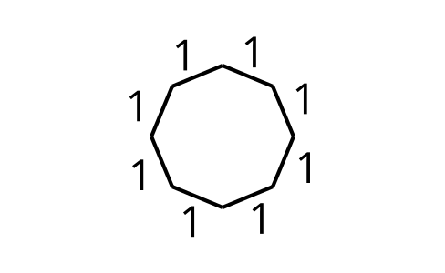

2 It’s Cool to Be Square

Student Task Statement
Use straightedge and compass moves to construct a square with segment $AB$ as one of the sides.

3 Trying to Circle a Square

Student Task Statement
- Here is square $ABCD$ with diagonal $BD$ drawn:
  - Construct a circle centered at $A$ with radius $AD$.
  - Construct a circle centered at $C$ with radius $CD$.
  - Draw the diagonal $AC$ and write a conjecture about the relationship between the diagonals $BD$ and $AC$.
  - Label the intersection of the diagonals as point $E$ and construct a circle centered at $E$ with radius $EB$. How are the diagonals related to this circle?
  - 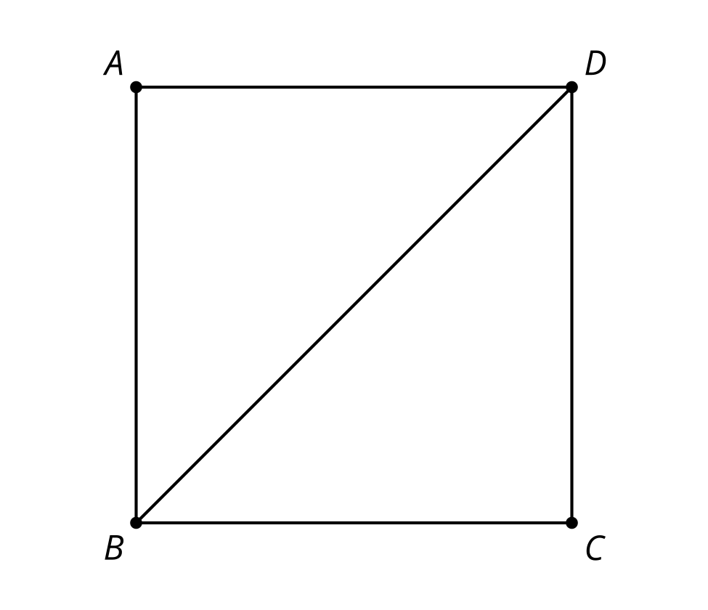
- Use your conjecture and straightedge and compass moves to construct a square inscribed in a circle.
© CC BY 2019 by Illustrative Mathematics®

