Lesson 8: Conditional Probability
- Let’s examine conditional probability.

8.1: She Made Some Tarts
- Noah will select 1 card at random from a standard deck of cards. Find the probabilities. Explain or show your reasoning.
- 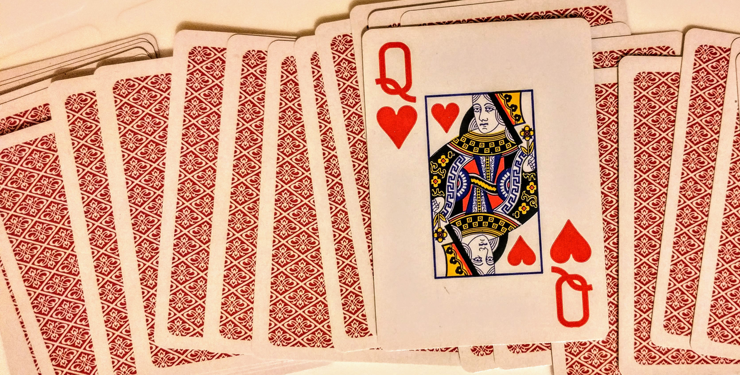
  - $P\left(\text{the card is a queen}\right)$
  - $P\left(\text{the card is a heart}\right)$
  - $P\left(\text{the card is a queen and heart}\right)$
- Elena pulls out only the hearts from the deck and sets the rest of the cards aside. She shuffles the hearts and draws one card. What is the probability she gets a queen?

8.2: Under One Condition
Kiran notices that the probabilities from the warm-up can be arranged into at least two equations.
$P\left(\text{the card is a queen and heart}\right)=P\left(\text{the card is a queen | the card is a heart}\right)⋅P\left(\text{the card is a heart}\right)$ since $\frac{1}{52}=\frac{1}{13}⋅\frac{13}{52}$.
$P\left(\text{the card is a queen and heart}\right)=P\left(\text{the card is a heart | the card is a queen}\right)⋅P\left(\text{the card is a queen}\right)$ since $\frac{1}{52}=\frac{1}{4}⋅\frac{4}{52}$.
Kiran wonders if it is always true that $P\left(\text{A and B}\right)=P\left(\text{A | B}\right)⋅P\left(B\right)$ for events A and B. He wants to check additional examples from drawing a card from a deck.
- If Event A is “the card is black” and Event B is “the card is a king,” does the equation hold? Explain or show your reasoning.
- If Event A is “the card is a face card” and Event B is “the card is a spade,” does the equation hold? Explain or show your reasoning.

8.3: Coin and Cube
A coin is flipped, then a standard number cube is rolled. Let A represent the event “the coin lands showing heads” and B represent “the standard number cube lands showing 4.”
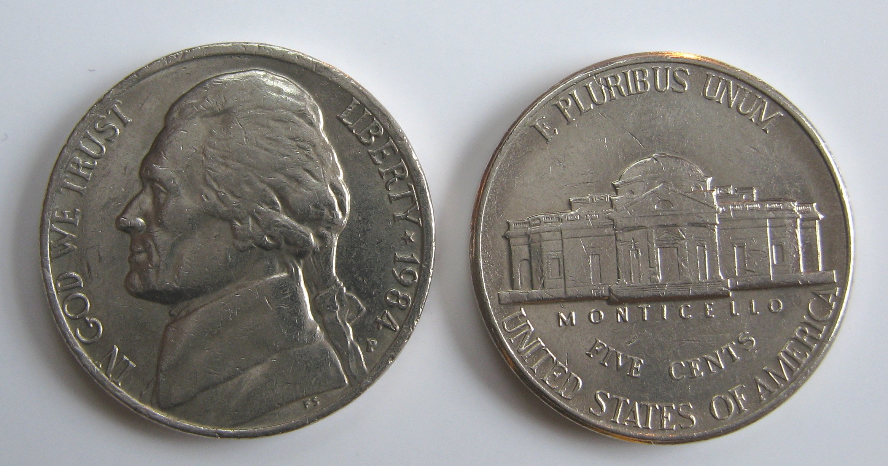
- Are events A and B independent or dependent? Explain your reasoning.
- Find the probabilities
  - $P\left(\text{A}\right)$
  - $P\left(\text{B}\right)$
  - $P\left(\text{A | B}\right)$
  - $P\left(\text{B | A}\right)$
- Describe the meaning of the events “not A” and “not B” in this situation, then find the probabilities.
  - $P\left(\text{A | not B}\right)$
  - $P\left(\text{B | not A}\right)$
- Are any of the probabilities the same? Is there a relationship between those situations? Explain your reasoning.

Are you ready for more?
Students are writing programs in their robotics class using two different programming languages that are very similar. 70% of the programs are written in the first programming language and the other 30% percent are written in the second programming language. The newer robots only accept programs written in the first programming language and the older robots only accept programs written in the second programming language.
In this robotics class, Andre’s job is to determine which programming language each program is written in. He determines the programming language correctly 90% of the time for each of the programs. If Andre determines that a program is written in the second programming language, what is the probability that the program is actually written in the first programming language? Explain your reasoning.

Lesson 8 Summary
A conditional probability is the probability that one event occurs under the condition that another event occurs.
For example, we will remove two marbles from a jar that contains 3 green marbles, 2 blue marbles, 1 white marble, and 1 black marble. We might consider the conditional probability that the second marble we remove is green given that the first marble removed was green. The notation for this probability is $P\left(\text{green second | green first}\right)$ where the vertical line can be read as “under the condition that the next event occurs” or “given that the next event occurs.” In this example, $P\left(\text{green second | green first}\right)=\frac{2}{6}$ since we assume the condition that the first marble drawn was green has happened, so the second draw only has 2 possible green marbles left to draw out of 6 marbles still in the jar.
To find the probability of two events happening together, we can use a multiplication rule:
$P\left(\text{A and B}\right)=P\left(\text{A | B}\right)⋅P\left(\text{B}\right)$
For example, to find the probability that we draw two green marbles from the jar, we could write out the entire sample space and find the probability from that or we could use this rule.
$P\left(\text{green second and green first}\right)=P\left(\text{green second | green first}\right)⋅P\left(\text{green first}\right)$
Since the probability of getting green on the first draw is $\frac{3}{7}$ and the conditional probability was considered previously, we can find the probability that both events occur using the multiplication rule.
$P\left(\text{green second and green first}\right)=\frac{2}{6}⋅\frac{3}{7}$
This tells us that the probability of getting green marbles in both draws is $\frac{1}{7}$ (since this is equivalent to $\frac{6}{42}$).
In cases where events A and B are independent, $P\left(\text{A | B}\right)=P\left(\text{A}\right)$ since the probability does not change whether B occurs or not. In these cases, the multiplication rule becomes:
$P\left(\text{A and B}\right)=P\left(\text{A}\right)⋅P\left(\text{B}\right)$
For example, when flipping a coin and rolling a standard number cube, the events “getting a tails for the coin” and “getting 5 for the number cube” are independent. That means we can find the probability of both events occurring to be $\frac{1}{12}$ by using the multiplication rule.
$P\left(\text{heads and 5}\right)=\frac{1}{2}⋅\frac{1}{6}$
© CC BY 2019 by Illustrative Mathematics®

