Lesson 2: Equations and Graphs
- Let’s explore solutions to equations

2.1: The Word List
A group is asked to memorize a list of 20 words, then recall as many as possible later. An equation that models the relationship between the position of the word on the list, $n$, and the number of people in the group who remembered the word, $P$, is $P=0.34n^{2}−8.7n+97.3$.
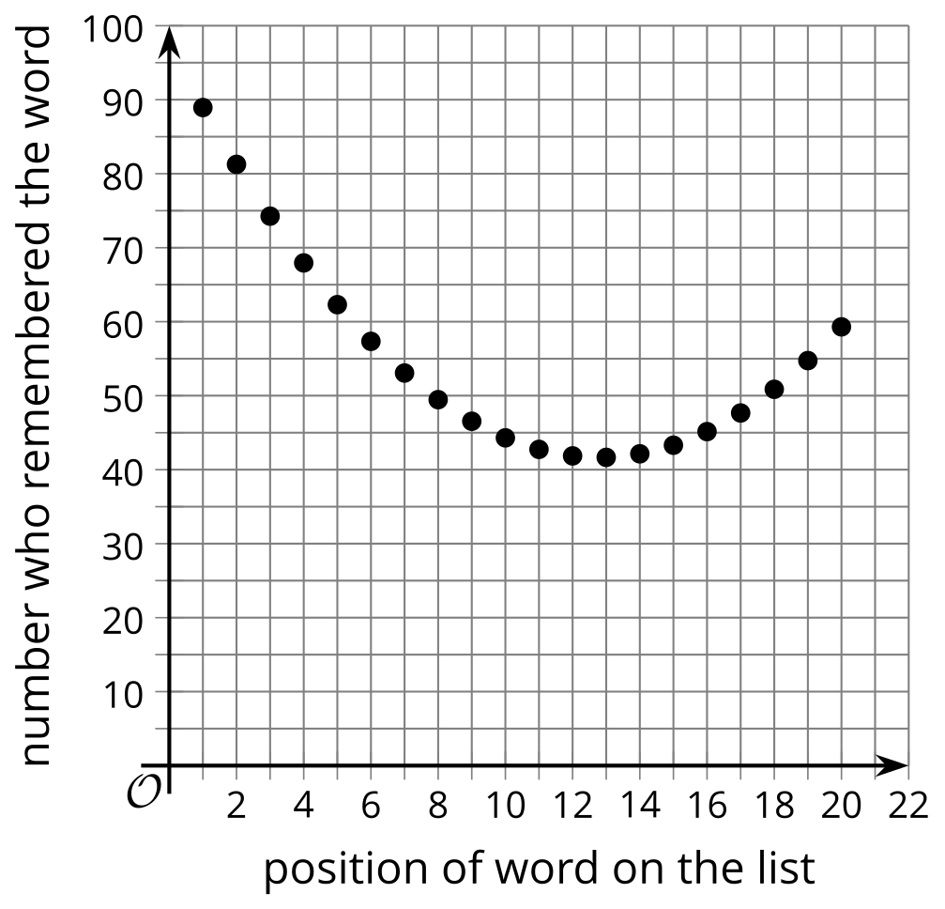
What do you notice? What do you wonder?

2.2: Seeing Solutions
- A person is hiking from the top of a mountain into a valley. The function $2,​000−32t$ represents their elevation in feet above sea level, $t$ minutes after they started their hike.
  - What does a solution to the equation $2000−32t=0$ mean?
  - Use technology to create a graph of $y=2,​000−32t$. Where do you see the solution to that equation on the graph?
- A new electronic device originally costs $1,000 but loses $175 worth of value every year.
  - Write a function that represents the worth of the device after $s$ years.
  - How many years until the device is worth $0?
  - Use technology to graph the function. Where can you see the solution to your equation on the graph?

2.3: Understanding Solutions in Situations
- The expression $5.25+0.85x$ represents the amount a yogurt shop charges for yogurt with $x$ ounces of toppings.
  - What does the equation $5.25+0.85x=7.08$ mean in this situation?
  - What would a solution to this equation mean?
  - Use technology to graph $y=5.25+0.85x$. Where can you see the solution to the equation on the graph?
- Drinks cost $1.50, sandwiches cost $4.00, and there is a flat delivery fee of $5 for each delivery regardless of the number of orders.
  - Write an expression that represents the amount it costs to have $x$ meals including a drink and a sandwich delivered to an office.
  - Write an equation that has a solution representing the number of drink and sandwich orders it would take to cost $80.
  - Graph $y=1.5x+4x+5$. Where can you see the solution to the equation on the graph?
- The temperature in a deep freezer in a laboratory is -40 degrees Celsius. The freezer breaks, so the temperature starts to rise by 2.5 degrees per hour.
  - Use technology to graph $y=\text{-}40+2.5x$.
  - Explain how to use this graph to find the time (after breaking) when the freezer temperature reaches 0 degrees Celsius.
- The expression $400−10x^{2}$ represents the height in meters of an object above the ground $x$ seconds after falling off a 400 meter building.
  - Write an equation that has a solution that would give the time in seconds when the object hit the ground.
  - Use technology to graph $y=400−10x^{2}$ and explain where you can see the solution to your equation on the graph.
© CC BY 2019 by Illustrative Mathematics®

