Lesson 7: Related Events
- Let’s see how events are related.

7.1: Drawing Crayons
A bag contains 1 crayon of each color: red, orange, yellow, green, blue, pink, maroon, and purple.
- A person chooses a crayon at random out of the bag, uses it for a bit, then puts it back in the bag. A second person comes to get a crayon chosen at random out of the bag. What is the probability the second person gets the yellow crayon?
- A person chooses a crayon at random out of the bag and walks off to use it. A second person comes to get a crayon chosen at random out of the bag. What is the probability the second person gets the yellow crayon?

7.2: Choosing Doors
- On a game show, a contestant is presented with 3 doors. One of the doors hides a prize and the other two doors have nothing behind them.
  - The contestant chooses one of the doors by number.
  - The host, knowing where the prize is, reveals one of the empty doors that the contestant did not choose.
  - The host then offers the contestant a chance to stay with the door they originally chose or to switch to the remaining door.
  - The final chosen door is opened to reveal whether the contestant has won the prize.
- Choose one partner to play the role of the host and the other to be the contestant. The host should think of a number: 1, 2, or 3 to represent the prize door. Play the game keeping track of whether the contestant stayed with their original door or switched and whether the contestant won or lost.
- Switch roles so that the other person is the host and play again. Continue playing the game until the teacher tells you to stop. Use the table to record your results.
 | - stay | - switch | - total
- win
- lose
- total
  - Based on your table, if a contestant decides they will choose to stay with their original choice, what is the probability they will win the game?
  - Based on your table, if a contestant decides they will choose to switch their choice, what is the probability they will win the game?
  - Are the two probabilities the same?
- In another version of the game, the host forgets which door hides the prize. The game is played in a similar way, but sometimes the host reveals the prize and the game immediately ends with the player losing, since it does not matter whether the contestant stays or switches.
- Choose one partner to play the role of the host and the other to be the contestant. The contestant should choose a number: 1, 2, or 3. The host should choose one of the other two numbers. The contestant can choose to stay with their original number or switch to the last number.
- After following these steps, roll the number cube to see which door contains the prize:
  - Rolling 1 or 4 means the prize was behind door 1.
  - Rolling 2 or 5 means the prize was behind door 2.
  - Rolling 3 or 6 means the prize was behind door 3.
- Play the game keeping track of whether the contestant stayed with their original door or switched and whether the contestant won or lost.
- Switch roles so that the other person is the host and play again. Continue playing the game until the teacher tells you to stop. Use the table to record your results.
 | - stay | - switch | - total
- win
- lose
- total
  - Based on your table, if a contestant decides they will choose to stay with their original choice, what is the probability they will win the game?
  - Based on your table, if a contestant decides they will choose to switch with their original choice, what is the probability they will win the game?
  - Are the two probabilities the same?

Are you ready for more?
In another version of the game, the contestant is presented with 5 doors. One of the doors hides a prize and the other four doors have nothing behind them.
- The contestant chooses 3 doors by number.
- The host, knowing where the prize is, reveals 3 of the doors that have nothing behind them. Two of the doors that the contestant has chosen that are empty and one of the other doors that are empty.
- The host then offers the contestant a chance to stay with the door they originally chose or to switch to the remaining door.
- The final chosen door is opened to reveal whether the contestant has won the prize.
Choose one partner to play the role of the host and the other to be the contestant. The host should think of a number: 1, 2, 3, 4, or 5 to represent the prize door. Play the game keeping track of whether the contestant stayed with their original door or switched and whether the contestant won or lost.
Switch roles so that the other person is the host and play again. Continue playing the game until the teacher tells you to stop. Use the table to record your results.
 | stay | switch | total
win
lose
total
- Based on your table, if a contestant decides they will choose to stay with their original choice, what is the probability they will win the game?
- Based on your table, if a contestant decides they will choose to switch with their original choice, what is the probability they will win the game?
- Are the two probabilities the same?

Lesson 7 Summary
When considering probabilities for two events it is useful to know whether the events are independent or dependent. Independent events are two events from the same experiment for which the probability of one event is not affected by whether the other event occurs or not. Dependent events are two events from the same experiment for which the probability of one event is affected by whether the other event occurs or not.
For example, let's say a bag contains 3 green blocks and 2 blue blocks. You are going to take two blocks out of the bag.
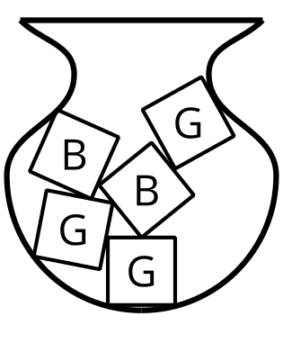
Consider two experiments:
- Take a block out, write down the color, return the block to the bag, and then choose a second block. The event, "the second block is green" is independent of the event, "the first block is blue." Since the first block is replaced, it doesn’t matter what block you picked the first time when you pick a second block.
- Take a block out, hold on to it, then take another block out. The same two events, "the second block is green" and "the first block is blue," are dependent.
If you get a blue block on the first draw, then the bag has 3 green blocks and 1 blue block in it, so $P\left(\text{green}\right)=\frac{3}{4}$.
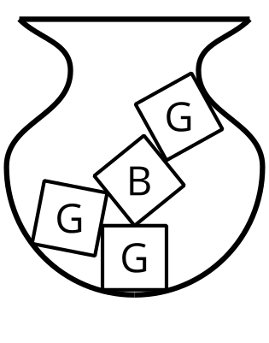
If you get a green block on the first draw, then the bag has 2 green blocks and 2 blue blocks in it, so $P\left(\text{green}\right)=\frac{1}{2}$.
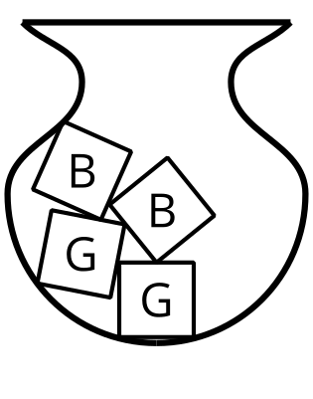
Since the probability of getting a green block on the second draw changes depending on whether the event of drawing a blue block on the first draw occurs or not, the two events are dependent.
In some cases, it is difficult to know whether events are independent without collecting some data. For example, a basketball player shoots two free throws. Does the probability of making the second shot depend on the outcome of the first shot? Some data would need to be collected about how often the player makes the second shot overall and how often the player makes the second shot after making the first so that you could compare the estimated probabilities.
© CC BY 2019 by Illustrative Mathematics®

