Lesson 1: Areas Around Areas
- Let’s explore rectangle areas

1.1: Estimation: Tennis Area
Estimation:
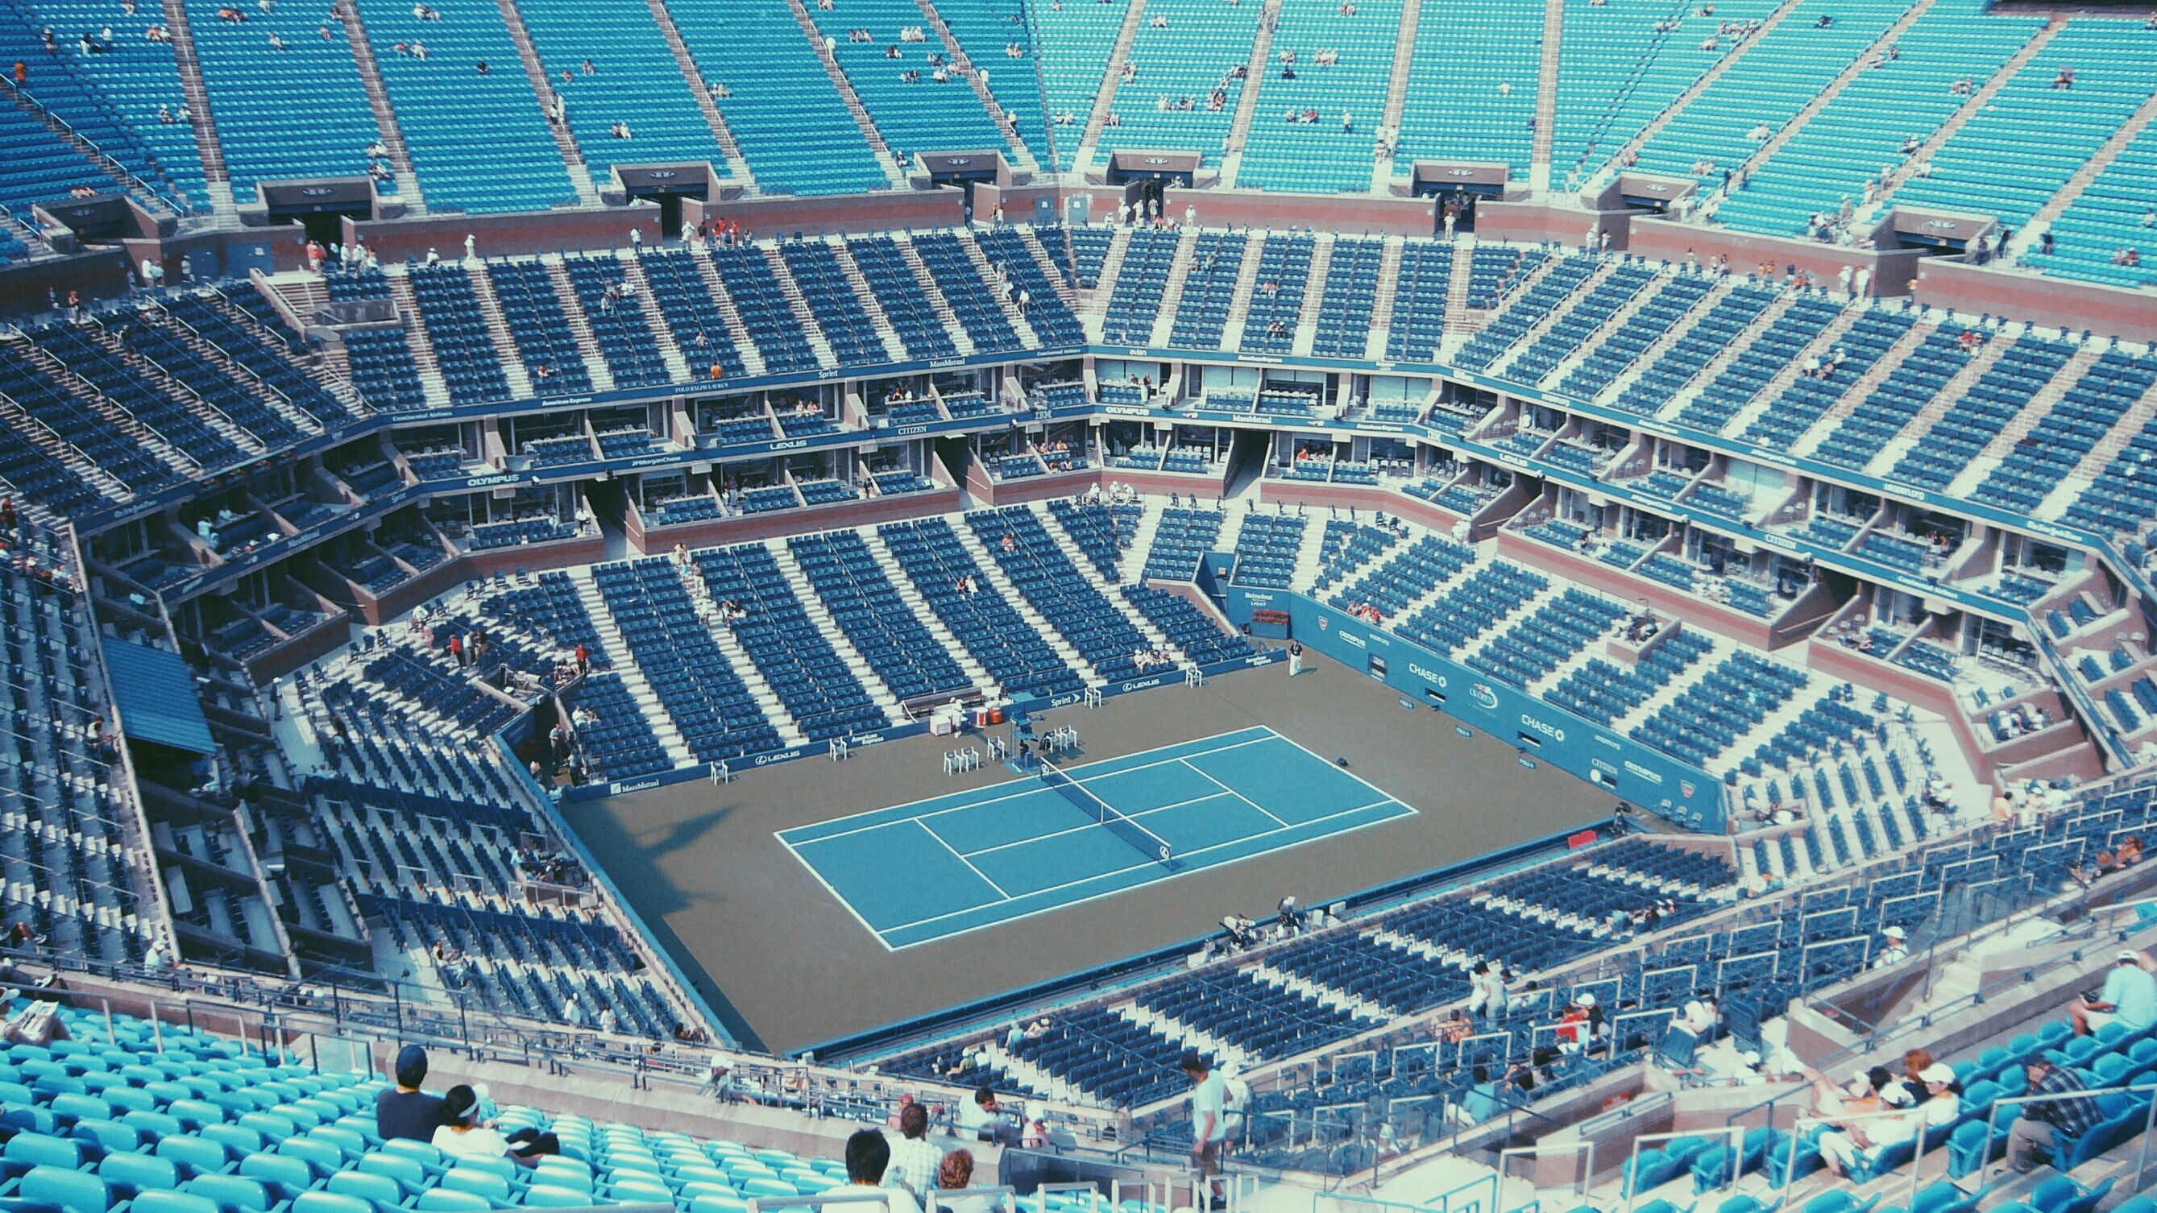
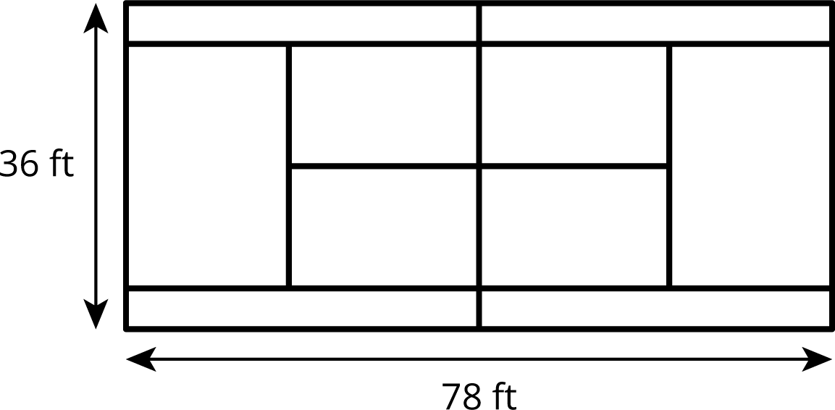
Estimate the area of the flat, gray ground surface that is not in the tennis court.
- Record an estimate that is:
- too low | - about right | - too high
- Explain your reasoning.

1.2: Pool Walkway
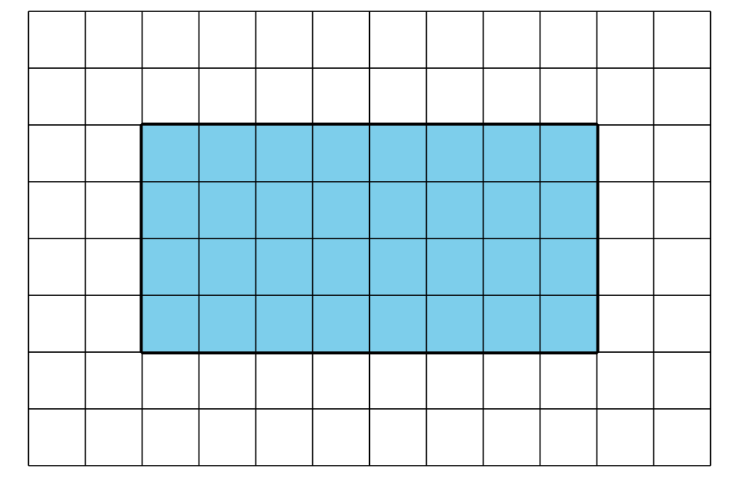
The pool is represented by the shaded region, and the walkway around a pool is tiled as shown in the diagram.
- What’s the area of the (shaded) pool if each tile is 1 square foot? 1 square meter? 4 square feet?
- What’s the area of the walkway and the pool when each tile is 1 square foot? 1 square meter? 4 square feet?
- What is the area of the walkway only when each tile is 1 square foot? 1 square meter? 4 square feet?
- Write an expression to find the total area of the walkway and pool if the length of the pool is $ℓ$ feet, the width of the pool is $w$ feet, and the walkway is 5 feet wide on each side of the pool.
- 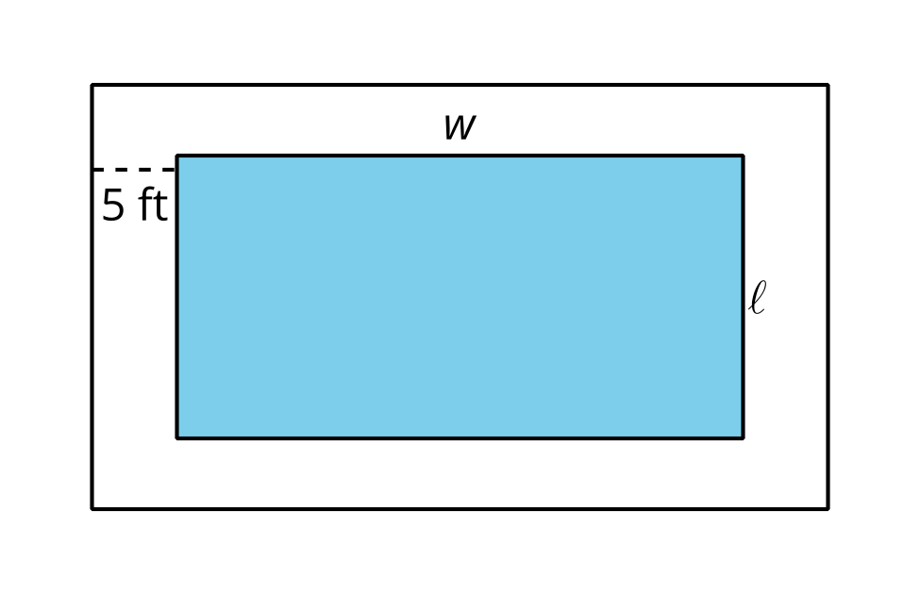
- What is the area of just the walkway?

1.3: Painting the Walls
Clare wants to paint the square wall in her bedroom that has a rectangular window. She needs the area of the wall space not including the window in order to determine how much paint is needed.
- Does it matter if the window is centered on the wall or not when trying to find the wall area that will be painted? Explain your reasoning.
- The total area of the window is 34 square feet. Find the height of the window if it has a width of 6 feet. Explain or show your reasoning.
- Find the area of wall space that will be painted if the window has an area of 34 square feet and the wall is square shaped and 10 feet wide? 13 feet wide? 15.5 feet wide? Explain or show your reasoning.
- Write an expression to find the total area of the wall space that will be painted if the height of the window is $h$ feet, the width is $w$ feet, and the entire wall is a square with length 20 feet.
© CC BY 2019 by Illustrative Mathematics®

