Lesson 1: Moving in the Plane
Let’s describe ways figures can move in the plane.

1.1: Which One Doesn’t Belong: Diagrams
Which one doesn’t belong?
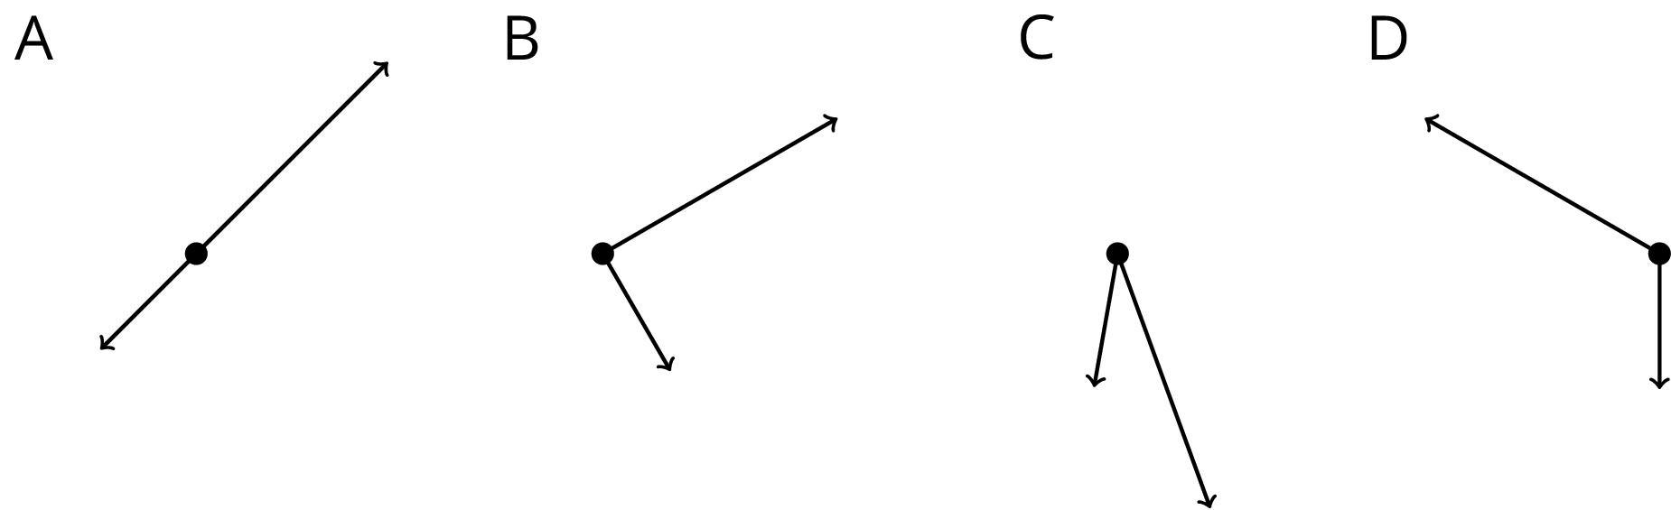

1.2: Triangle Square Dance
Your teacher will give you three pictures. Each shows a different set of dance moves.
- Arrange the three pictures so you and your partner can both see them right way up. Choose who will start the game.
  - The starting player mentally chooses A, B, or C and describes the dance to the other player.
  - The other player identifies which dance is being talked about: A, B, or C.
- After one round, trade roles. When you have described all three dances, come to an agreement on the words you use to describe the moves in each dance.
- With your partner, write a description of the moves in each dance.

Are you ready for more?
We could think of each dance as a new dance by running it in reverse, starting in the 6th frame and working backwards to the first.
- Pick a dance and describe in words one of these reversed dances.
- How do the directions for running your dance in the forward direction and the reverse direction compare?

Lesson 1 Summary
Here are two ways for changing the position of a figure in a plane without changing its shape or size:
- Sliding or shifting the figure without turning it. Shifting Figure A to the right and up puts it in the position of Figure B.
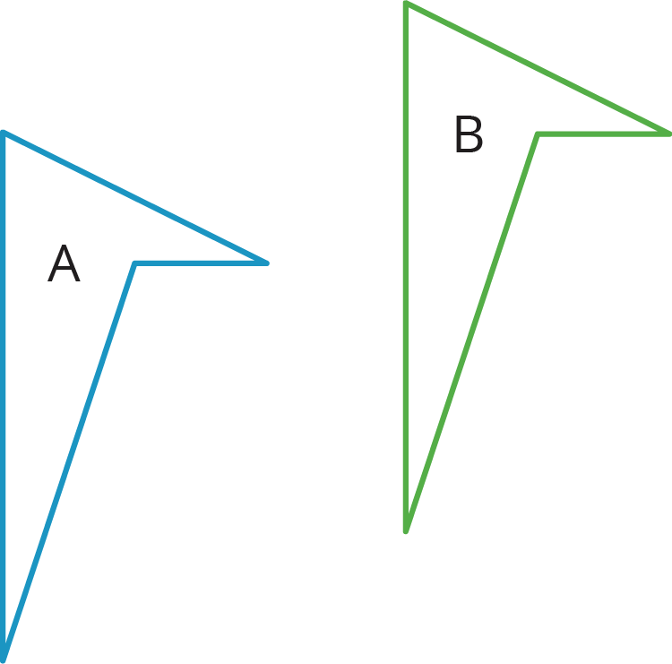
- Turning or rotating the figure around a point. Figure A is rotated around the bottom vertex to create Figure C.
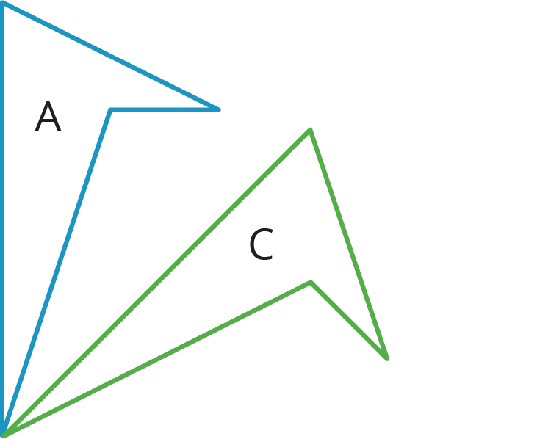
© CC BY Open Up Resources. Adaptations CC BY IM.

