## Unit 7 Lesson 3: Comparing Positive and Negative Numbers

### 1 Which One Doesn’t Belong: Inequalities (Warm up)

#### Student Task Statement

Which inequality doesn’t belong?

### 2 Comparing Temperatures

#### Student Task Statement

Here are the low temperatures, in degrees Celsius, for a week in Anchorage, Alaska.

| day | Mon | Tues | Weds | Thurs | Fri | Sat | Sun |
| --- | --- | --- | --- | --- | --- | --- | --- |
| temperature | 5 | -1 | -5.5 | -2 | 3 | 4 | 0 |

1. Plot the temperatures on a number line. Which day of the week had the lowest low temperature?
2. The lowest temperature ever recorded in the United States was -62 degrees Celsius, in Prospect Creek Camp, Alaska. The average temperature on Mars is about -55 degrees Celsius.
   1. Which is warmer, the coldest temperature recorded in the USA, or the average temperature on Mars? Explain how you know.
   2. Write an inequality to show your answer.
3. On a winter day the low temperature in Anchorage, Alaska, was -21 degrees Celsius and the low temperature in Minneapolis, Minnesota, was -14 degrees Celsius.

* Jada said, “I know that 14 is less than 21, so -14 is also less than -21. This means that it was colder in Minneapolis than in Anchorage.”
* Do you agree? Explain your reasoning.

#### Activity Synthesis

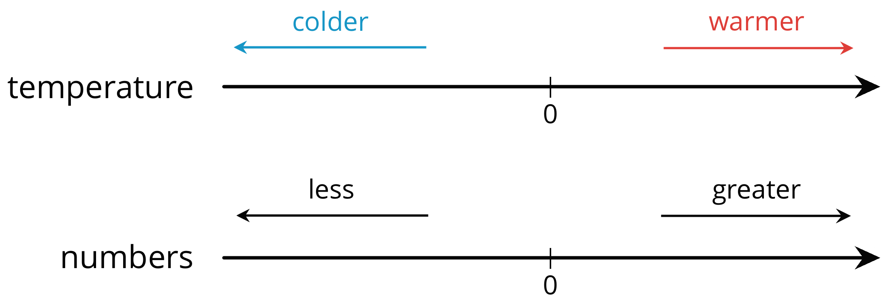

### 3 Rational Numbers on a Number Line

#### Student Task Statement

1. Plot the numbers -2, 4, -7, and 10 on the number line. Label each point with its numeric value.

* 

1. Decide whether each inequality statement is true or false. Be prepared to explain your reasoning.
2. Andre says that is less than because, of the two numbers, is closer to 0. Do you agree? Explain your reasoning.
3. Answer each question. Be prepared to explain how you know.
   1. Which number is greater: or ?
   2. Which is farther from 0: or ?
   3. Which number is greater: or ?
   4. Which is farther from 0: or ?
   5. Is the number that is farther from 0 always the greater number? Explain your reasoning.

#### Activity Synthesis

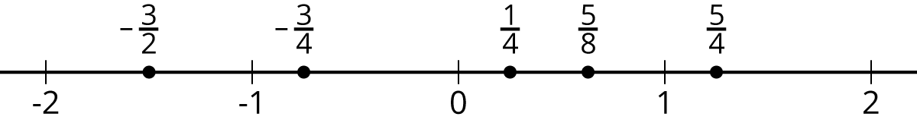

#### Images for Activity Synthesis





© CC BY Open Up Resources. Adaptations CC BY IM.