Lesson 10 Practice Problems
- A rotation takes $P$ to $Q$. What could be the measure of the angle of rotation in radians? Select all that apply.
- 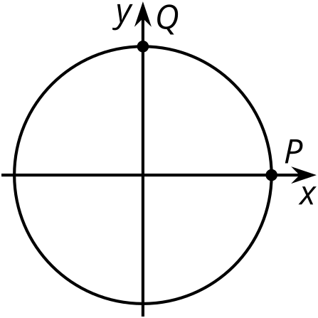
  - $\frac{3π}{2}$
  - $\frac{π}{2}$
  - $\frac{π}{4}$
  - $\frac{5π}{2}$
  - $\frac{5π}{4}$

  - A $\frac{2π}{3}$ radian rotation takes $N$ to $P$. Label $P$.
  - A $\frac{7π}{6}$ radian rotation takes $N$ to $Q$. Label $Q$.
  - A $\frac{25π}{6}$ radian rotation takes $N$ to $R$. Label $R$.
- 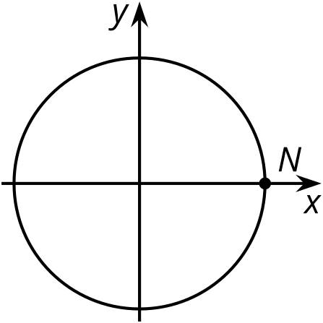
- Here is a wheel with radius 1 foot.
- 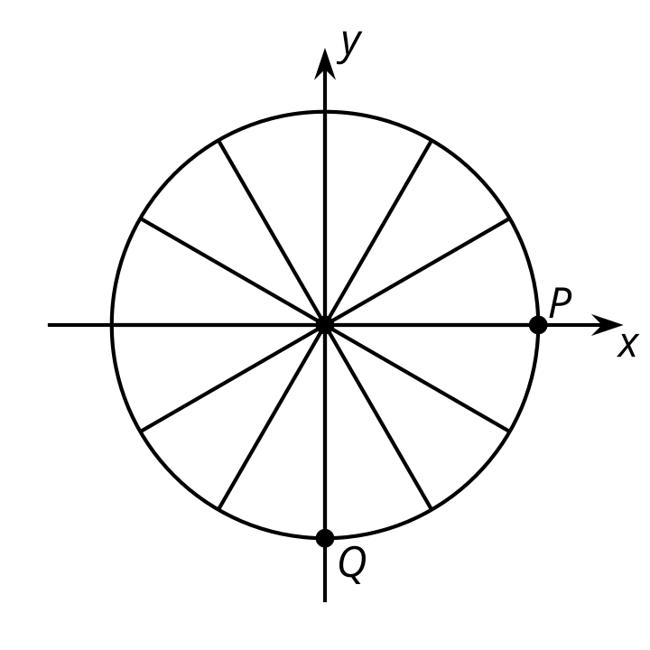
  - List three different counterclockwise angles the wheel can rotate so that point $P$ ends up at position $Q$.
  - How many feet does the wheel roll for each of these angles?
- The point $P$ on the unit circle is in the 0 radian position.
  - Which counterclockwise rotations take $P$ back to itself? Explain how you know.
  - Which counterclockwise rotations take $P$ to the opposite point on the unit circle? Explain how you know.
- Here is the unit circle with a point $P$ at $\left(1,0\right)$. Find the coordinates of $P$ after the circle rotates the given amount counterclockwise around its center.
- 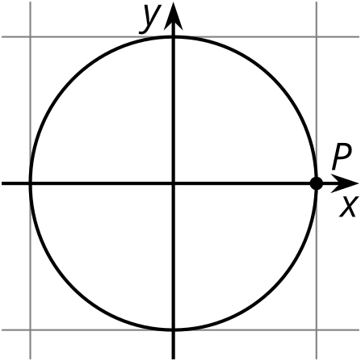
  - $\frac{1}{3}$ of a full rotation
  - $\frac{1}{2}$ of a full rotation
  - $\frac{2}{3}$ of a full rotation
- (From Unit 6, Lesson 4.)
- Here is a graph of $y=sin\left(θ\right)$.
  - Plot the points on the graph where $sin\left(θ\right)=\text{-}\frac{1}{2}$.
  - For which angles $θ$ does $sin\left(θ\right)=\text{-}\frac{1}{2}$?
- 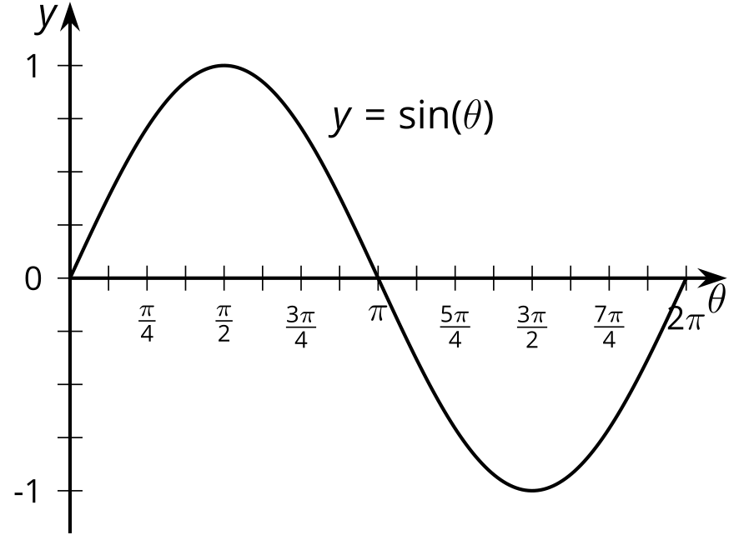
- (From Unit 6, Lesson 9.)
© CC BY 2019 by Illustrative Mathematics®

