Lesson 14: Outliers & Means
- Let’s explore outliers in data sets.

14.1: Math Talk: Outliers
Solve each expression mentally.
$20+1.5\left(10\right)$
$20−1.5\left(10\right)$
$20+1.5\left(14\right)$
$20+1.5\left(13\right)$

14.2: Mountain Hike
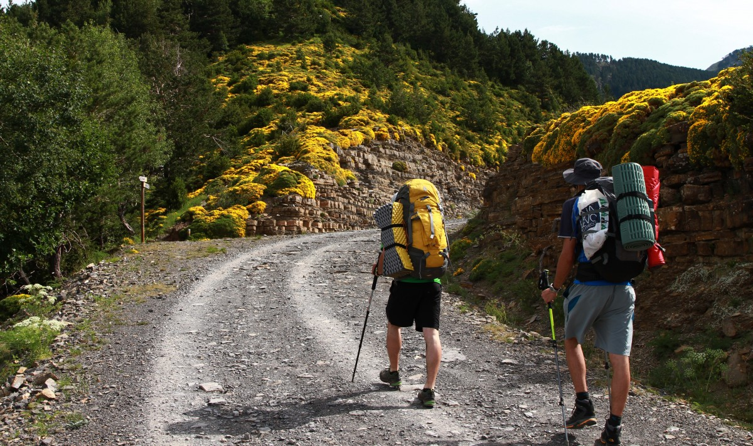
Andre records how long it takes him (in minutes) to hike a mountain each day for 6 days.
50 | 52 | 58 | 55 | 59 | 50

- Calculate the mean number of minutes it takes Andre to hike a mountain.
- Andre plans to hike the same mountain trail one more day. Estimate the time it will take him to complete the trail for the seventh day. Explain your reasoning.
- What do you think will happen to the mean time for the week if Andre's grandfather comes on the hike with him for the seventh day?
- Calculate the mean number of minutes using the values when Andre's grandfather comes on the hike for the seventh day: 50, 52, 58, 55, 59, 50, 130.
- If Andre’s grandfather did not come with him on the hike, Andre thinks he could have finished the trail in 60 minutes. Calculate the mean hiking time using Andre’s estimate for the seventh day: 50, 52, 58, 55, 59, 50, 60.

14.3: The Meaning of an Outlier
For each set of data, answer these questions:
- Use the data to compute the quartiles (Q1 and Q3) and the interquartile range.
- Use the expressions $\text{Q1}−1.5⋅\text{IQR}$ and $\text{Q3}+1.5⋅\text{IQR}$ to help find where an outlier may be.
- Are any of the values outliers? Explain your reasoning.
- A group of students recorded the distance, in miles, of the park nearest their home:
2.3, 4, 1.6, 15, 3.8, 0.75, 1.7
- Han visits a website to price the next phone he wants to get. He sees the following prices, in dollars:
200, 485, 492, 512, 453, 503
- The amount of points Clare scored in her last 8 basketball games are:
17, 14, 16, 2, 13, 14, 15, 17
- Kiran’s math test scores, as a percentage, were:
57, 82, 80, 85, 89, 84
- The height in feet of the roller coasters at the amusement park are:
415, 456, 423, 442, 30
© CC BY 2019 by Illustrative Mathematics®

