Unit 5 Lesson 5: Comparing Relationships with Equations

1 Notice and Wonder: Patterns with Rectangles (Warm up)

Student Task Statement
Do you see a pattern? What predictions can you make about future rectangles in the set if your pattern continues?

2 More Conversions

Student Task Statement
The other day you worked with converting meters, centimeters, and millimeters. Here are some more unit conversions.
- Use the equation $F=\frac{9}{5}C+32$, where $F$ represents degrees Fahrenheit and $C$ represents degrees Celsius, to complete the table.
- temperature $\left(​^{∘}\text{C}\right)$ | - temperature $\left(​^{∘}\text{F}\right)$
- 20
- 4
- 175
- Use the equation $c=2.54n$, where $c$ represents the length in centimeters and $n$ represents the length in inches, to complete the table.
- length (in) | - length (cm)
- 10
- 8
- 3$\frac{1}{2}$
- Are these proportional relationships? Explain why or why not.

3 Total Edge Length, Surface Area, and Volume

Student Task Statement
Here are some cubes with different side lengths. Complete each table. Be prepared to explain your reasoning.
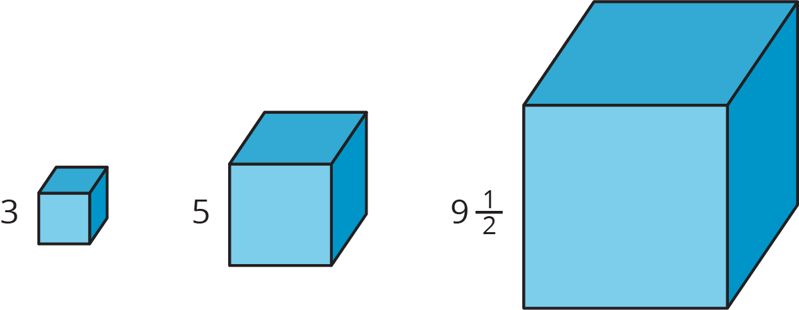
- How long is the total edge length of each cube?
- side  length | - total  edge length
- 3
- 5
- $9\frac{1}{2}$
- $s$
- What is the surface area of each cube?
- side  length | - surface  area
- 3
- 5
- $9\frac{1}{2}$
- $s$
- What is the volume of each cube?
- side  length | - volume
- 3
- 5
- $9\frac{1}{2}$
- $s$
- Which of these relationships is proportional? Explain how you know.
- Write equations for the total edge length $E$, total surface area $A$, and volume $V$ of a cube with side length $s$.

4 All Kinds of Equations (Optional)

Student Task Statement
Here are six different equations.
$y=4+x$
$y=\frac{x}{4}$
$y=4x$
$y=4^{x}$
$y=\frac{4}{x}$
$y=x^{4}$
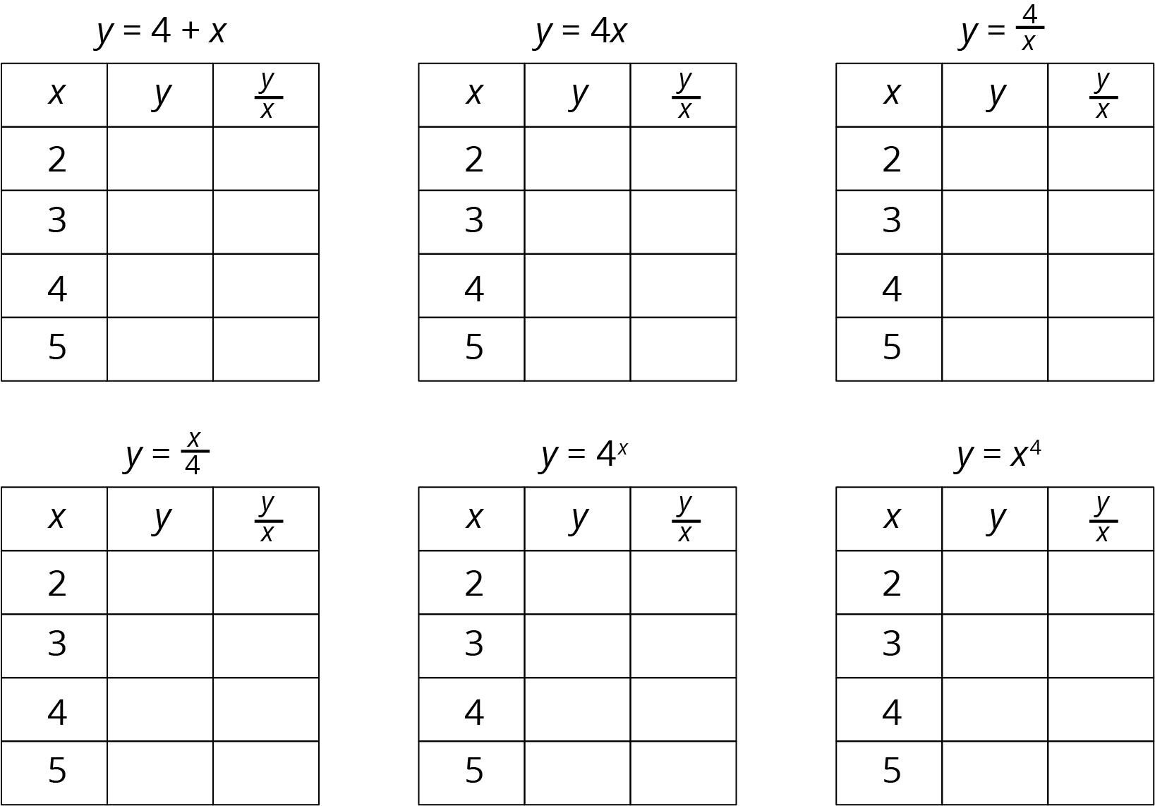
- Predict which of these equations represent a proportional relationship.
- Complete each table using the equation that represents the relationship.
- Do these results change your answer to the first question? Explain your reasoning.
- What do the equations of the proportional relationships have in common?
© CC BY Open Up Resources. Adaptations CC BY IM.

