Unit 7 Lesson 6: Rewriting Quadratic Expressions in Factored Form (Part 1)

1 Puzzles of Rectangles (Warm up)

Student Task Statement
Here are two puzzles that involve side lengths and areas of rectangles. Can you find the missing area in Figure A and the missing length in Figure B? Be prepared to explain your reasoning.

Figure A
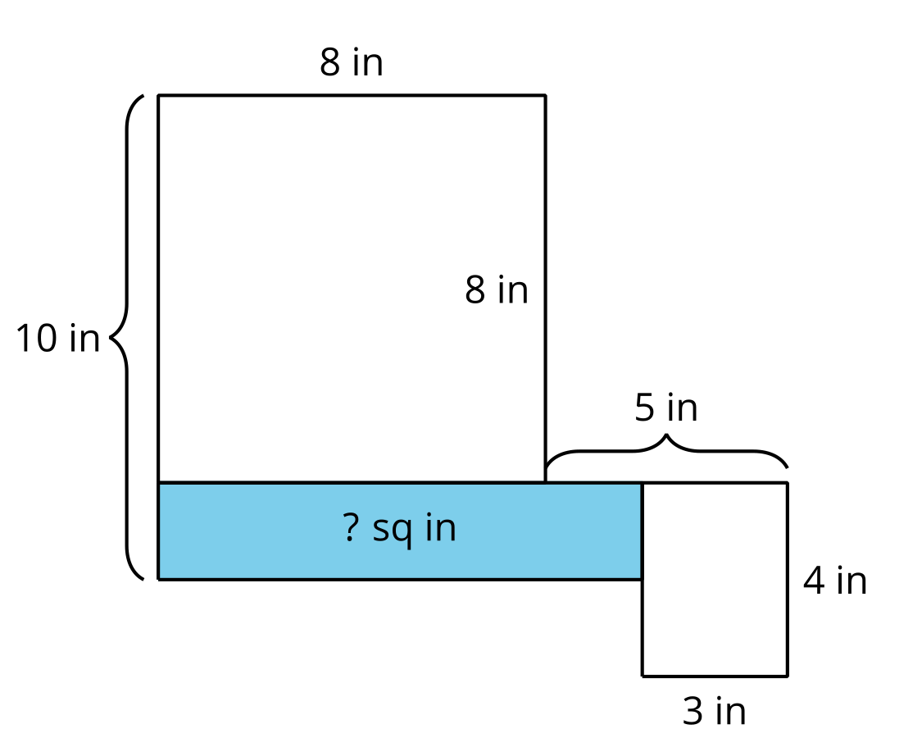
​​​​​​

Figure B
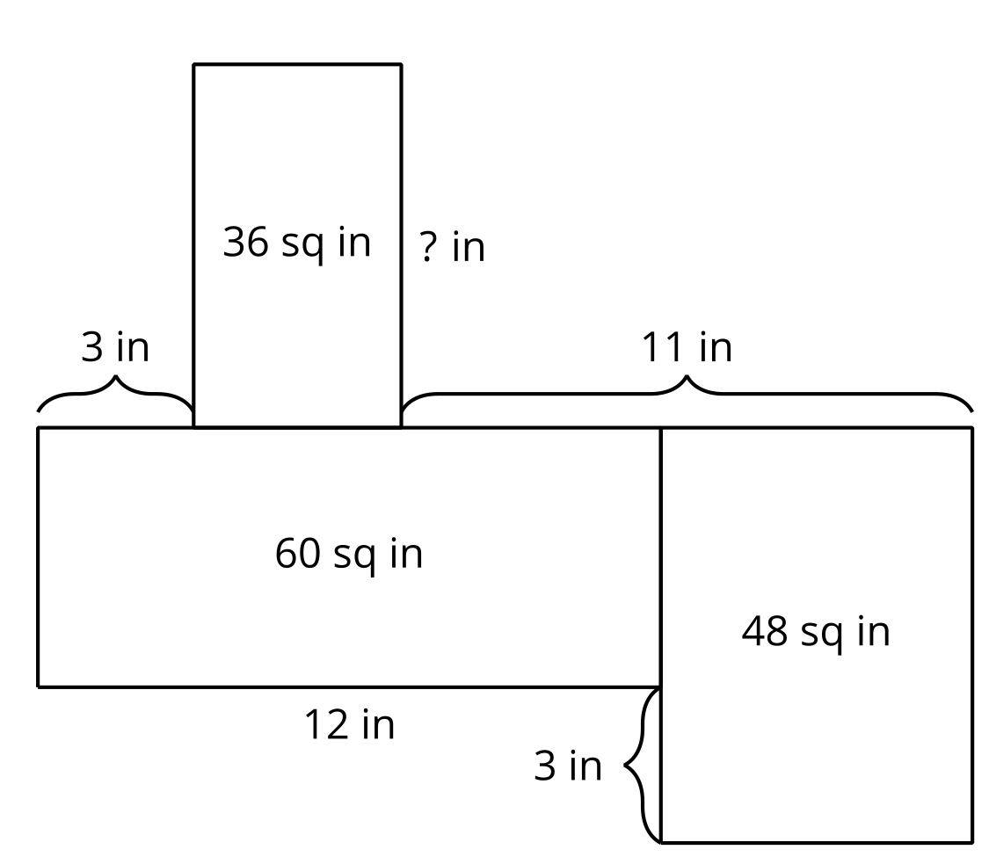

2 Using Diagrams to Understand Equivalent Expressions

Student Task Statement
- Use a diagram to show that each pair of expressions is equivalent.
- $x\left(x+3\right)$ and $x^{2}+3x$
- $x\left(x+\text{-}6\right)$ and $x^{2}−6x$
- $\left(x+2\right)\left(x+4\right)$ and $x^{2}+6x+8$
- $\left(x+4\right)\left(x+10\right)$ and $x^{2}+14x+40$
- $\left(x+\text{-}5\right)\left(x+\text{-}1\right)$ and $x^{2}−6x+5$
- $\left(x−1\right)\left(x−7\right)$ and $x^{2}−8x+7$
- Observe the pairs of expressions that involve the product of two sums or two differences. How is each expression in factored form related to the equivalent expression in standard form?

3 Let’s Rewrite Some Expressions!

Student Task Statement
Each row in the table contains a pair of equivalent expressions.
Complete the table with the missing expressions. If you get stuck, consider drawing a diagram.
factored form | standard form
$x\left(x+7\right)$
 | $x^{2}+9x$
 | $x^{2}−8x$
$\left(x+6\right)\left(x+2\right)$
 | $x^{2}+13x+12$
$\left(x−6\right)\left(x−2\right)$
 | $x^{2}−7x+12$
 | $x^{2}+6x+9$
 | $x^{2}+10x+9$
 | $x^{2}−10x+9$
 | $x^{2}−6x+9$
 | $x^{2}+\left(m+n\right)x+mn$
© CC BY 2019 by Illustrative Mathematics®

