Unit 5 Lesson 17: Scaling One Dimension

1 Driving the Distance (Warm up)

Student Task Statement
Here is a graph of the amount of gas burned during a trip by a tractor-trailer truck as it drives at a constant speed down a highway:
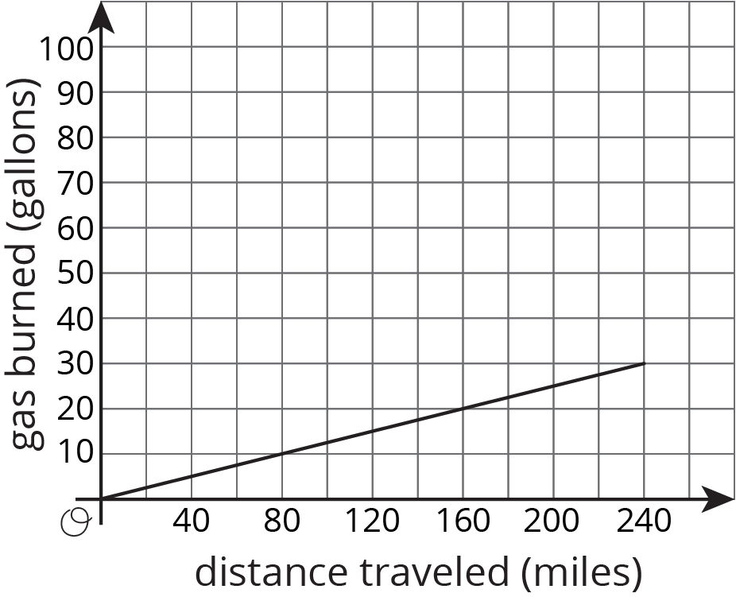
- At the end of the trip, how far did the truck drive, and how much gas did it use?
- If a truck traveled half this distance at the same rate, how much gas would it use?
- If a truck traveled double this distance at the same rate, how much gas would it use?
- Complete the sentence: ___________ is a function of _____________.

2 Double the Edge (Optional)

Student Task Statement
There are many right rectangular prisms with one edge of length 5 units and another edge of length 3 units. Let $s$ represent the length of the third edge and $V$ represent the volume of these prisms.
- Write an equation that represents the relationship between $V$ and $s$.
- Graph this equation and label the axes.

- What happens to the volume if you double the edge length $s$? Where do you see this in the graph? Where do you see it algebraically?

3 Halve the Height (Optional)

Student Task Statement
There are many cylinders with radius 5 units. Let $h$ represent the height and $V$ represent the volume of these cylinders.
- Write an equation that represents the relationship between $V$ and $h$. Use 3.14 as an approximation of $π$.
- Graph this equation and label the axes.
- What happens to the volume if you halve the height, $h$? Where can you see this in the graph? How can you see it algebraically?

4 Figuring Out Cone Dimensions (Optional)

Student Task Statement
Here is a graph of the relationship between the height and the volume of some cones that all have the same radius:
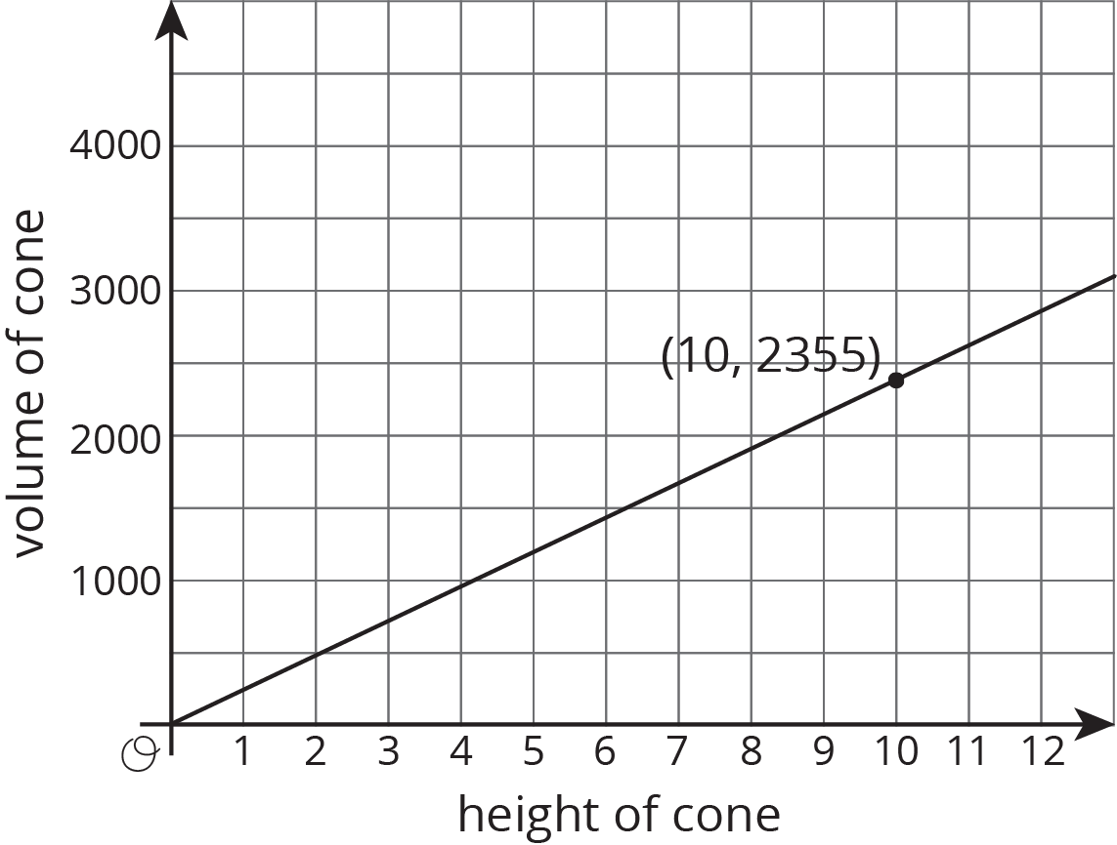
- What do the coordinates of the labeled point represent?
- What is the volume of the cone with height 5? With height 30?
- Use the labeled point to find the radius of these cones. Use 3.14 as an approximation for $π$.
- Write an equation that relates the volume $V$ and height $h$.
© CC BY Open Up Resources. Adaptations CC BY IM.

