Lesson 13: Using the Pythagorean Theorem and Similarity
- Let’s explore right triangles with altitudes drawn to the hypotenuse.

13.1: Similar, Right?
Is triangle $ADC$ similar to triangle $CDB$? Explain or show your reasoning.
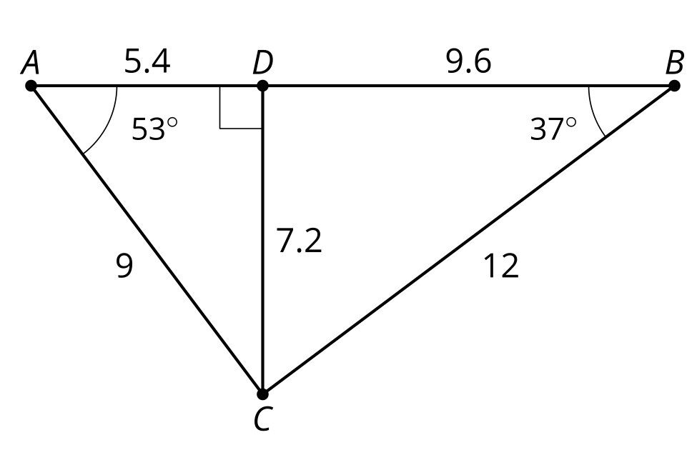

13.2: Tangled Triangles
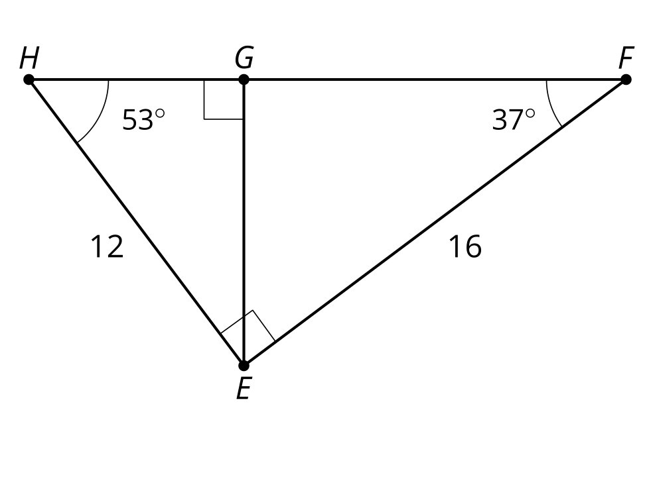
Trace the 2 smaller triangles onto separate pieces of tracing paper.
- Turn your tracing paper and convince yourself all 3 triangles are similar.
- Write 3 similarity statements.
- Determine the scale factor for each pair of triangles.
- Determine the lengths of sides $HG$, $GF$, and $HF$.

13.3: More Tangled Triangles
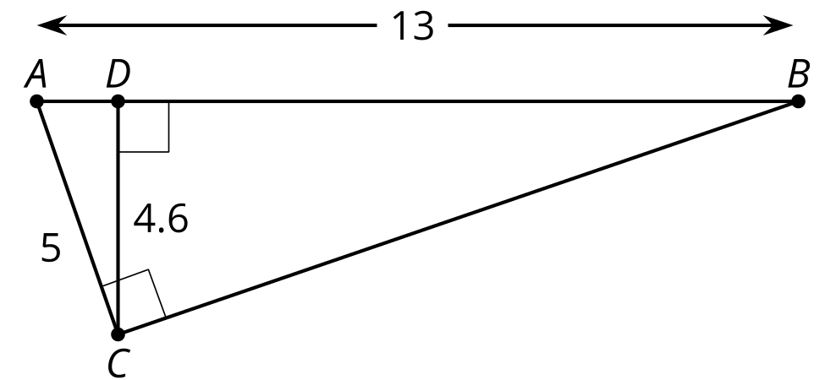
- Convince yourself there are 3 similar triangles. Write a similarity statement for the 3 triangles.
- Write as many equations about proportional side lengths as you can.
- What do you notice about these equations?

Are you ready for more?
Tyler says that since triangle $ACD$ is similar to triangle $ABC$, the length of $CB$ is 11.96. Noah says that since $ABC$ is a right triangle, we can use the Pythagorean Theorem. So the length of $CB$ is 12 exactly. Do you agree with either of them? Explain or show your reasoning.

Lesson 13 Summary
When we draw an altitude from the hypotenuse of a right triangle, we get lots of similar triangles that can be used to find missing lengths. An altitude is a segment from one vertex of the triangle to the line containing the opposite side that is perpendicular to the opposite side. For right triangle $PQR$ we can draw the altitude $PS$ .
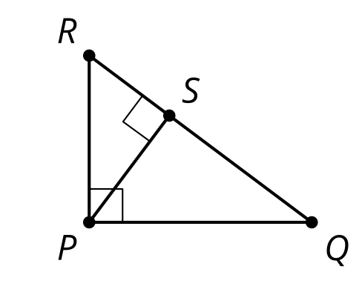
Why are triangles $PQR$, $SQP$, and $SPR$ all similar to each other?
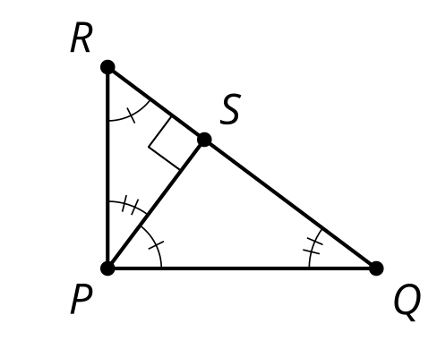
Triangles $PQR$ and $SQP$ are similar by the Angle-Angle Triangle Similarity Theorem because angle $Q$ is in both triangles, and both triangles are right triangles, so angles $RPQ$ and $PSQ$ are congruent. Triangles $PQR$ and $SPR$ are similar by the Angle-Angle Triangle Similarity Theorem because angle $R$ is in both triangles, and both triangles are right triangles, so angles $RPQ$ and $RSP$ are congruent. Because triangles $SQP$ and $SPR$ are both similar to triangle $PQR$, they are also similar to each other.
Since the triangles $PQR$, $SQP$, and $SPR$ are all similar, corresponding angles are congruent and pairs of corresponding sides are scaled copies of each other, by the same scale factor. We can use the proportionality of pairs of corresponding side lengths to find missing side lengths. For example, suppose we need to find $PS$ and know $RS=3$ and $QS=7$. Since triangle $SQP$ is similar to triangle $SPR$, we know $\frac{RS}{PS}=\frac{PS}{QS}$. So $\frac{3}{PS}=\frac{PS}{7}$ and $PS=\sqrt{21}$. Or, suppose we need to find $SQ$ and know $PQ=5$ and $RQ=12$. Since triangle $PQR$ is similar to triangle $SQP$, we know $\frac{RQ}{PQ}=\frac{PQ}{SQ}$. So $\frac{12}{5}=\frac{5}{SQ}$ and $SQ=\frac{25}{12}$.
© CC BY 2019 by Illustrative Mathematics®

