Lesson 6 Practice Problems
- The picture shows angles $A$ and $B$. Explain why $sin\left(B\right)=\text{-}sin\left(A\right)$ and why $cos\left(B\right)=\text{-}cos\left(A\right)$.
- 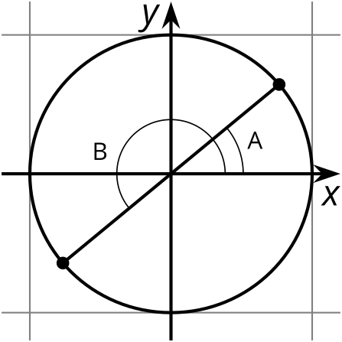
- Which statements are true? Select all that apply.
  - $sin\left(θ\right)>0$ for an angle $θ$ in quadrant 2
  - $cos\left(θ\right)>0$ for an angle $θ$ in quadrant 2
  - $tan\left(θ\right)>0$ for an angle $θ$ in quadrant 2
  - $sin\left(θ\right)>0$ for an angle $θ$ in quadrant 3
  - $cos\left(θ\right)>0$ for an angle $θ$ in quadrant 3
  - $tan\left(θ\right)>0$ for an angle $θ$ in quadrant 3
- The tangent of an angle satisfies $tan\left(θ\right)=10$.
  - Which quadrant could $θ$ lie in? Explain how you know.
  - Estimate the possible value(s) of $θ$. Explain your reasoning.
- Evaluate each of the following:
  - $tan\left(\frac{5π}{4}\right)$
  - $sin\left(\frac{3π}{2}\right)$
  - $cos\left(\frac{7π}{4}\right)$
- The sine of an angle $θ$ in the second quadrant is $0.6$. What is $tan\left(θ\right)$? Explain how you know.
- Triangle $ABC$ is an isosceles right triangle in the unit circle.
- 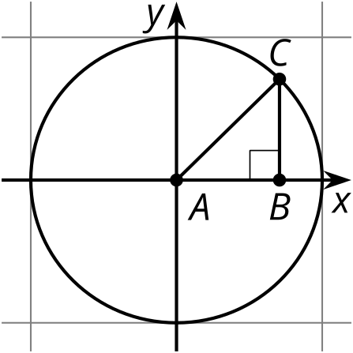
  - Explain why $sin\left(A\right)=cos\left(A\right)$.
  - Use the Pythagorean Theorem to explain why $2{\left(sin\left(A\right)\right)}^{2}=1$.
- (From Unit 6, Lesson 5.)
- Triangle $DEF$ is similar to triangle $ABC$. The scale factor going from $△DEF$ to $△ABC$ is 3.
- 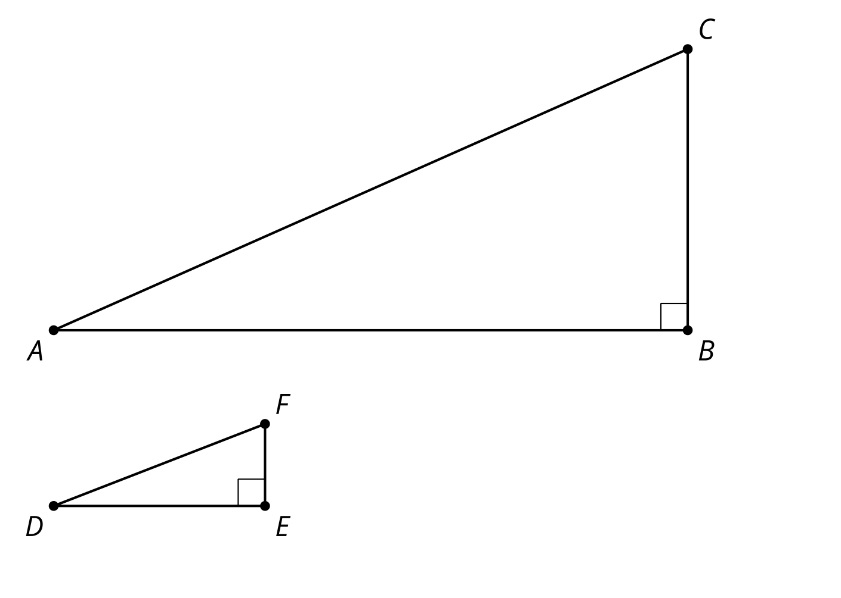
  - Explain why the length of segment $AB$ is 3 times the length of segment $DE$ and the length of segment $BC$ is 3 times the length of segment $EF$.
  - Explain why $sin\left(A\right)=sin\left(D\right)$.
- (From Unit 6, Lesson 2.)
- Which of the following is true for angle $θ$? Select all that apply.
- 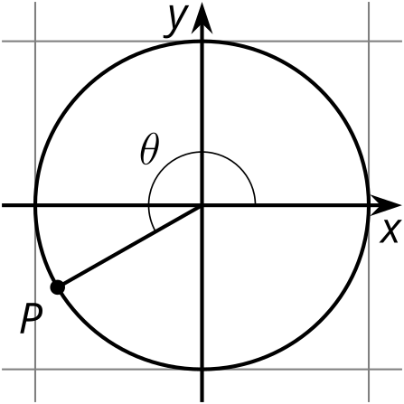
  - $sin\left(θ\right)<0$
  - $sin\left(θ\right)>0$
  - $cos\left(θ\right)<0$
  - $cos\left(θ\right)>0$
  - $sin\left(θ\right)>cos\left(θ\right)$
  - $sin\left(θ\right)<cos\left(θ\right)$
- (From Unit 6, Lesson 5.)
© CC BY 2019 by Illustrative Mathematics®

