Lesson 10: Measures of Center
- Let’s explore the relationship between measures of center and the shape of data.

10.1: Estimation: Lamp Post
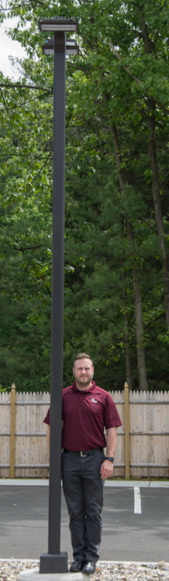
How tall is the lamp post?
- Record an estimate that is:
- too low | - about right | - too high
- Explain your reasoning.

10.2: Balance Point
For each graph, estimate the balance point. The balance point is where you think the number line would balance. Record your balance point on the graph with a $Δ$ symbol. Then, calculate the mean and median for each data set.
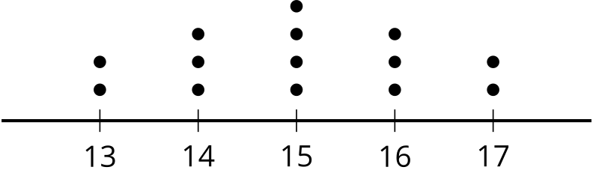

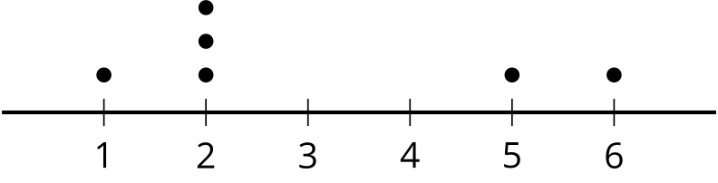
​​​​​​

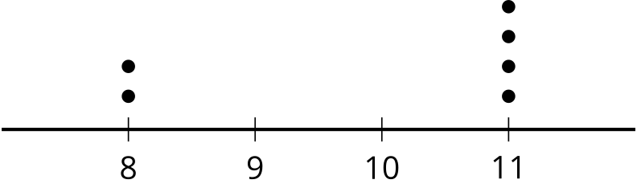
​​​​​​

10.3: Mean vs. Median
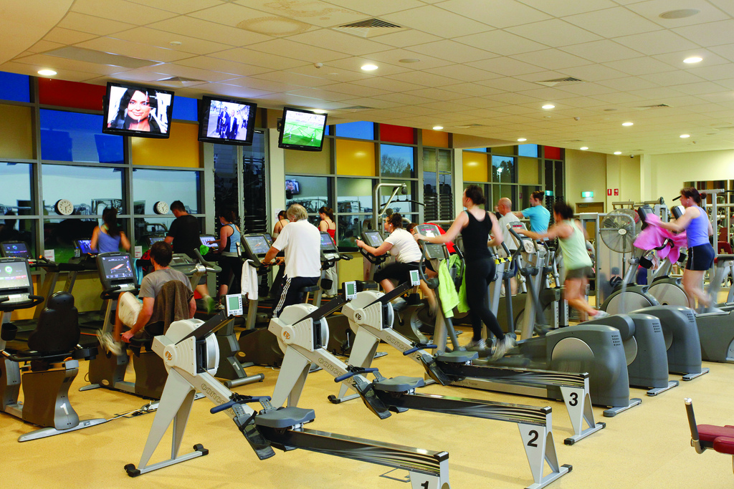
When people join a gym, they are assessed on their fitness by doing several exercises. The results are given as a score between 1 and 100 with 100 representing peak fitness for the person’s age. The gym claims they can improve scores for members after only 2 months.
After 2 months, 11 people are assessed again, and the number of points they improve on in the assessment is shown in the dot plot.
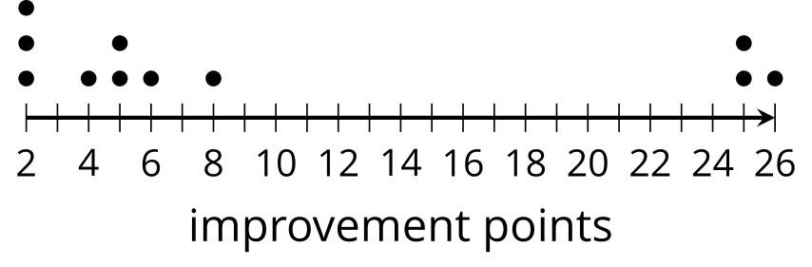
- What is the mean improvement among these members?
- What is the median?
- Which measure of center is a better representation of the members’ improvement? Explain your reasoning.
© CC BY 2019 by Illustrative Mathematics®

