Unit 5 Lesson 20: The Volume of a Sphere

1 Sketch a Sphere (Warm up)

Student Task Statement
Here is a method for quickly sketching a sphere:
- Draw a circle.
- Draw an oval in the middle whose edges touch the sphere.
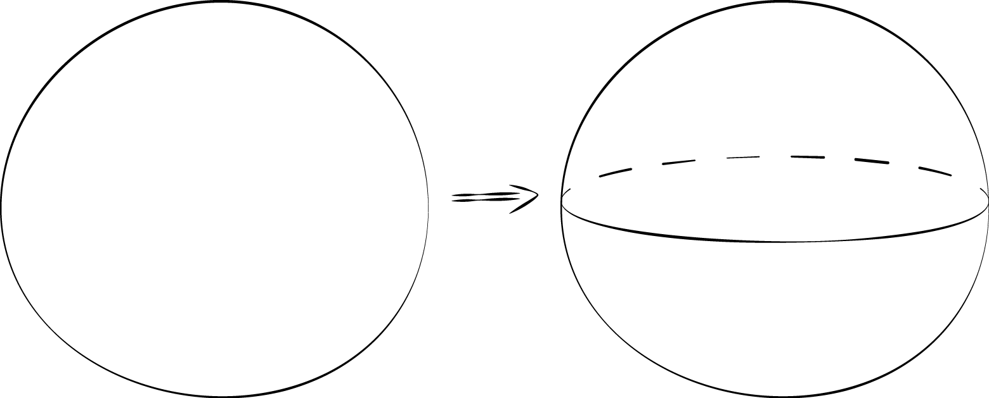
- Practice sketching some spheres. Sketch a few different sizes.
- For each sketch, draw a radius and label it $r$.

2 A Sphere in a Cylinder

Images for Launch
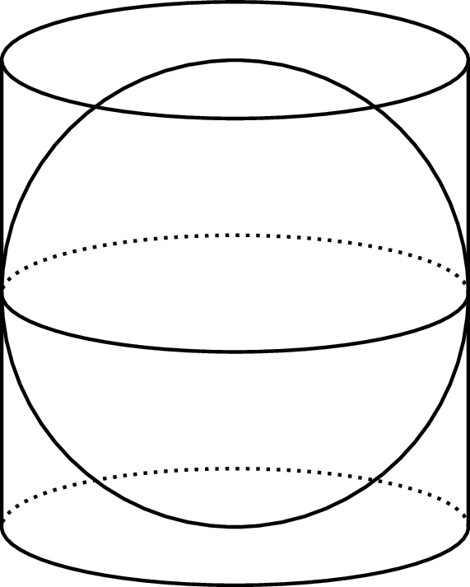

Student Task Statement
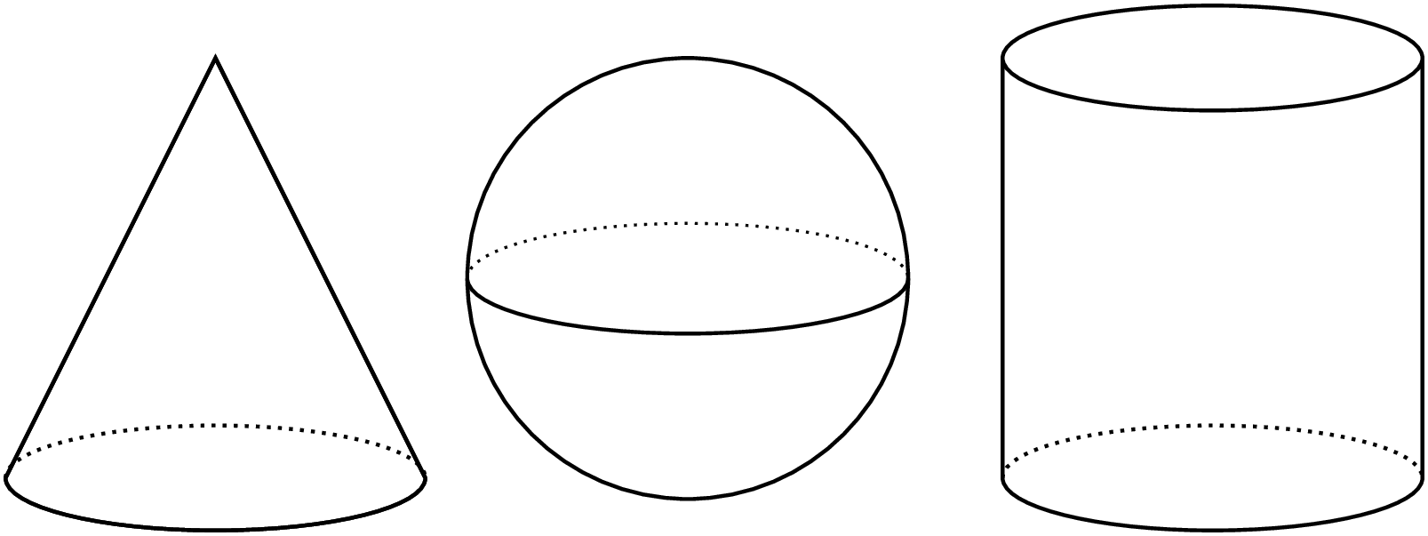
Here are a cone, a sphere, and a cylinder that all have the same radii and heights. The radius of the cylinder is 5 units. When necessary, express all answers in terms of $π$.
- What is the height of the cylinder?
- What is the volume of the cylinder?
- What is the volume of the cone?
- What is the volume of the sphere? Explain your reasoning.

3 Spheres in Cylinders

Student Task Statement
Here are a cone, a sphere, and a cylinder that all have the same radii and heights. Let the radius of the cylinder be $r$ units. When necessary, express answers in terms of $π$.
- What is the height of the cylinder in terms of $r$?
- What is the volume of the cylinder in terms of $r$?
- What is the volume of the cone in terms of $r$?
- What is the volume of the sphere in terms of $r$?
- A volume of the cone is $\frac{1}{3}$ the volume of a cylinder. The volume of the sphere is what fraction of the volume of the cylinder?
© CC BY Open Up Resources. Adaptations CC BY IM.

