Lesson 9 Practice Problems
- Which statement is not true for the function $f$ given by $f\left(θ\right)=sin\left(θ\right)$, for values of $θ$ between 0 and $2π$?
  - The outputs of the function range from -1 to 1.
  - $sinθ=1$ only when $θ=\frac{π}{2}$
  - $sinθ=0$ only when $θ=0$
  - $sinθ>0$ for $0<θ<π$
- Angle $θ$, measured in radians, satisfies $cos\left(θ\right)=0$. What could the value of $θ$ be? Select all that apply.
  - 0
  - $\frac{π}{4}$
  - $\frac{π}{2}$
  - $π$
  - $\frac{3π}{2}$
- Here are the graphs of two functions.
  - Which is the graph of $y=cos\left(θ\right)$? Explain how you know.
  - Which is the graph of $y=sin\left(θ\right)$? Explain how you know.
- 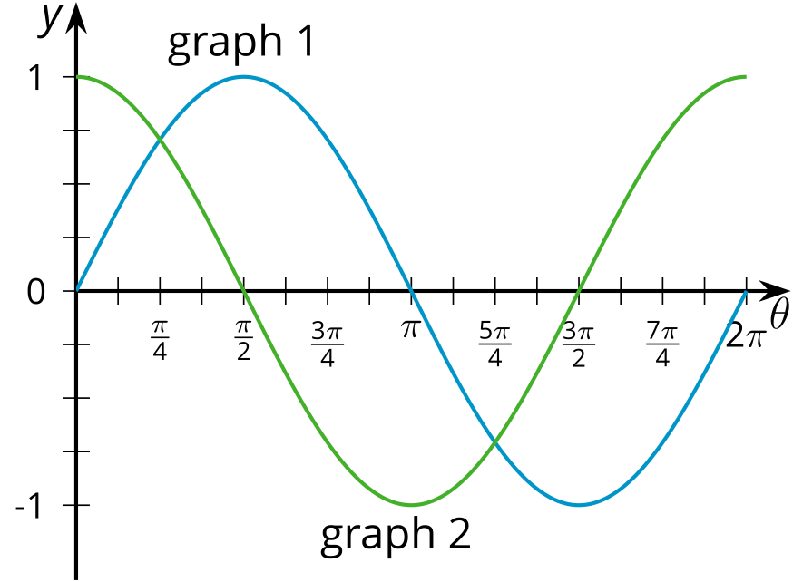
- Which statements are true for both functions $y=cos\left(θ\right)$ and $y=sin\left(θ\right)$? Select all that apply.
  - The function is periodic.
  - The maximum value is 1.
  - The maximum value occurs at $θ=0$.
  - The period of the function is $2π$.
  - The function has a value of about 0.71 when $θ=\frac{π}{4}$.
  - The function has a value of about 0.71 when $θ=\frac{3π}{4}$.
- Here is a graph of a function $f$.
- 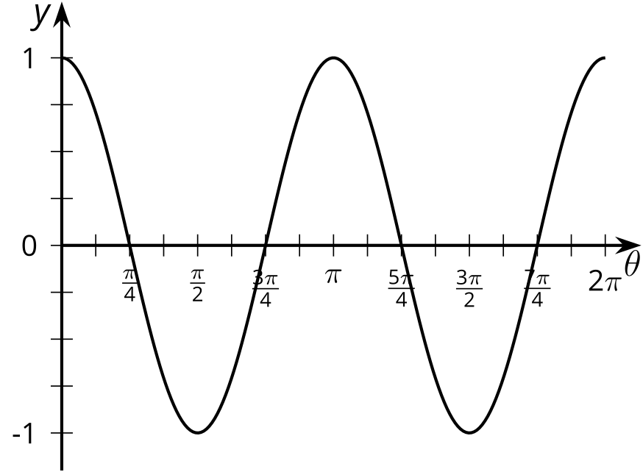
- The function $f$ is either defined by $f\left(θ\right)=\cos^{2}\left(θ\right)+\sin^{2}\left(θ\right)$ or $f\left(θ\right)=\cos^{2}\left(θ\right)−\sin^{2}\left(θ\right)$. Which definition is correct? Explain how you know.
- The minute hand on a clock is 1.5 feet long. The end of the minute hand is 6 feet above the ground at one time each hour. How many feet above the ground could the center of the clock be? Select all that apply.
  - 4.5
  - 5
  - 6
  - 7
  - 7.5
- (From Unit 6, Lesson 7.)
- Here is a graph of the water level height, $h$, in feet, relative to a fixed mark, measured at a beach over several days, $d$.
- 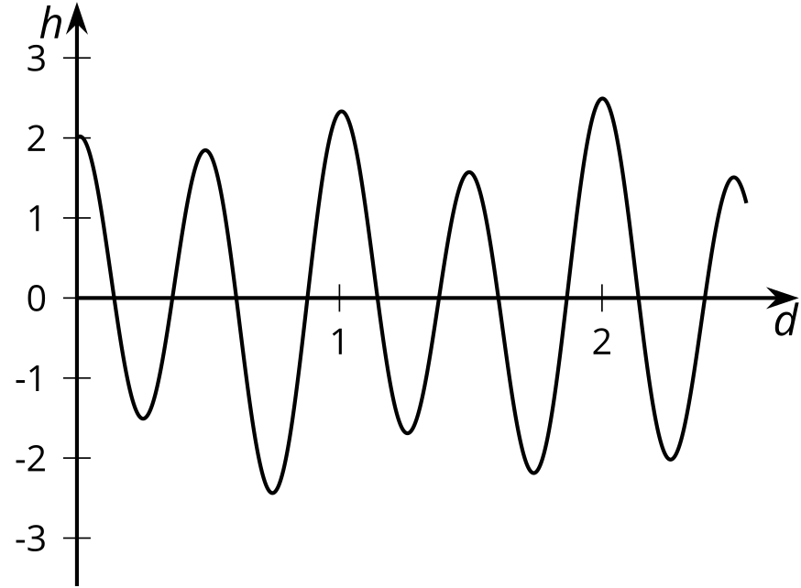
  - Explain why the water level is a function of time.
  - Describe how the water level varies each day.
  - What does it mean in this context for the water level to be a periodic function of time?
- (From Unit 6, Lesson 8.)
© CC BY 2019 by Illustrative Mathematics®

