Unit 5 Lesson 16: Finding Cone Dimensions

1 Number Talk: Thirds (Warm up)

Student Task Statement
For each equation, decide what value, if any, would make it true.
$27=\frac{1}{3}h$
$27=\frac{1}{3}r^{2}$
$12π=\frac{1}{3}πa$
$12π=\frac{1}{3}πb^{2}$

2 An Unknown Radius (Optional)

Student Task Statement
The volume $V$ of a cone with radius $r$ is given by the formula $V=\frac{1}{3}πr^{2}h$.
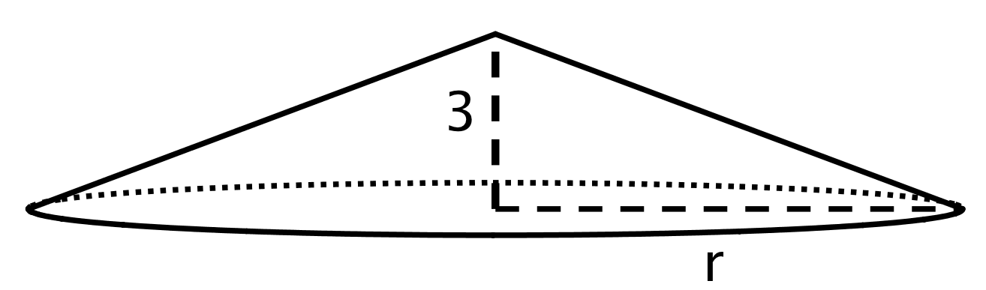
The volume of this cone with height 3 units and radius $r$ is $V=64π$ cubic units. This statement is true:
$64π=\frac{1}{3}πr^{2}⋅3$ What does the radius of this cone have to be? Explain how you know.

3 Cones with Unknown Dimensions

Student Task Statement
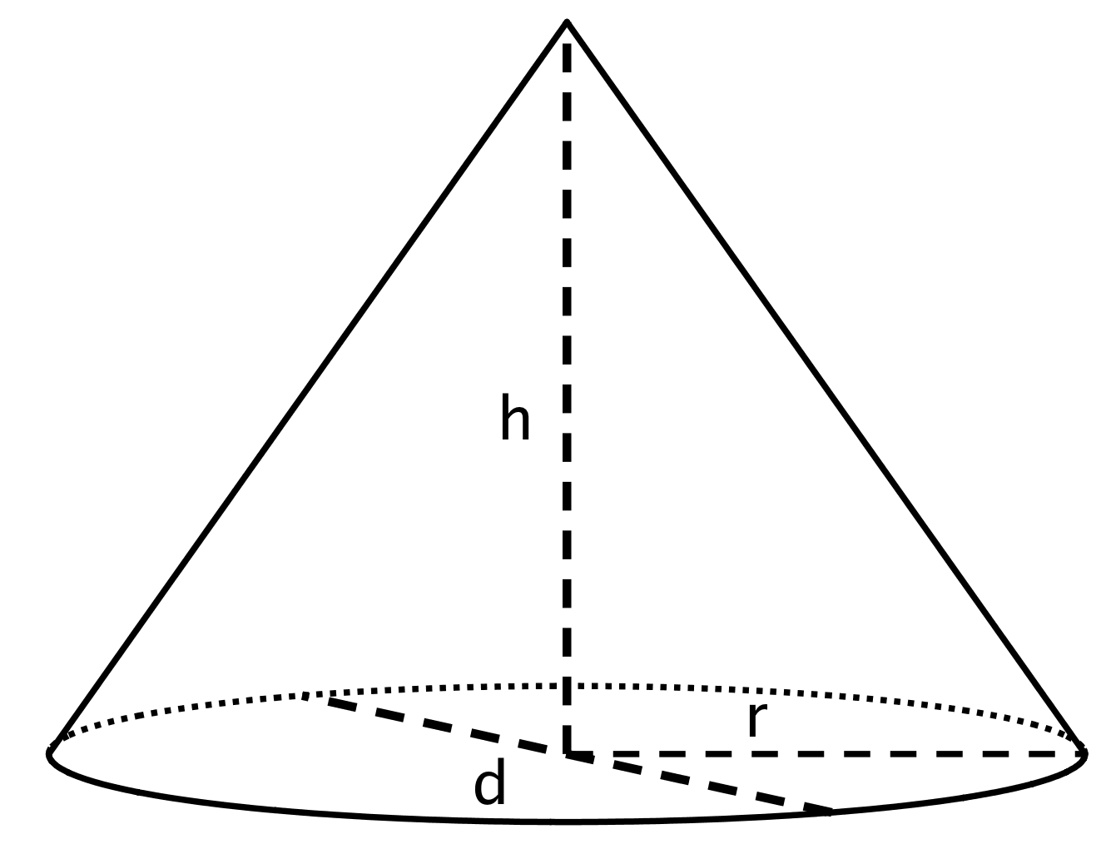
Each row of the table has some information about a particular cone. Complete the table with the missing dimensions.
diameter (units) | radius (units) | area of the base (square units) | height (units) | volume of cone (cubic units)
 | 4 |  | 3
 | $\frac{1}{3}$ |  | 6
 |  | $144π$ | $\frac{1}{4}$
20 |  |  |  | $200π$
 |  |  | 12 | $64π$
 |  |  | 3 | 3.14

4 Popcorn Deals

Student Task Statement
A movie theater offers two containers:
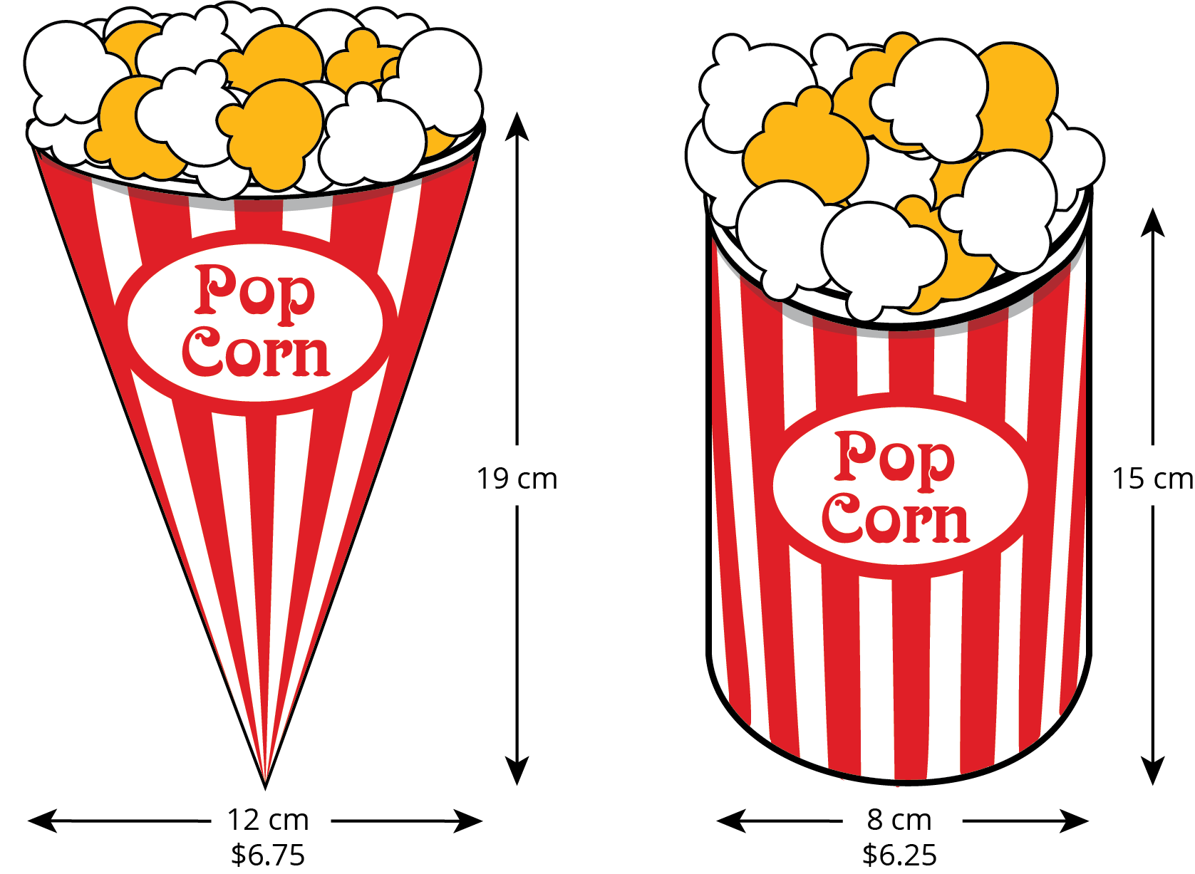
Which container is the better value? Use 3.14 as an approximation for $π$.
© CC BY Open Up Resources. Adaptations CC BY IM.

