Unit 5 Lesson 14: Finding Cylinder Dimensions

1 A Cylinder of Unknown Height (Warm up)

Student Task Statement
What is a possible volume for this cylinder if the diameter is 8 cm? Explain your reasoning.
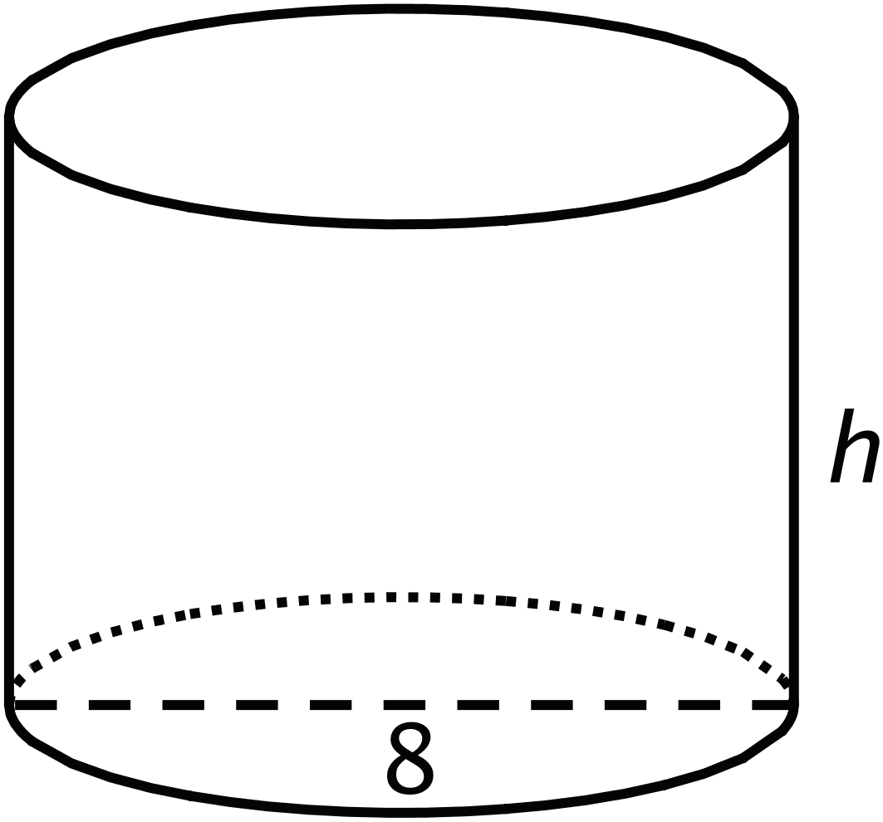

2 What’s the Dimension?

Student Task Statement
The volume $V$ of a cylinder with radius $r$ is given by the formula $V=πr^{2}h$.
- The volume of this cylinder with radius 5 units is $50π$ cubic units. This statement is true: $50π=5^{2}πh$
- 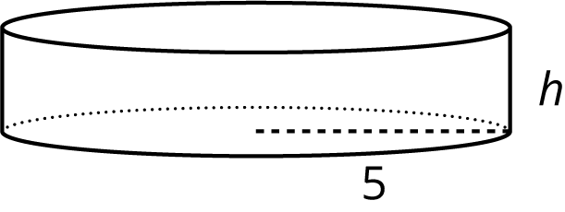
- What does the height of this cylinder have to be? Explain how you know.
- The volume of this cylinder with height 4 units is $36π$ cubic units. This statement is true: $36π=r^{2}π4$
- 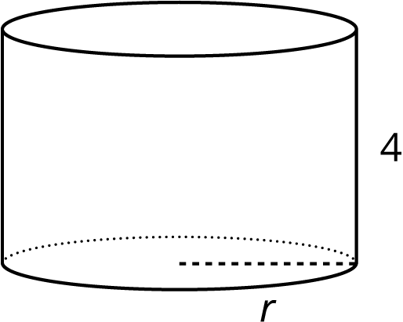
- What does the radius of this cylinder have to be? Explain how you know.

3 Cylinders with Unknown Dimensions

Student Task Statement
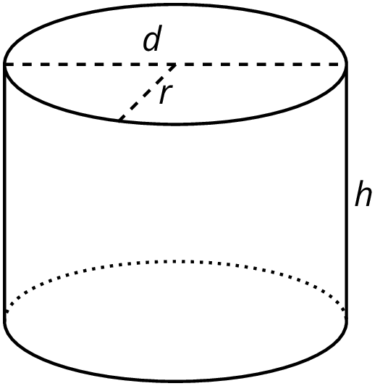
Each row of the table has information about a particular cylinder. Complete the table with the missing dimensions.
diameter (units) | radius (units) | area of the base (square units) | height (units) | volume (cubic units)
 | 3 |  | 5
12 |  |  |  | $108π$
 |  |  | 11 | $99π$
8 |  |  |  | $16π$
 |  |  | 100 | $16π$
 | 10 |  |  | $20π$
20 |  |  |  | 314
 |  |  | $b$ | $π⋅b⋅a^{2}$

© CC BY Open Up Resources. Adaptations CC BY IM.

