Lesson 25: Summing Up
- Let’s figure out a better way to add numbers.

25.1: Notice & Wonder: A Snowflake’s Return
What do you notice? What do you wonder?
iteration | total number of triangles added since the first
0  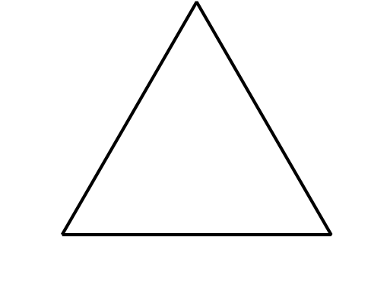 | 0
1 | 3
2 | $3+3\left(4\right)=15$
3 | $3+3\left(4\right)+3{\left(4\right)}^{2}=63$
$n$ | $3+3\left(4\right)+3{\left(4\right)}^{2}+...+3{\left(4\right)}^{n−1}$

25.2: A Geometric Addition Formula
Earlier, we learned that the $n$th term of a geometric sequence with an initial value of $a$ and a common ratio of $r$ is $a\left(r^{n−1}\right)$.
For a Koch Snowflake, it turns out that we can find the number of triangles added on at each iteration by having $a=3$ and $r=4$. The sum $s$ of the first $n$ terms in this geometric sequence tell us how many triangles total make up the $n$th iteration of the snowflake
$s=3+3\left(4\right)+3\left(4^{2}\right)+...+3\left(4^{n−1}\right)$
More generally, the sum of the first $n$ terms of any geometric sequence can be expressed as
$s=a+a\left(r\right)+a\left(r^{2}\right)+...+a\left(r^{n−1}\right)$
or
$s=a\left(1+r+r^{2}+...+r^{n−1}\right)$
- What would happen if we multiplied each side of this equation by $\left(1−r\right)$? (hint: $\left(x−1\right)\left(x^{3}+x^{2}+x+1\right)=x^{4}−1$.)
- Rewrite the new equation in the form of $s=$.
- Use this new formula to calculate how many triangles after the original are in the first 5, 10, and 15 iterations of the Koch Snowflake.

Are you ready for more?
If the initial triangle has sides that are each one unit long, find an equation for the perimeter $P$ of the Koch Snowflake after the $n$th iteration and graph $\left(n,P\right)$ for iterations 0 through 5.
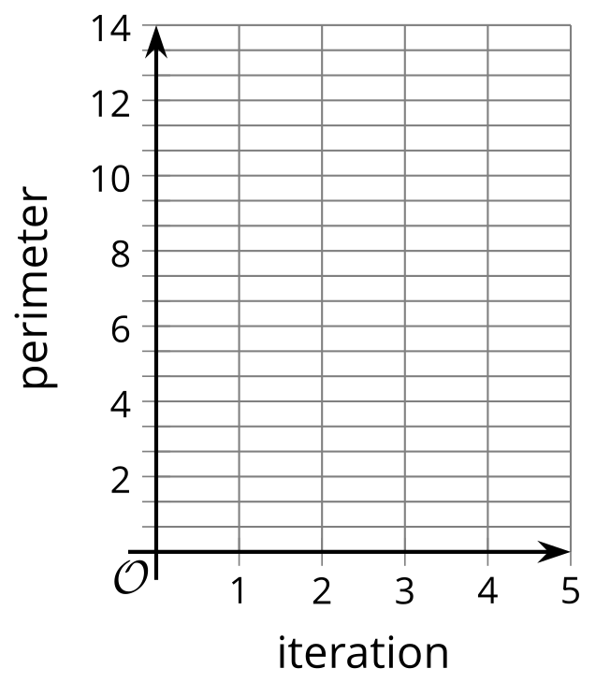

25.3: The Sum of Antibiotics
Han is prescribed a course of antibiotics for an infection. He is told to take a 150 mg dose of the antibiotic regularly every 12 hours for 15 days. Han is curious about the antibiotic and learns that at the end of the 12 hours, only 5% of the dose is still in his body.
- How much of the antibiotic is in the body right after the first, second, and third doses?
- When will the total amount of the antibiotic in Han be highest over the course of the 15 day treatment? Explain your reasoning.

Lesson 25 Summary
Sometimes identities can help us see and write a pattern in a simpler form. Imagine a chessboard where 1 grain of rice is placed on the first square, 2 on the second, 4 on the third, and so on. How many grains of rice are on the 64-square chessboard? Trying to add up 64 numbers is difficult to do one at a time, especially because the first 20 squares have more than one million grains of rice on them! If we write out what this sum $s$ is, we have
$s=1+2+4+...+2^{63}$
If we rewrite this expression as $2^{63}+...+2^{2}+2+1$, we have an expression similar to one we’ve seen before, $x^{n−1}+x^{n−2}+...+x^{2}+x+1$.
In an earlier lesson, we showed that $\left(x−1\right)\left(x^{n−1}+x^{n−2}+...+x^{2}+x+1\right)$ is equivalent to the simpler expression $\left(x^{n}−1\right)$. Using this identity with $x=2$ and $n=64$, we have
$\begin{matrix}\left(2^{64−1}+2^{64−2}+...+2^{2}+2+1\right) & =s \\ \left(2−1\right)\left(2^{64−1}+2^{64−2}+...+2^{2}+2+1\right) & =\left(2−1\right)s \\ 2^{64}−1 & =\left(2−1\right)s \\ \frac{2^{64}−1}{2−1} & =s \\ 2^{64}−1 & =s\end{matrix}$
This means that the sum total of all the grains of rice is $2^{64}−1$, or $18,​446,​744,​073,​709,​551,​615$. More generally, for any geometric sequence starting at $a$ with a common ratio $r$, the sum $s$ of the first $n$ terms is given by $s=a\frac{1−r^{n}}{1−r}$.
© CC BY 2019 by Illustrative Mathematics®

