Lesson 9: Conditions for Triangle Similarity
- Let’s prove some triangles similar.

9.1: Math Talk: Angle-Side-Angle As A Helpful Tool
How could you justify each statement?
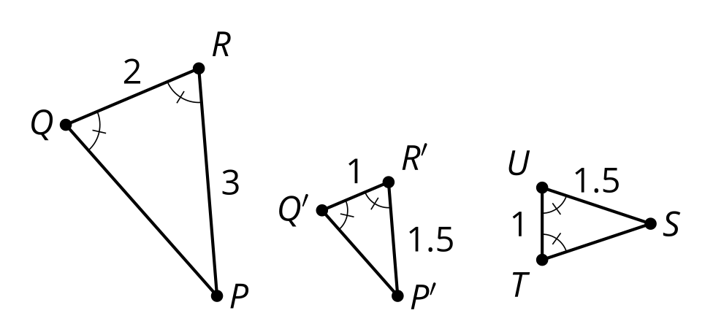
Triangle $P^{′}Q^{′}R^{′}$ is congruent to triangle $STU$.
Triangle $PQR$ is similar to triangle $STU$.
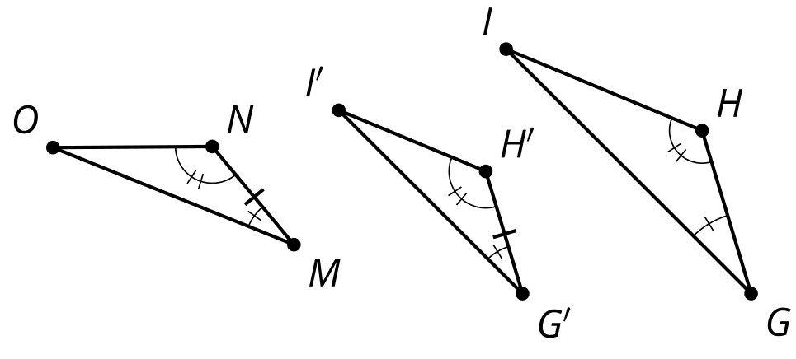
Triangle $G^{′}H^{′}I^{′}$ is congruent to triangle $MNO$.
Triangle $GHI$ is similar to triangle $MNO$.

9.2: How Many Pieces?
For each problem, draw 2 triangles that have the listed properties. Try to make them as different as possible.
- One angle is 45 degrees.
- One angle is 45 degrees and another angle is 30 degrees.
- One angle is 45 degrees and another angle is 30 degrees. The lengths of a pair of corresponding sides are 2 cm and 6 cm.
- Compare your triangles with your neighbors’ triangles. Which ones seem to be similar no matter what?
- Prove your conjecture.

9.3: Any Two Angles?
Here are 2 triangles. One triangle has a 60 degree angle and a 40 degree angle. The other triangle has a 40 degree angle and an 80 degree angle.
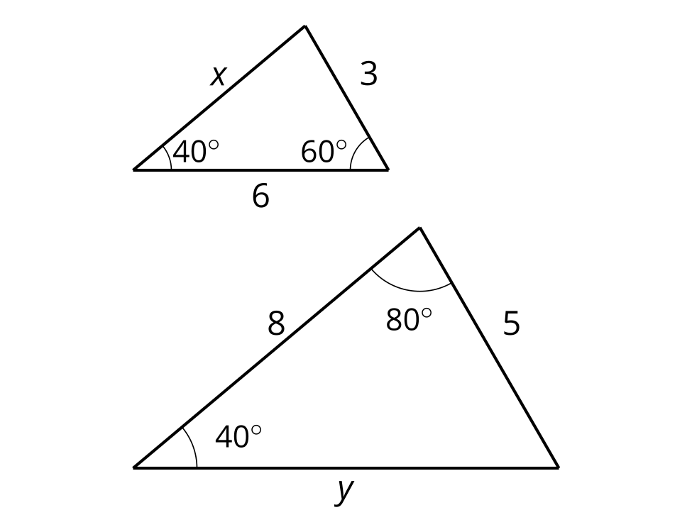
- Explain how you know the triangles are similar.
- How long are the sides labeled $x$ and $y$?

Are you ready for more?
Under what conditions is there an Angle-Angle Quadrilateral Similarity Theorem? What about an Angle-Angle-Angle Quadrilateral Similarity Theorem? Explain or show your reasoning.

Lesson 9 Summary
When 2 angles of one triangle are congruent to 2 angles of a second triangle, the 2 triangles are similar. We call this the Angle-Angle Triangle Similarity Theorem.
In the diagram, angle $A$ is congruent to angle $D$, and angle $B$ is congruent to angle $E$. If a sequence of rigid motions and dilations moves the first figure so that it fits exactly over the second, then we have shown that the Angle-Angle Triangle Similarity Theorem is true.

$∠A≅∠D,∠B≅∠E$
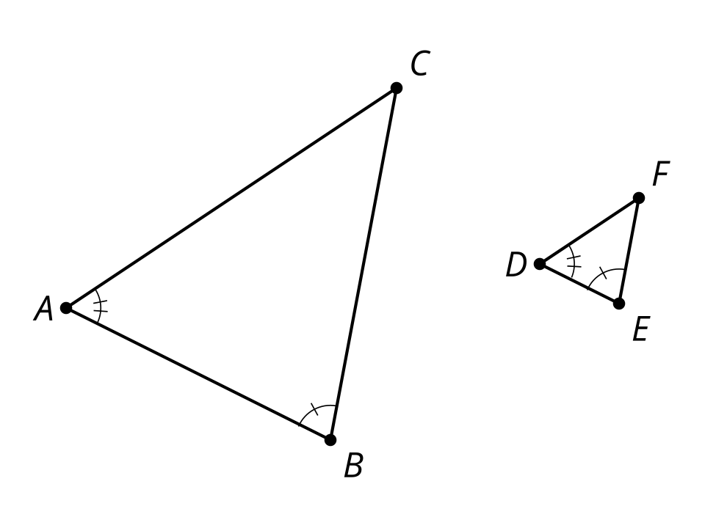
Dilate triangle $ABC$ by the ratio $\frac{DE}{AB}$, so that $A^{′}B^{′}$ is congruent to $DE$. Now triangle $A^{′}B^{′}C^{′}$ is congruent to triangle $DEF$ by the Angle-Side-Angle Triangle Congruence Theorem, which means there is a sequence of rotations, reflections, and translations that takes $A^{′}B^{′}C^{′}$ onto $DEF$.
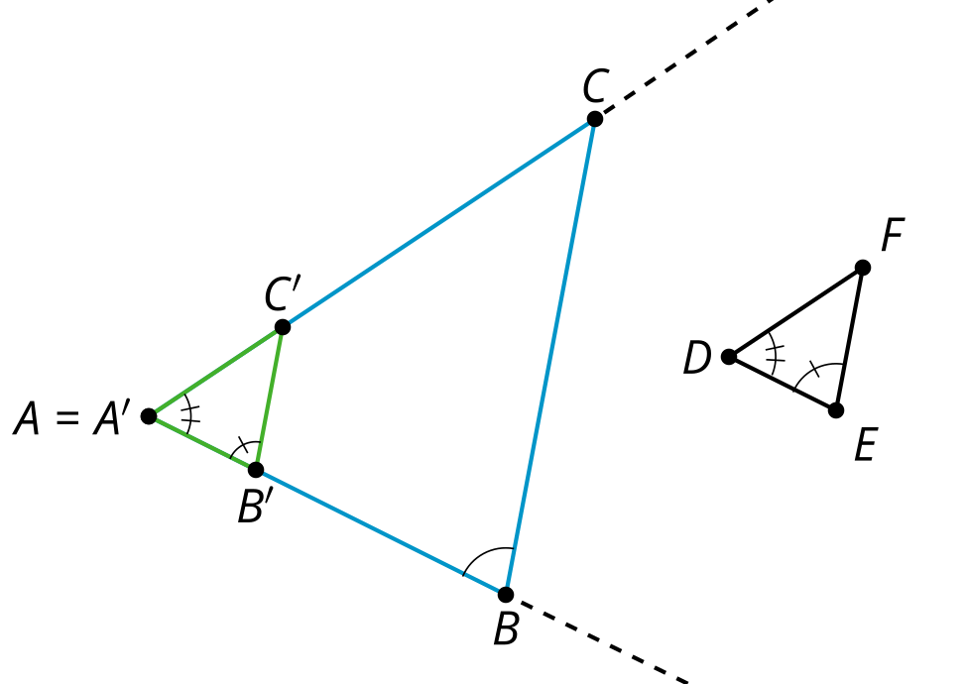
Therefore, a dilation followed by a sequence of rotations, reflections, and translations will take triangle $ABC$ onto triangle $DEF$, which is the definition of similarity. We have shown that a dilation and a sequence of rigid motions takes triangle $ABC$ to triangle $DEF$, so the triangles are similar.
© CC BY 2019 by Illustrative Mathematics®

