Unit 7 Lesson 1: Finding Unknown Inputs

1 What Goes Up Must Come Down (Warm up)

Student Task Statement
A mechanical device is used to launch a potato vertically into the air. The potato is launched from a platform 20 feet above the ground, with an initial vertical velocity of 92 feet per second.
The function $h\left(t\right)=\text{-}16t^{2}+92t+20$ models the height of the potato over the ground, in feet, $t$ seconds after launch.
Here is the graph representing the function.
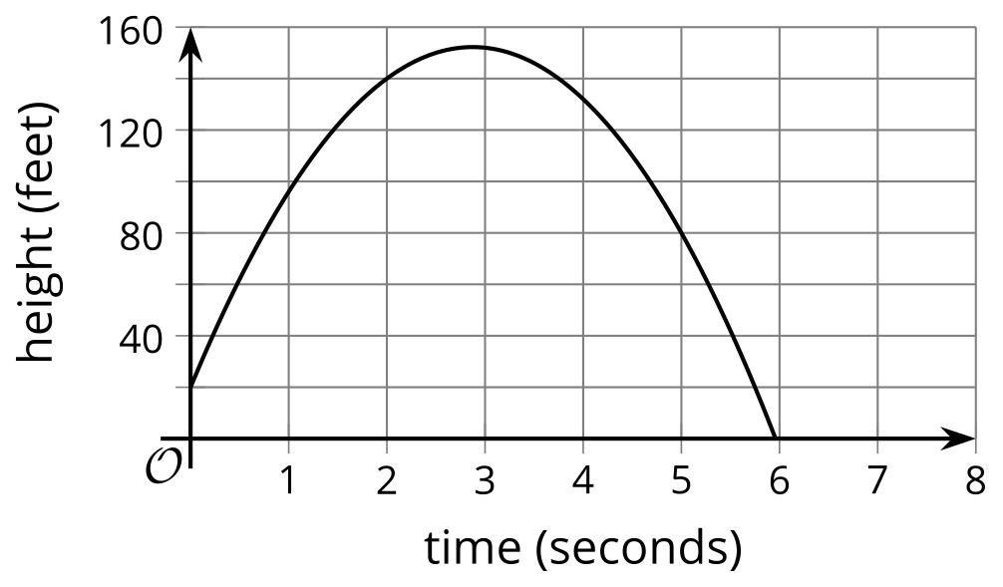
For each question, be prepared to explain your reasoning.
- What is the height of the potato 1 second after launch?
- 8 seconds after launch, will the potato still be in the air?
- Will the potato reach 120 feet? If so, when will it happen?
- When will the potato hit the ground?

2 A Trip to the Frame Shop

Student Task Statement
Your teacher will give you a picture that is 7 inches by 4 inches, a piece of framing material measuring 4 inches by 2.5 inches, and a pair of scissors.
Cut the framing material to create a rectangular frame for the picture. The frame should have the same thickness all the way around and have no overlaps. All of the framing material should be used (with no leftover pieces). Framing material is very expensive!
You get 3 copies of the framing material, in case you make mistakes and need to recut.

3 Representing the Framing Problem

Student Task Statement
Here is a diagram that shows the picture with a frame that is the same thickness all the way around. The picture is 7 inches by 4 inches. The frame is created from 10 square inches of framing material (in the form of a rectangle measuring 4 inches by 2.5 inches).
- Write an equation to represent the relationship between the measurements of the picture and of the frame, and the area of the framed picture. Be prepared to explain what each part of your equation represents.
- What would a solution to this equation mean in this situation?
© CC BY 2019 by Illustrative Mathematics®

