Lesson 18 Practice Problems
- For each growth rate, find the associated growth factor.
  - 30% increase
  - 30% decrease
  - 2% increase
  - 2% decrease
  - 0.04% increase
  - 0.04% decrease
  - 100% increase
- In 1990, the population $p$ of India was about 870.5 million people. By 1995, there were about 960.9 million people. The equation $p=870.5⋅{\left(1.021\right)}^{t}$ approximates the number of people, in millions, in terms of the number of years $t$ since 1990.
  - By what factor does the number of people grow in one year?
  - If $d$ is time in decades, write an equation expressing the number of people in millions, $p$, in terms of decades, $d$, since 1990.
  - Use the model $p=870.5⋅{\left(1.021\right)}^{t}$ to predict the number of people in India in 2015.
  - The 2015, the population of India was 1,311 million. How does this compare with the predicted number?
- An investor paid $156,000 for a condominium in Texas in 2008. The value of the homes in the neighborhood have been appreciating by about 12% annually.
- Select all the expressions that could be used to calculate the value of the house, in dollars, after $t$ years.
  - $156,​000⋅{\left(0.12\right)}^{t}$
  - $156,​000⋅{\left(1.12\right)}^{t}$
  - $156,​000⋅{\left(1+0.12\right)}^{t}$
  - $156,​000⋅{\left(1−0.12\right)}^{t}$
  - $156,​000⋅{\left(1+\frac{0.12}{12}\right)}^{t}$
- A credit card has a nominal annual interest rate of 18%, and interest is compounded monthly. The cardholder uses the card to make a $30 purchase.
- Which expression represents the balance on the card after 5 years, in dollars, assuming no further charges or payments are made?
  - $30{\left(1+18\right)}^{5}$
  - $30{\left(1+0.18\right)}^{5}$
  - $30{\left(1+\frac{0.18}{12}\right)}^{5}$
  - $30{\left(1+\frac{0.18}{12}\right)}^{5⋅12}$
- The expression $1,​500⋅{\left(1.085\right)}^{3}$ represents an account balance in dollars after three years with an initial deposit of $1,500. The account pays 8.5% interest, compounded annually for three years.
  - Explain how the expression would change if the bank had compounded the interest quarterly for the three years.
  - Write a new expression to represent the account balance, in dollars, if interest is compounded quarterly.
- The function, $f$, defined by $f\left(t\right)=1,​000⋅{\left(1.07\right)}^{t}$, represents the amount of money in a bank account $t$ years after it was opened.
  - How much money was in the account when it was opened?
  - Sketch a graph of $f$.
  - When does the account value reach $2,000?
- (From Unit 5, Lesson 9.)
- The graph shows the number of patients with an infectious disease over a period of 15 weeks.
  - Give an example of a domain for which the average rate of change is a good measure of how the function changes.
  - Give an example of a domain for which the average rate of change is not a good measure of how the function changes.
- 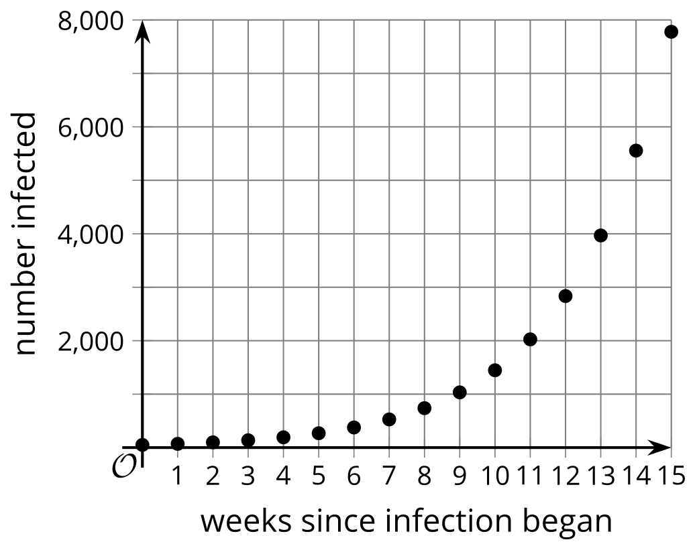
- (From Unit 5, Lesson 10.)
- A party will have pentagonal tables placed together. The number of people, $P$, who can sit at the tables is a function of the number of tables, $n$.
  - Explain why the equation $P=3n+2$ defines this function.
  - How many tables are needed if 47 people come to the party?
  - How many tables are needed if 99 people come to the party?
  - Write the inverse of this function and explain what the inverse function tells us.
- 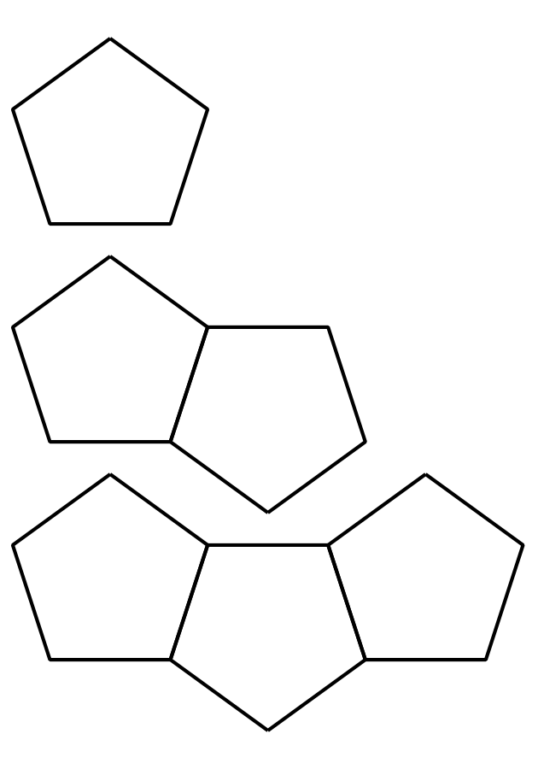
- (From Unit 4, Lesson 16.)
© CC BY 2019 by Illustrative Mathematics®

