Lesson 10: Rate of Change
- Let’s calculate the rate of change of some relationships.

10.1: Growing Bamboo
The graph represents function $h$, which gives the height in inches of a bamboo plant $t$ months after it has been planted.
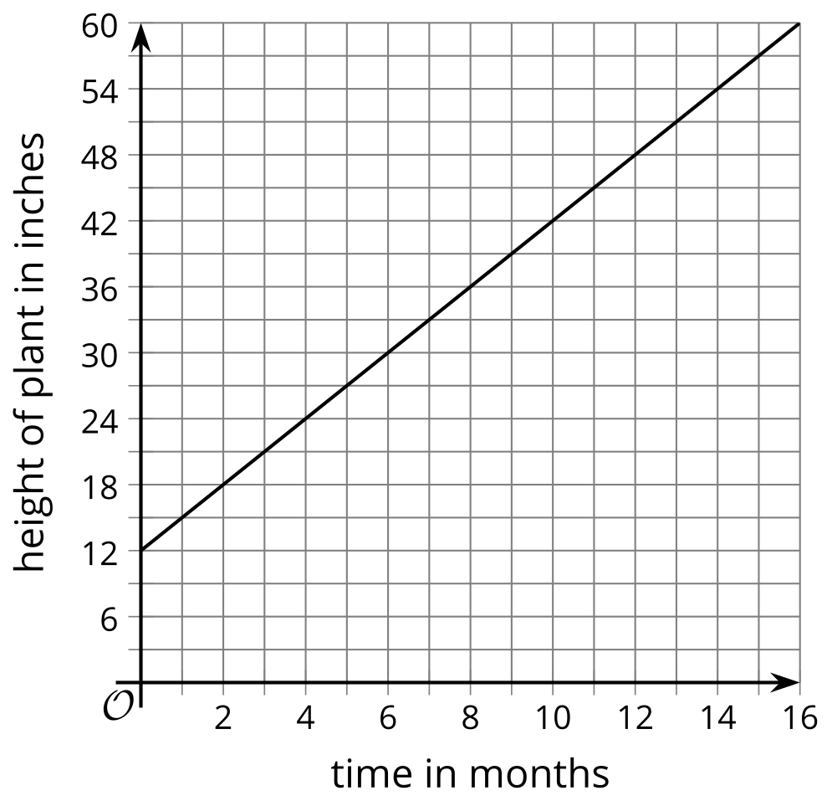
- What does this statement mean? $h\left(4\right)=24$
- What is the value of $h\left(10\right)$?
- What is $c$ if $h\left(c\right)=30$?
- What is the value of $h\left(12\right)−h\left(2\right)$?
- How many inches does the plant grow each month? How can you see this on the graph?

10.2: A Growing Account Balance
The balance in a savings account is defined by the function $b$. This graph represents the function.

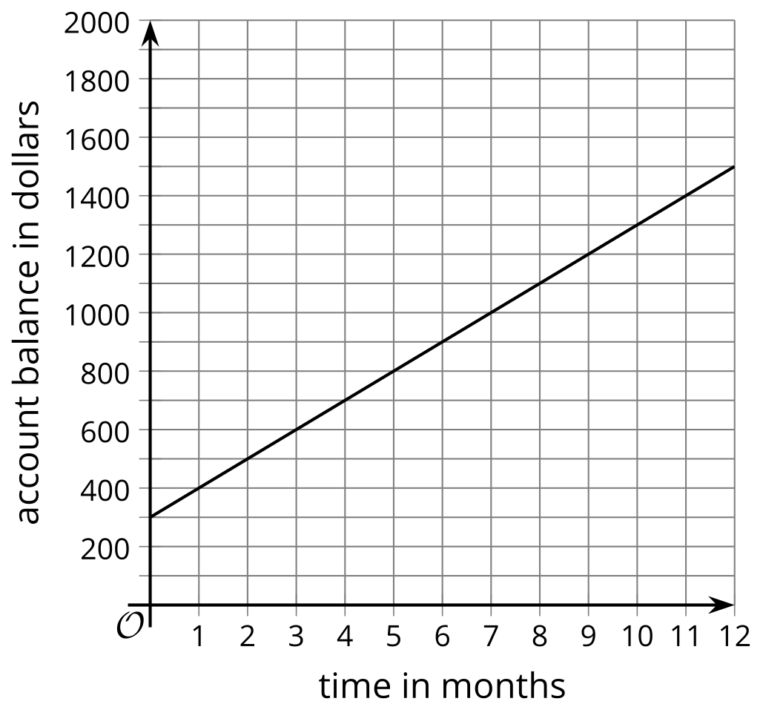
- What is . . .
  - $b\left(3\right)$
  - $b\left(7\right)$
  - $b\left(7\right)−b\left(3\right)$
  - $7−3$
  - $\frac{b\left(7\right)−b\left(3\right)}{7−3}$
- Also calculate $\frac{b\left(11\right)−b\left(1\right)}{11−1}$
- You should have gotten the same value, twice. What does this value have to do with this situation?

10.3: The Temperature Outside
Here are a graph and a table that represent the same function. The function relates the hour of day to the outside air temperature in degrees Fahrenheit at a specific location.
$t$ | $p\left(t\right)$ | $t$ | $p\left(t\right)$
0 | 48 | 6 | 57
1 | 50 | 7 | 56
2 | 55 | 8 | 55
3 | 53 | 9 | 50
4 | 51.5 | 10 | 52
5 | 52.5

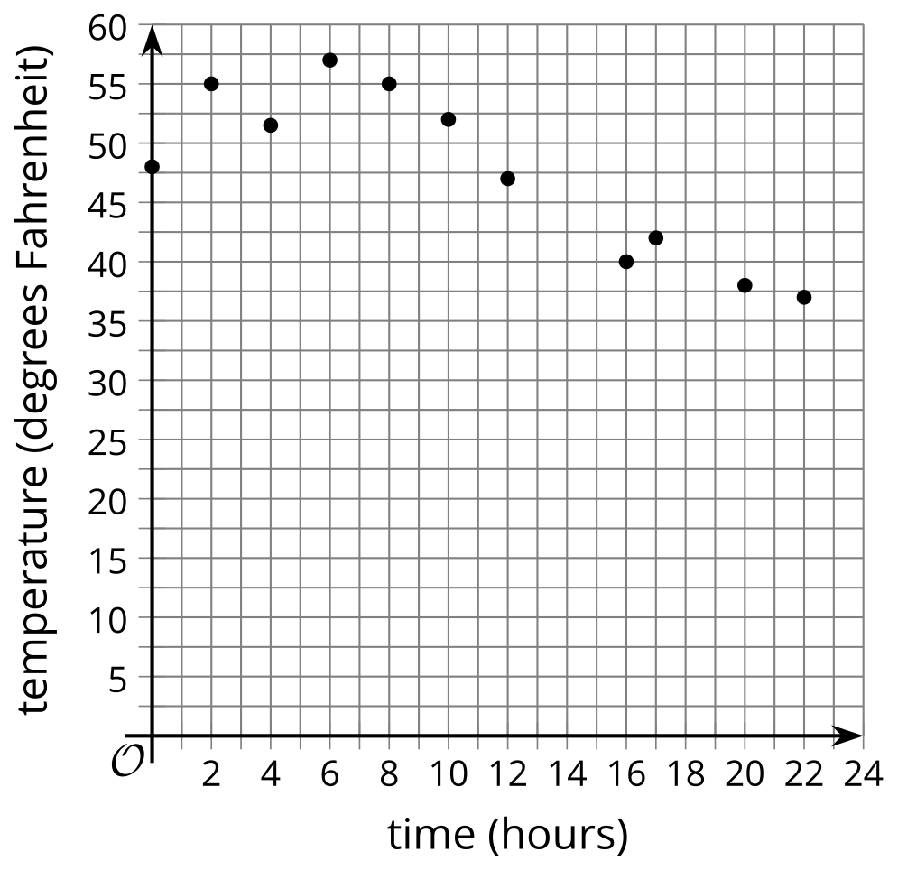
Match each expression to a value. Then, explain what the expression means in this situation.
- $p\left(12\right)$
- $p\left(8\right)$
- $p\left(12\right)−p\left(8\right)$
- $12−8$
- $\frac{p\left(12\right)−p\left(8\right)}{12−8}$
- $p\left(10\right)$
- $p\left(20\right)$
- $p\left(10\right)−p\left(20\right)$
- $10−20$
- $\frac{p\left(10\right)−p\left(20\right)}{10−20}$
- 4
- -2.75
- 44
- -1.4
- 55
- 14
- -11
- 38
- -10
- 52
© CC BY 2019 by Illustrative Mathematics®

