Lesson 3: Which One?
- Let’s explore the best uses of box plots, dot plots and histograms.

3.1: Math Talk: What Was the Final Temperature?
Mentally evaluate the final temperature in each scenario.
The temperature was 20 degrees Celsius and it dropped 18 degrees.
The temperature was 20 degrees Celsius and it dropped 20 degrees.
The temperature was 20 degrees Celsius and it dropped 25 degrees.
The temperature was 20 degrees Celsius and it dropped 33 degrees.

3.2: Best Representation
Use the class data to create a dot plot, box plot, and three histograms, each with different bin sizes.
- Create a dot plot.
- ​​
- Create a box plot.
- 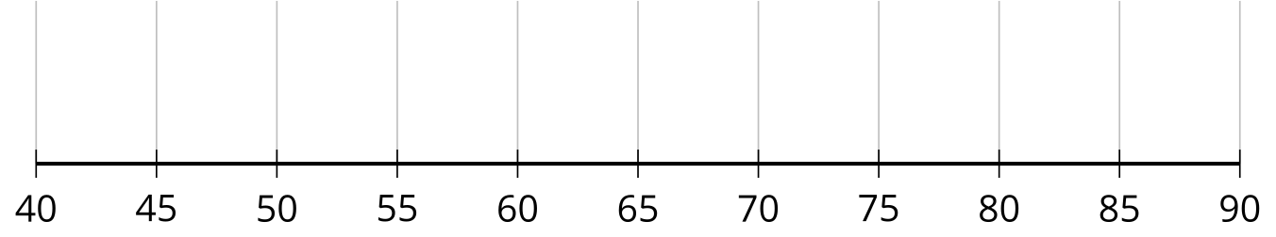
- Create a histogram using intervals of length 20.
- 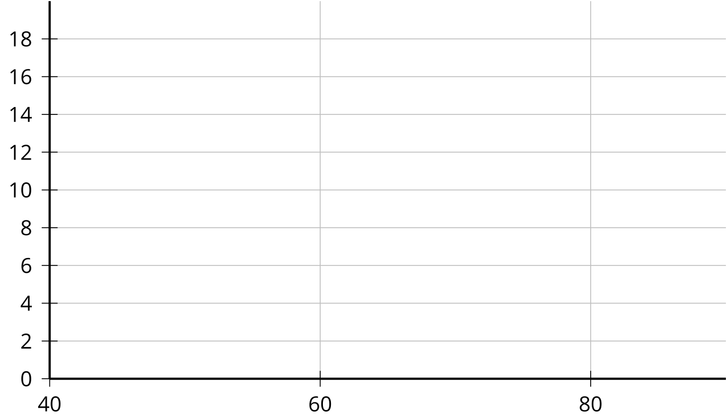
- Create a histogram using intervals of length 10.
- 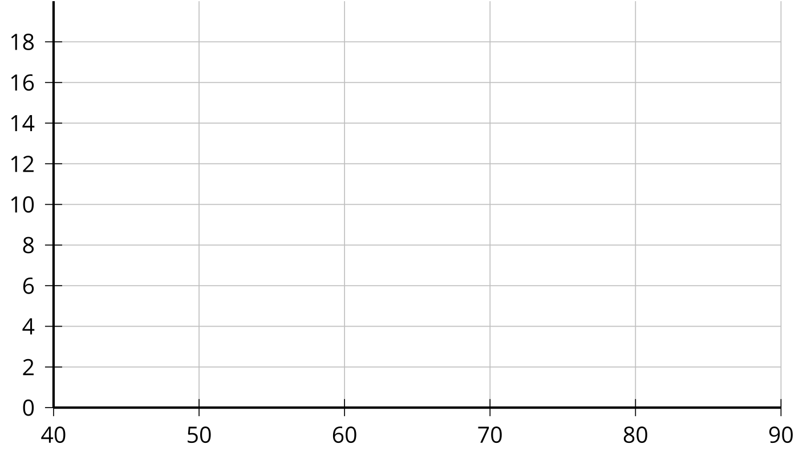
- Create a histogram using intervals of length 5.
- 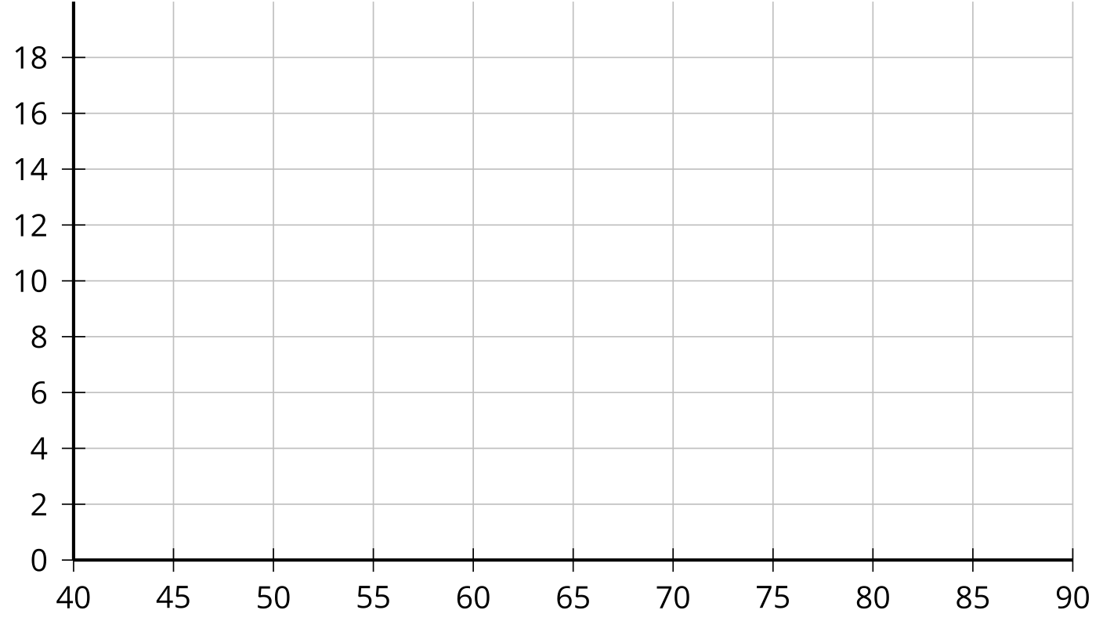
- Which of these representations would you use to summarize your class’ data: the dot plot, the box plot, or one of the histograms? Explain your reasoning.

3.3: Which One?
There are several baskets on a table, and each basket contains a certain number of strawberries. Here are three data displays showing the number of strawberries in each basket.
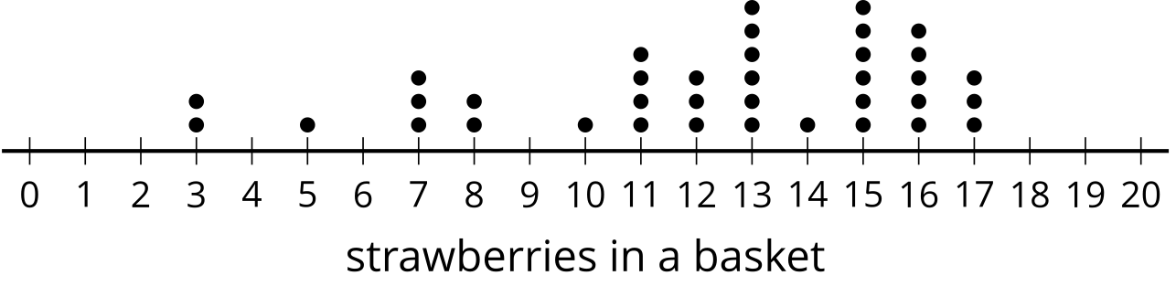
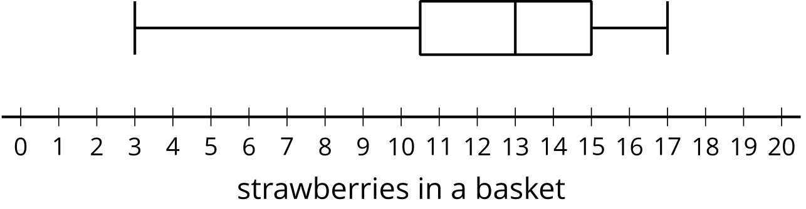
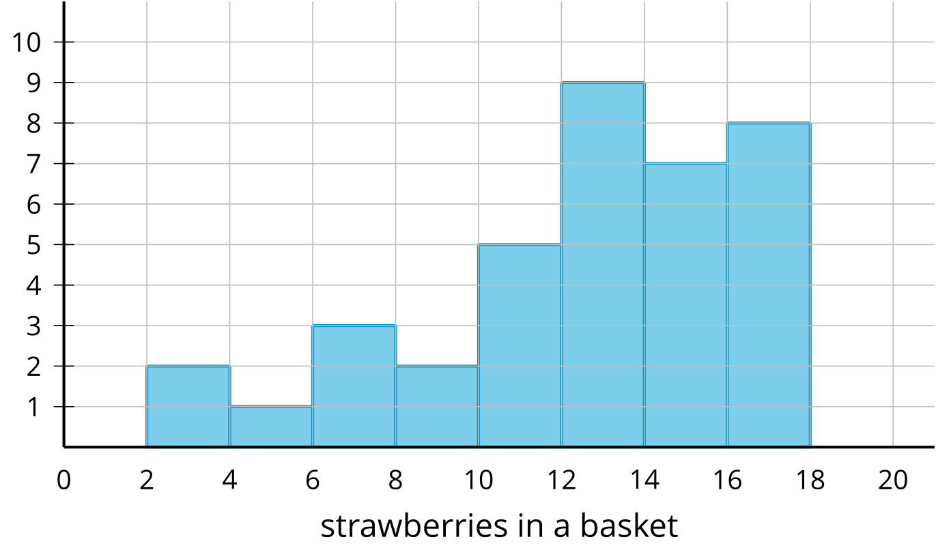
- Kiran makes these claims. For each claim, decide whether you agree or disagree. Explain your reasoning using at least one of the data displays.
  - There are 4 baskets that contain 11 strawberries.
  - The range of the number of strawberries in baskets can be found using any of the three data displays.
  - The number of baskets of strawberries can only be found using the dot plot.
  - The interquartile range can be found using the dot plot or box plot, but is easiest with the box plot.
  - The total number of strawberries in all the baskets can only be determined from the dot plot.
- Complete the table to show the frequency of baskets containing strawberries in each range. Which representation did you use?
number of strawberries | frequency
0–6
6–12
12–18
© CC BY 2019 by Illustrative Mathematics®

