Lesson 18 Practice Problems
- Andre and Jada both found $657÷3$ using the partial quotients method, but they did the calculations differently, as shown here.
- 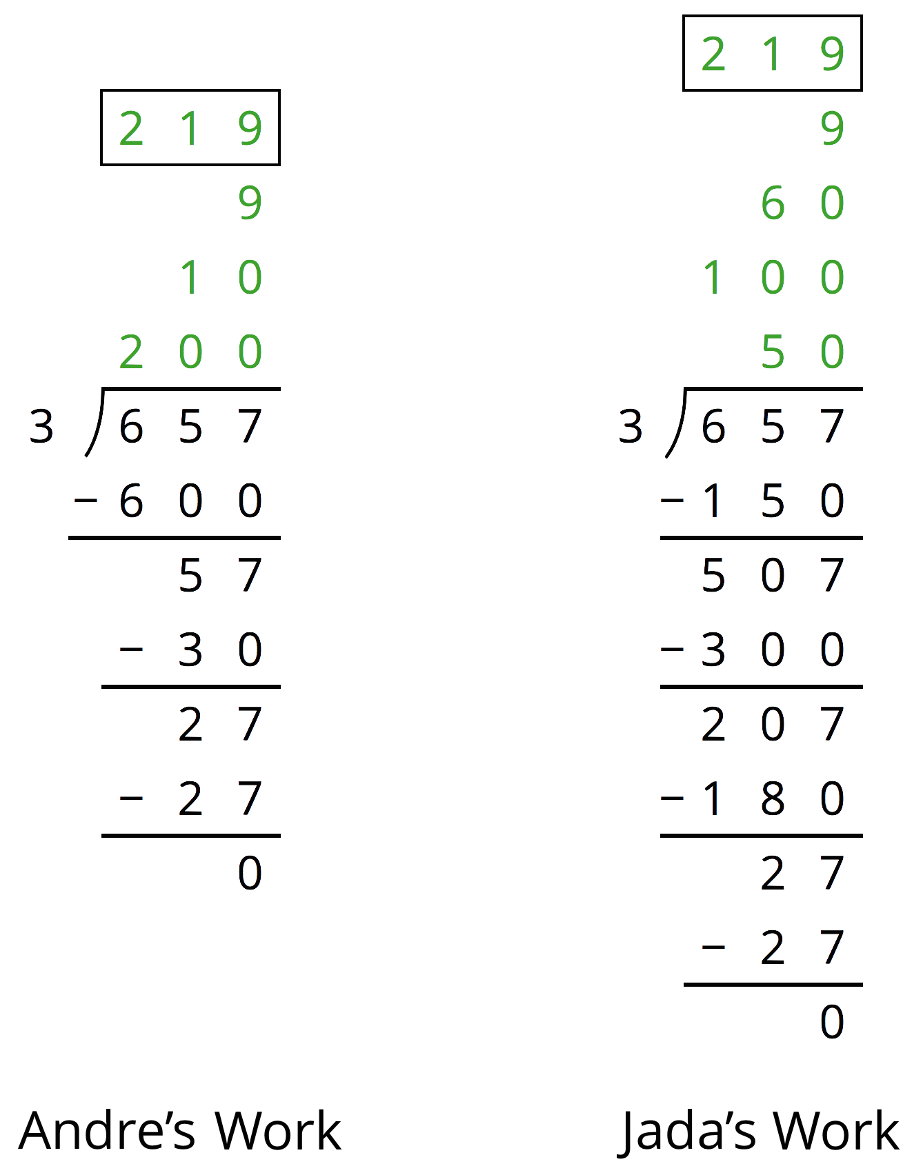
  - How is Jada's work the same as Andre’s work? How is it different?
  - Explain why they have the same answer.
- Here is a long-division calculation of $917÷7$.
- 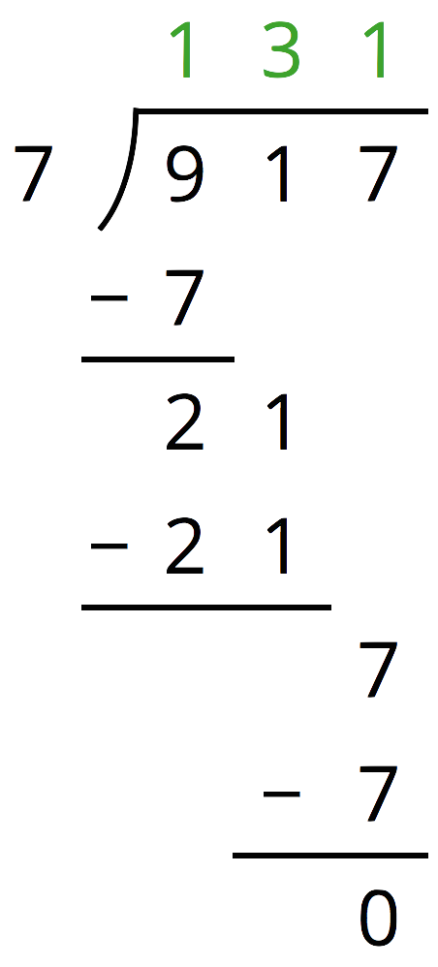
  - There is a 7 under the 9 of 917. What does this 7 represent?
  - What does the subtraction of 7 from 9 mean?
  - Why is a 1 written next to the 2 from $9−7$?
- Han's calculation of $972÷9$ is shown here.
- 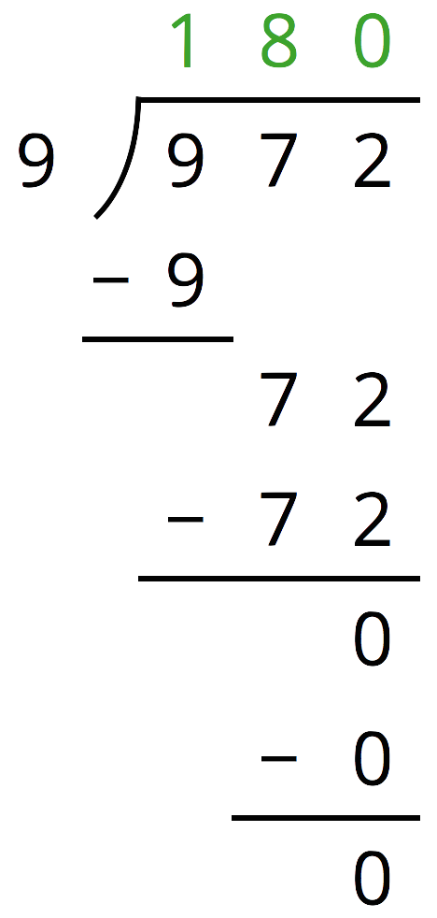
  - Find $180⋅9$.
  - Use your calculation of $180⋅9$ to explain how you know Han has made a mistake.
  - Identify and correct Han’s mistake.
- Find each quotient.
- 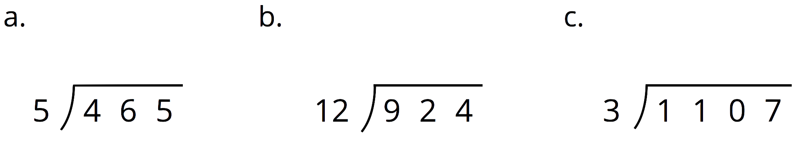

- The mass of one coin is 16.718 grams. The mass of a second coin is 27.22 grams. How much greater is the mass of the second coin than the first? Show your reasoning.
- (From Unit 3, Lesson 15.)
- One micrometer is a millionth of a meter. A certain spider web is 4 micrometers thick. A fiber in a shirt is 1 hundred-thousandth of a meter thick.
  - Which is wider, the spider web or the fiber? Explain your reasoning.
  - How many meters wider?
- (From Unit 3, Lesson 15.)
© CC BY Open Up Resources. Adaptations CC BY IM.

