Unit 5 Lesson 12: How Much Will Fit?

1 Two Containers (Warm up)

Images for Launch
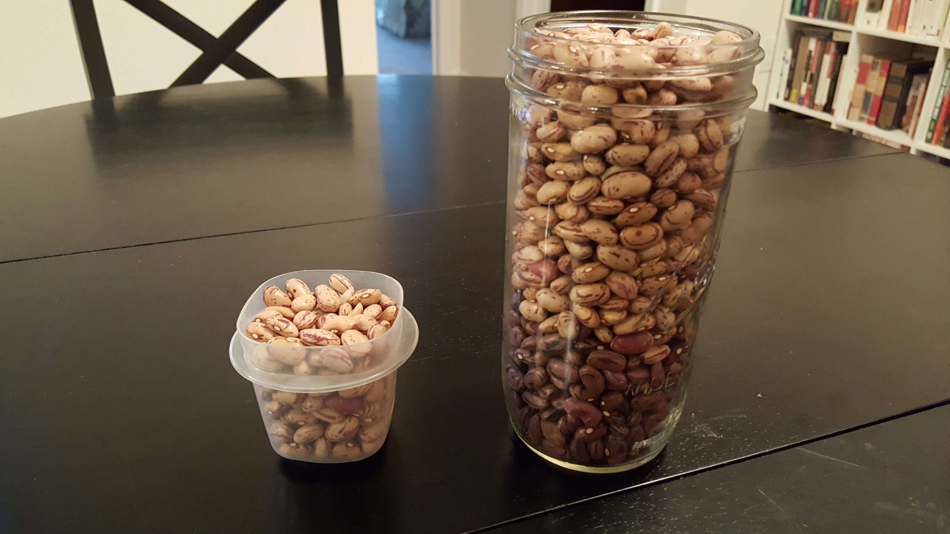

Student Task Statement
Your teacher will show you some containers. The small container holds 200 beans. Estimate how many beans the large jar holds.

2 What’s Your Estimate?

Images for Launch
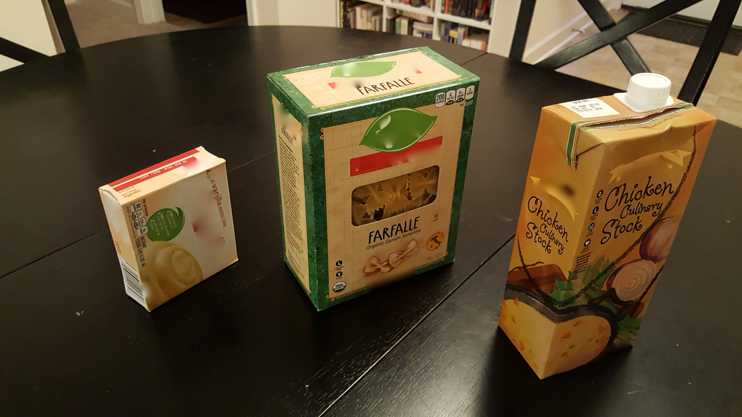
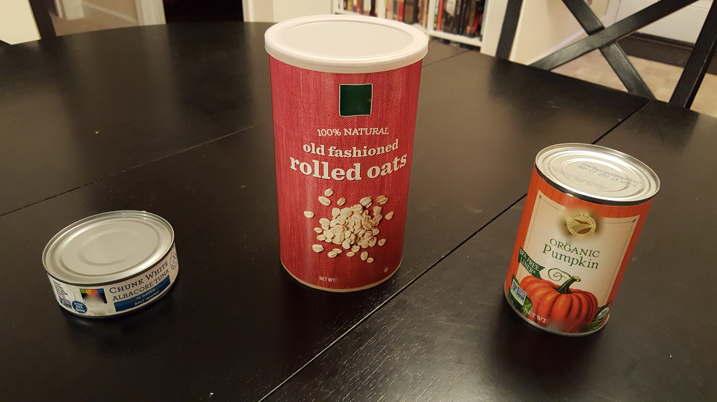
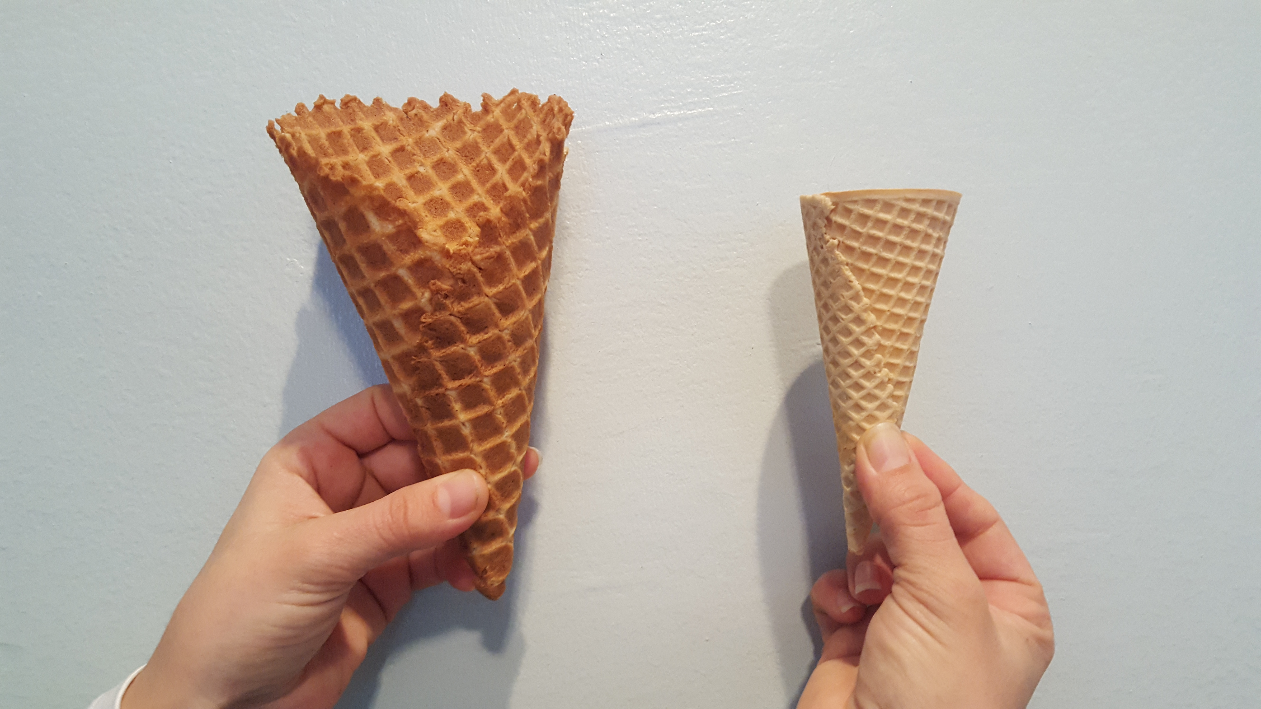
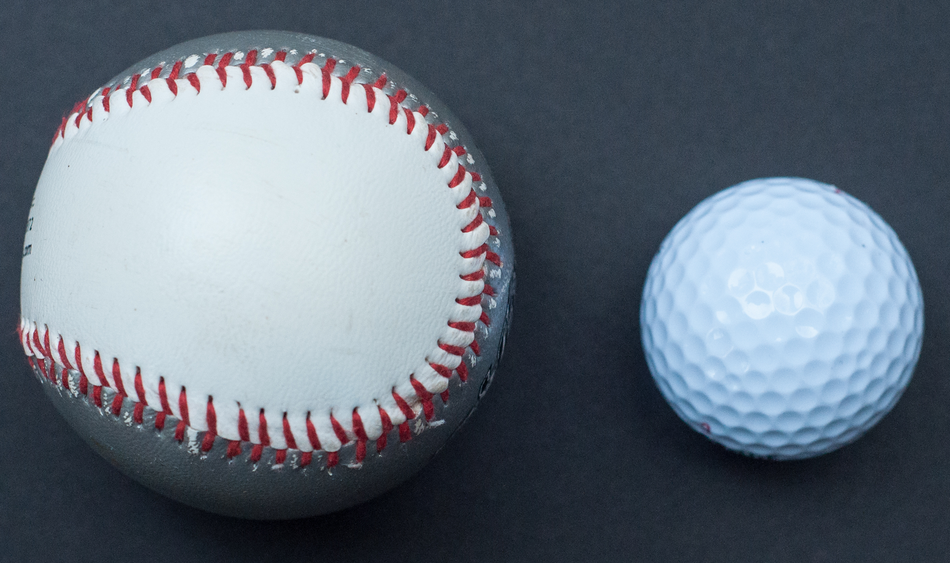

Student Task Statement
Your teacher will show you some containers.
- If the pasta box holds 8 cups of rice, how much rice would you need for the other rectangular prisms?
- If the pumpkin can holds 15 fluid ounces of rice, how much do the other cylinders hold?
- If the small cone holds 2 fluid ounces of rice, how much does the large cone hold?
- If the golf ball were hollow, it would hold about 0.2 cups of water. If the baseball were hollow, how much would the sphere hold?

3 Do You Know These Figures?

Student Task Statement
- What shapes are the faces of each type of object shown here? For example, all six faces of a cube are squares.
- 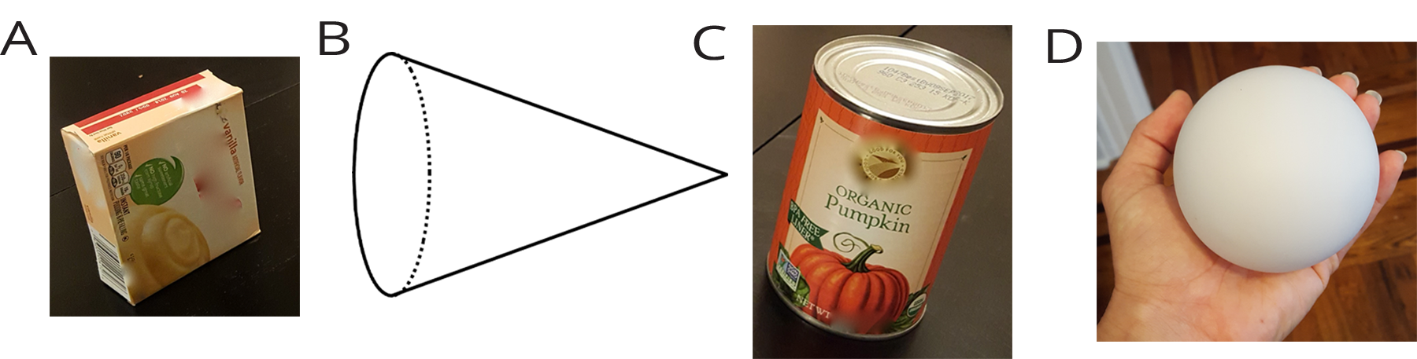
- Which faces could be referred to as a “base” of the object?
- Here is a method for quickly sketching a cylinder:
- Draw two ovals.
- Connect the edges.
- Which parts of your drawing would
be hidden behind the cylinder?
Make these parts dashed lines.
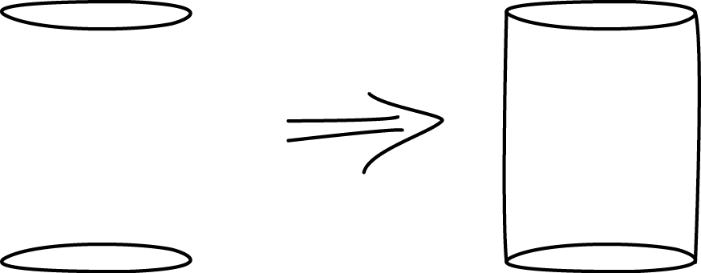
- Practice sketching some cylinders. Sketch a few different sizes, including short, tall, narrow, wide, and sideways. Label the radius $r$ and height $h$ on each cylinder.
© CC BY Open Up Resources. Adaptations CC BY IM.

