Lesson 8: Are They All Similar?
- Let’s prove figures are similar.

8.1: Stretched or Distorted? Rectangles
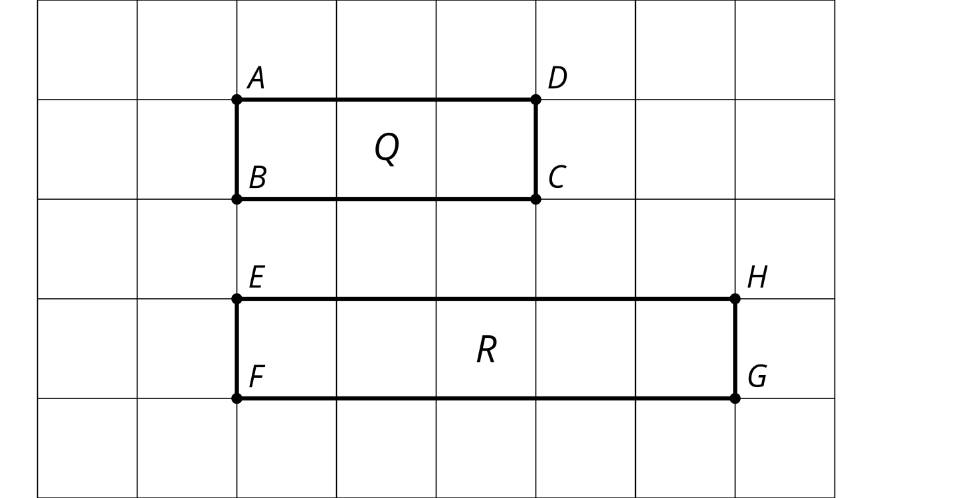
Are these rectangles similar? Explain how you know.

8.2: Faulty Logic
Tyler wrote a proof that all rectangles are similar. Make the image Tyler describes in each step in his proof. Which step makes a false assumption? Why is it false?
- Draw 2 rectangles. Label one $ABCD$ and the other $PQRS$.
- Translate rectangle $ABCD$ by the directed line segment from $A$ to $P$. $A^{′}$ and $P$ now coincide. The points coincide because that’s how we defined our translation.
- Rotate rectangle $A^{′}B^{′}C^{′}D^{′}$ by angle $D^{′}A^{′}S$. Segment $A^{″}D^{″}$ now lies on ray $PS$. The rays coincide because that’s how we defined our rotation.
- Dilate rectangle $A^{″}B^{″}C^{″}D^{″}$ using center $A^{″}$ and scale factor $\frac{PS}{AD}$. Segments $A^{‴}D^{‴}$ and $PS$ now coincide. The segments coincide because $A^{″}$ was the center of the rotation, so $A^{″}$ and $P$ don’t move, and since $D^{″}$ and $S$ are on the same ray from $A^{″}$, when we dilate $D^{″}$ by the right scale factor, it will stay on ray $PS$ but be the same distance from $A^{″}$ as $S$ is, so $S$ and $D^{‴}$ will coincide.
- Because all angles of a rectangle are right angles, segment $A^{‴}B^{‴}$ now lies on ray $PQ$. This is because the rays are on the same side of $PS$ and make the same angle with it. (If $A^{‴}B^{‴}$ and $PQ$ don’t coincide, reflect across $PS$ so that the rays are on the same side of $PS$.)
- Dilate rectangle $A^{‴}B^{‴}C^{‴}D^{‴}$ using center $A^{‴}$ and scale factor $\frac{PQ}{AB}$. Segments $A^{⁗}B^{⁗}$ and $PQ$ now coincide by the same reasoning as in step 4.
- Due to the symmetry of a rectangle, if 2 rectangles coincide on 2 sides, they must coincide on all sides.

8.3: Always? Prove it!
Choose one statement from the list. Decide if it is true or not.
If it is true, write a proof. If it is not, provide a counterexample.
Repeat with another statement.
Statements:
- All equilateral triangles are similar.
- All isosceles triangles are similar.
- All right triangles are similar.
- All circles are similar.

Are you ready for more?
Here is an $x$ by $x+1$ rectangle and a 1 by $x$ rectangle. They are similar. What are the possible dimensions of these golden rectangles? Explain or show your reasoning.
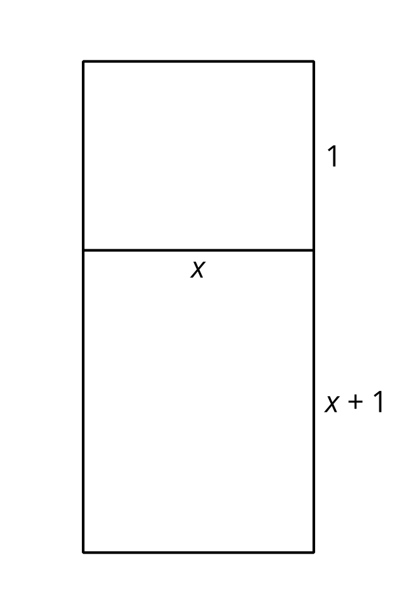

Lesson 8 Summary
One figure is similar to another if there is a sequence of rigid motions and dilations that takes the first figure so that it fits exactly over the second. Consider any 2 circles, $A$ and $B$. Translate the circle centered at $A$ along directed line segment $AB$.
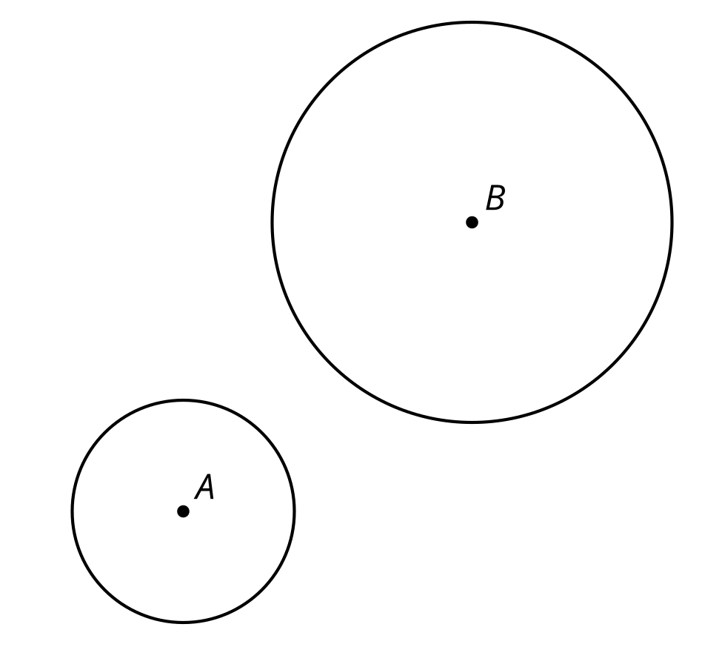
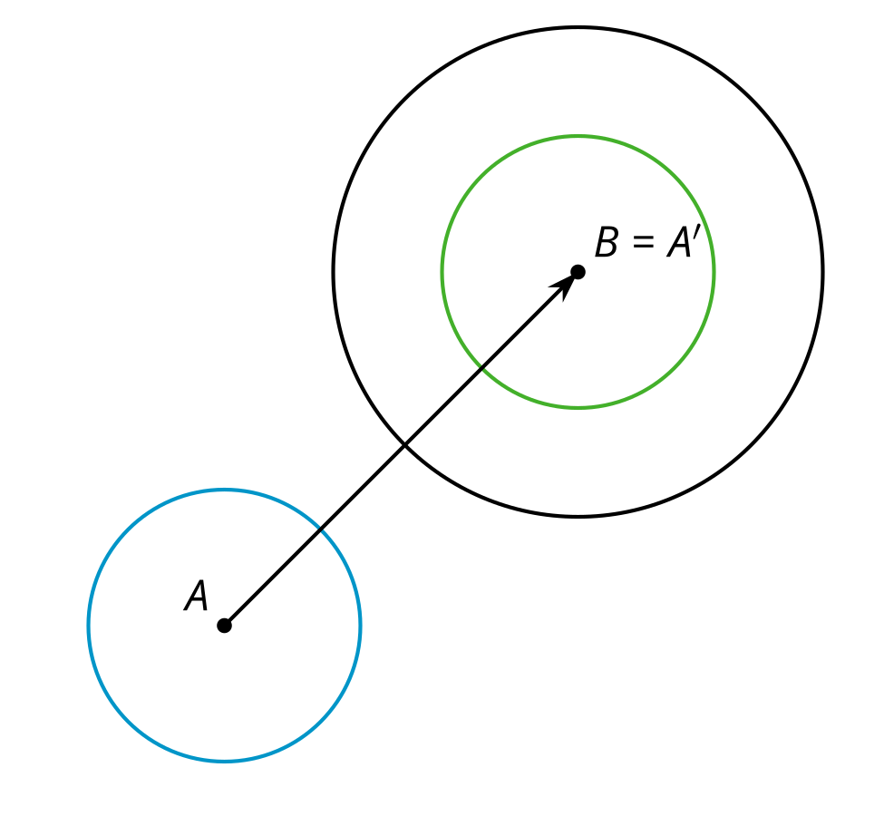
Now a dilation with center $B$ and a scale factor that is the length of the radius of the circle centered at $B$ divided by the length of the radius of the circle centered at $A$ will take the circle centered at $A$ onto the circle centered at $B$, proving that all circles are similar.
We can also show that all equilateral triangles are similar. Because we are talking about triangles, we can use the theorem that having all pairs of corresponding angles congruent and all pairs of corresponding side lengths in the same proportion is enough to prove that the triangles are similar. All the pairs of corresponding angles are congruent because all the angles in both triangles measure ${60}^{∘}$. All the pairs of corresponding side lengths must be in the same proportion, because within each triangle, all the sides are congruent. Therefore, whatever scale factor works for one pair of sides will work for all 3 pairs of corresponding sides. If all pairs of corresponding sides are in the same proportion and all pairs of corresponding angles are congruent, then all equilateral triangles are similar.
© CC BY 2019 by Illustrative Mathematics®

