Lesson 1 Practice Problems
- Here is a clock face. For each time given, name the number the second hand points at.
  - 15 seconds after 1:00.
  - 30 seconds after 1:00.
  - 1 minute after 1:00.
  - 5 minutes after 1:00.
- 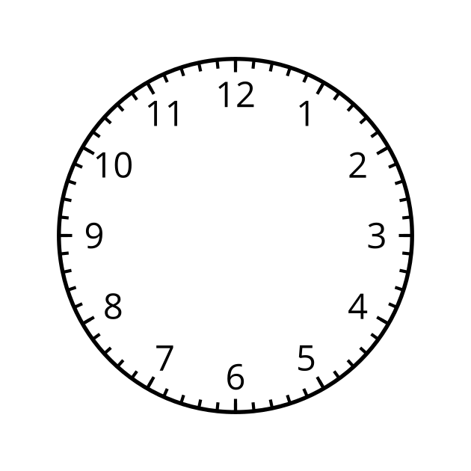
- At 12:15, the end of the minute hand of a clock is 8 feet above the ground. At 12:30, it is 6.5 feet off the ground.
  - How long is the minute hand of the clock? Explain how you know.
  - How high is the clock above the ground?
- Here is a point on a circle centered at $\left(0,0\right)$.
- Which equation defines the circle?
- 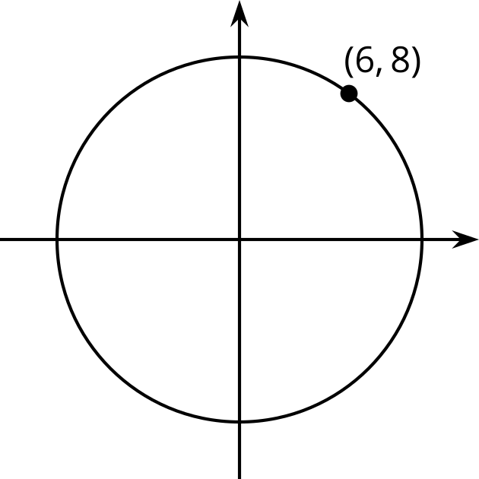
  - $x+y=10$
  - $x^{2}+y^{2}=10$
  - $x^{2}+y^{2}=100$
  - ${\left(x−6\right)}^{2}+{\left(y−8\right)}^{2}=100$
- The point $\left(3,4\right)$ is on a circle centered at $\left(0,0\right)$. Which of these points lie on the circle? Select all that apply.
  - $\left(\text{-}3,\text{-}4\right)$
  - $\left(4,3\right)$
  - $\left(0,5\right)$
  - $\left(0,0\right)$
  - $\left(\text{-}5,0\right)$
- Match each polynomial with its end behavior as $x$ gets larger and larger in the positive and negative directions. (Note: some of the answer choices are not used and some answer choices may be used more than once.)
  - $f\left(x\right)=\frac{6}{x−6}$
  - $g\left(x\right)=\frac{3x}{x−6}$
  - $h\left(x\right)=\frac{3x−18}{x−6}$
  - $k\left(x\right)=\frac{3x^{2}−16x+12}{x−6}$
  - $m\left(x\right)=\frac{\left(x+5\right)\left(x−4\right)\left(x−6\right)}{x−6}$
  - The graph approaches $y=6$.
  - The graph approaches $y=3$.
  - The graph approaches $y=0$.
  - The graph approaches $y=x^{2}+x−20$.
  - The graph approaches $y=3x^{2}+16x−12$.
  - The graph approaches $y=3x+2$.
  - The graph approaches $y=x−3$.
- (From Unit 2, Lesson 19.)
- Find the solution(s) to each equation.
  - $x^{2}−6x+8=0$
  - $x^{2}−6x+9=0$
  - $x^{2}−6x+10=0$
- (From Unit 3, Lesson 18.)
© CC BY 2019 by Illustrative Mathematics®

