## Unit 2 Lesson 21: From One- to Two-Variable Inequalities

### 1 Describing Regions of the Plane (Warm up)

#### Student Task Statement

For each graph, what do all the ordered pairs in the shaded region have in common?

A

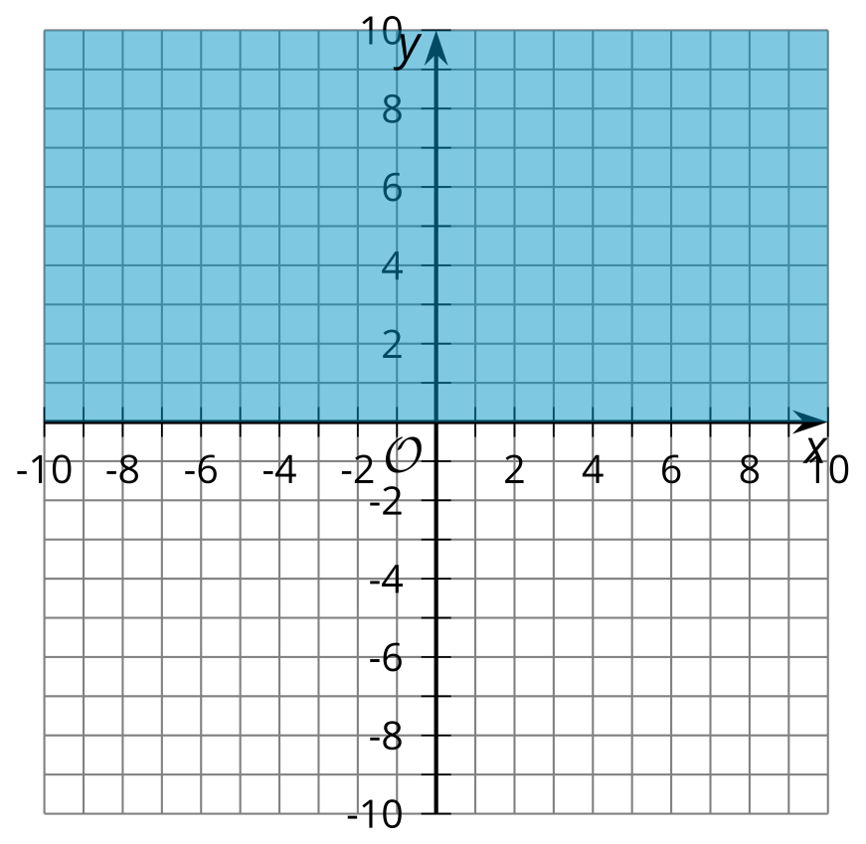

B

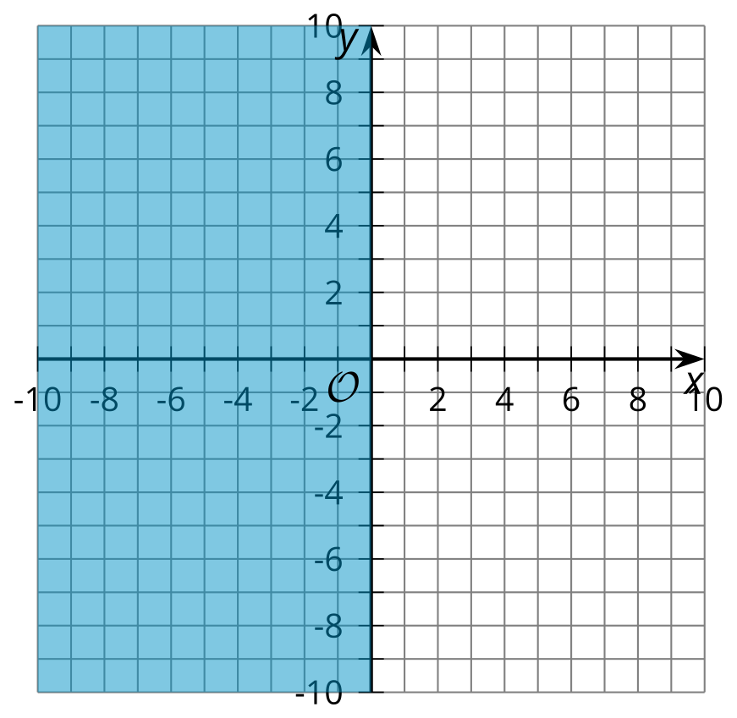

C

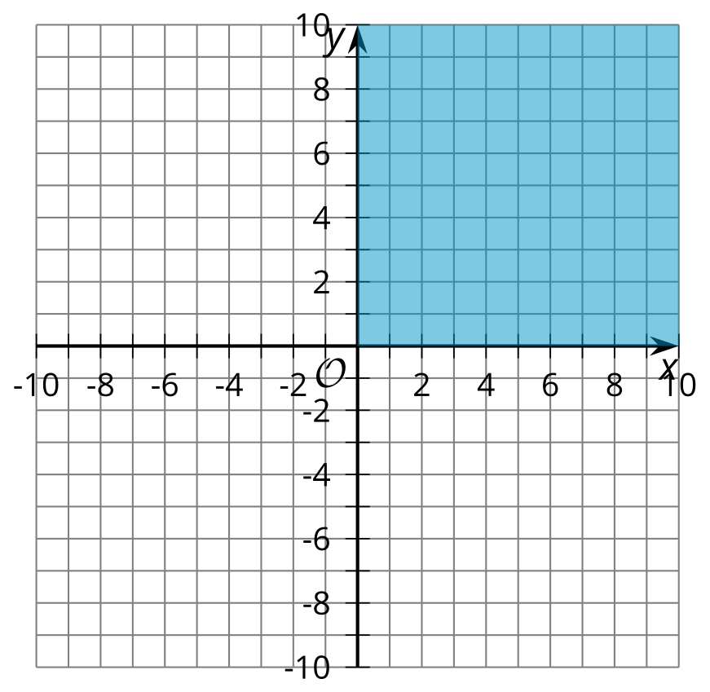

D

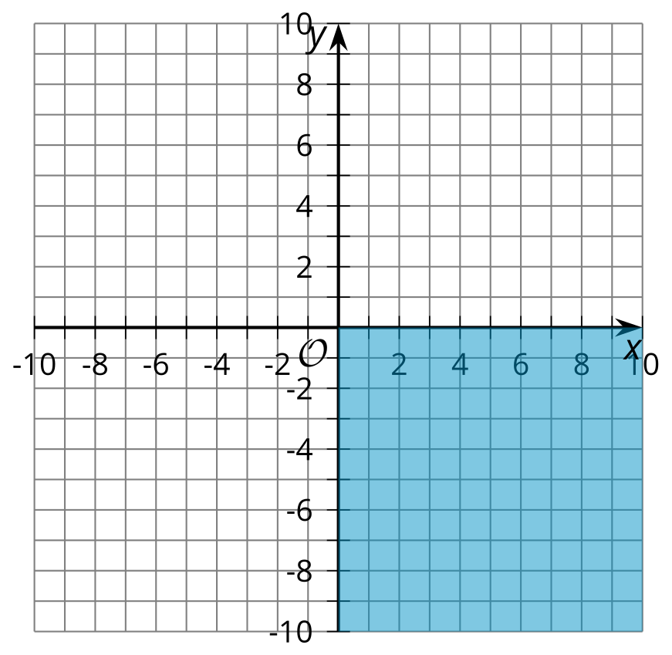

### 2 More or Less

#### Student Task Statement

1. Write at least 3 values for that make the inequality true.
2. Graph the solution to each inequality on a number line.
   1. 
   2. 
   3. 
3. Using the inequality , write 3 coordinate pairs for which the -coordinate makes the inequality true. Use the coordinate plane to plot your 3 points.

* 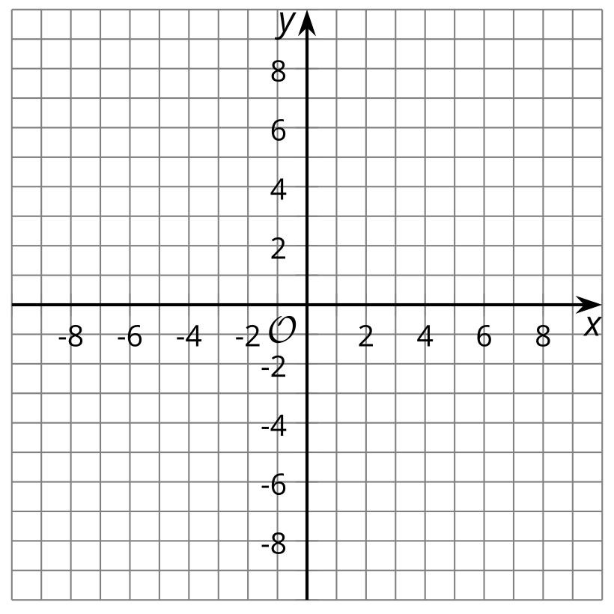

### 3 Above or Below the Line

#### Student Task Statement

1. Graph the line that represents the equation

* 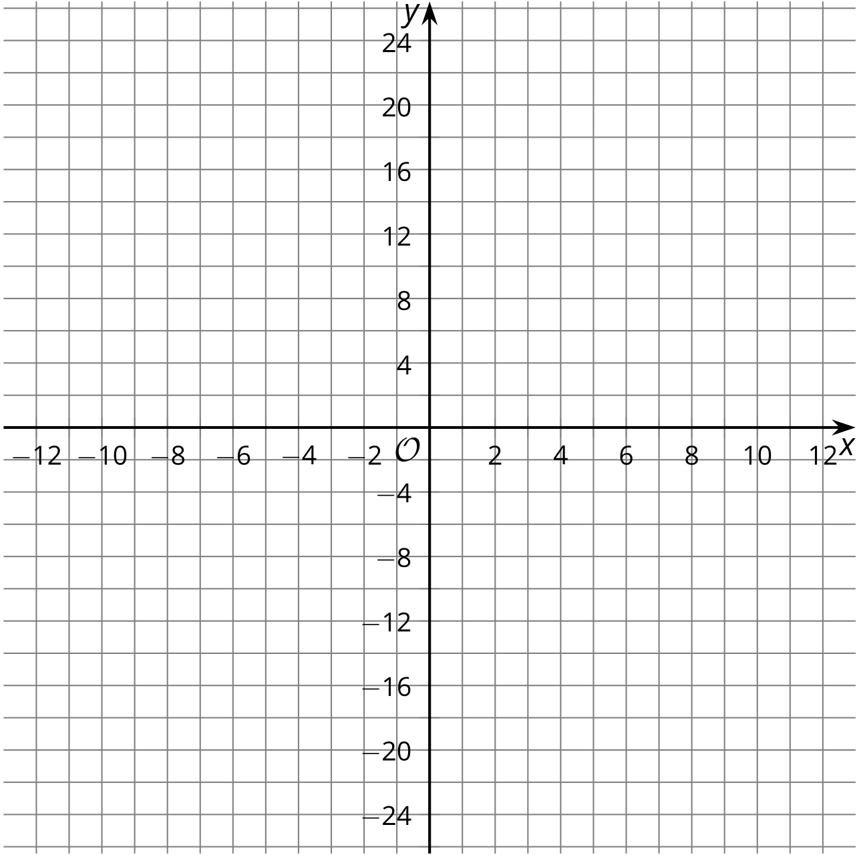

1. Is the point on the line?
   1. Explain how you know using the graph.
   2. Explain how you know using the equation.
2. Use the 3 points  and
   1. Write values for and so that the points are on the line.
   2. Write values for and so that the points are above the line.
   3. Write values for and so that the points are below the line.



© CC BY 2019 by Illustrative Mathematics®