Lesson 7: Reasoning about Similarity with Transformations
- Let’s describe similar triangles.

7.1: Notice and Wonder: Nested Triangles
What do you notice? What do you wonder?
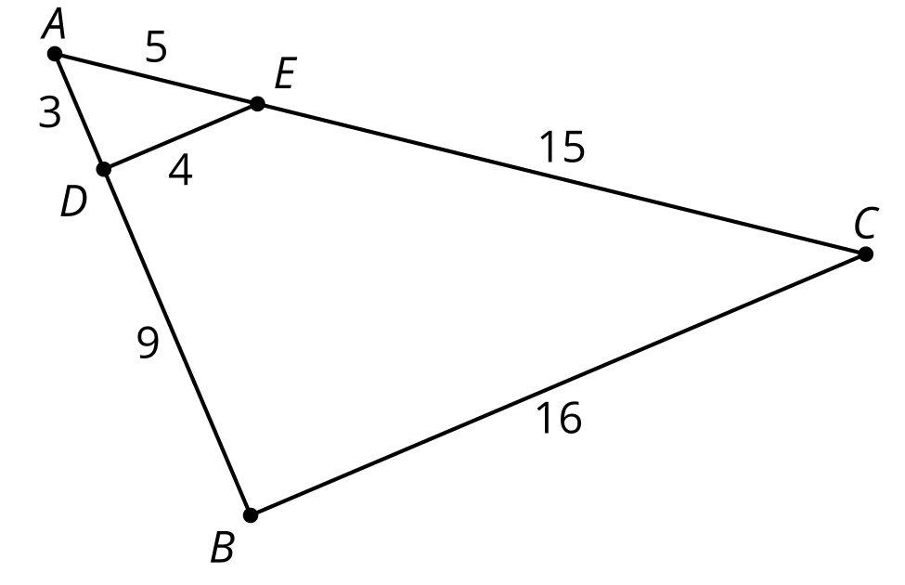

7.2: Stretched or Distorted? Triangles
- Sketch 2 triangles with all pairs of corresponding angles congruent, and with all pairs of corresponding side lengths in the same proportion.
- Label your triangles $ABC$ and $DEF$ so that angle $A$ is congruent to angle $D$, angle $B$ is congruent to angle $E$, and angle $C$ is congruent to angle $F$. Label each side with its length.
- Do the 2 triangles you drew fit the definition of similar? Explain your reasoning.
- Switch sketches with your partner. Find a sequence of rigid motions and dilations that will take one of their triangles onto the other. Will the same sequence work for your triangles?

Are you ready for more?
How many sequences are there that take one similar triangle to the other? Explain or show your reasoning.

7.3: Invisible Triangles: Similarity
Player 1: You are the transformer. Take the transformer card.
Player 2: Select a triangle card. Do not show it to anyone. Study the diagram to figure out which sides and which angles correspond. Tell Player 1 what you have figured out.
Player 1: Take notes about what they tell you so that you know which parts of their triangles correspond. Think of a sequence of rigid motions and dilations you could tell your partner to get them to take one of their triangles onto the other. Be specific in your language. The notes on your card can help with this.
Player 2: Listen to the instructions from the transformer. Use tracing paper to follow their instructions. Draw the image after each step. Let them know when they have lined up 1, 2, or all 3 pairs of vertices on your triangles.

Lesson 7 Summary
One figure is similar to another if there is a sequence of rigid motions and dilations that takes the first figure so that it fits exactly over the second. By the properties of dilations and rigid motions, similar figures have corresponding angles congruent and pairs of corresponding side lengths in the same proportion.
In the case of triangles, the converse of this statement is true as well. If a pair of triangles has all pairs of corresponding side lengths in the same proportion, and all pairs of corresponding angles congruent, then the triangles must be similar. Imagine any pair of triangles with all pairs of corresponding side lengths in the same proportion, and all pairs of corresponding angles congruent. The same sequence of rigid motions and dilations will work to show that the triangles are similar.
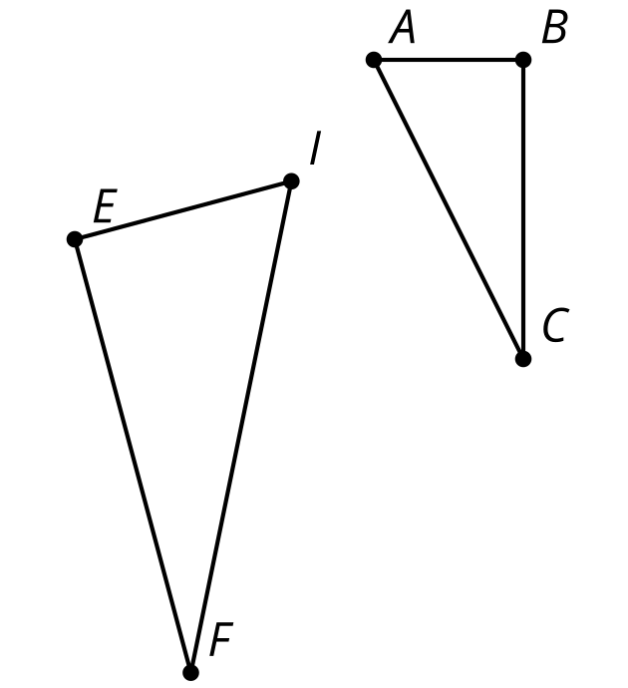
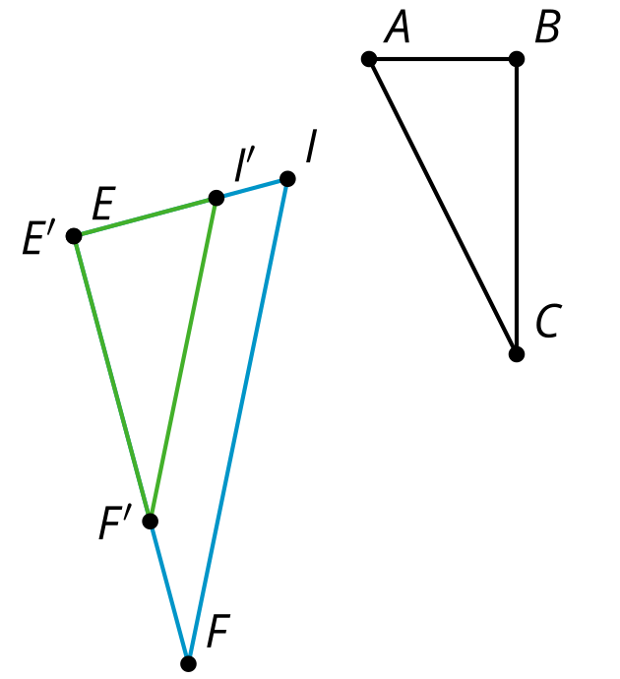
For example, triangle $EFI$ was dilated using $E$ as the center by the scale factor given by $\frac{BC}{EF}$. Because we wisely chose the scale factor this way, we know that side $BC$ is congruent to side $E^{′}F^{′}$. We already know that all pairs of corresponding angles are congruent, which means we have enough information to use the Angle-Side-Angle Triangle Congruence Theorem to prove that triangle $E^{′}F^{′}I^{′}$ is congruent to triangle $ABC$.
That means that triangle $ABC$ can be lined up exactly with a dilation of triangle $EFI$, which is the definition of similarity. It doesn’t matter what the triangles look like or where we start. We can always define a dilation that made one pair of corresponding sides congruent, and then use the Angle-Side-Angle Triangle Congruence Theorem to finish proving that there is a sequence of dilations and rigid motions that takes one triangle onto the other.
© CC BY 2019 by Illustrative Mathematics®

