Lesson 5 Practice Problems
- A population $p$ of migrating butterflies satisfies the equation $p=100,​000⋅{\left(\frac{4}{5}\right)}^{w}$ where $w$ is the number of weeks since they began their migration.
  - Complete the table with the population after different numbers of weeks.
- $w$ | - 0 | - 1 | - 2 | - 3 | - 4
  - $p$
  - Graph the butterfly population.
  - Think carefully about how to choose a scale for the axes.
  - 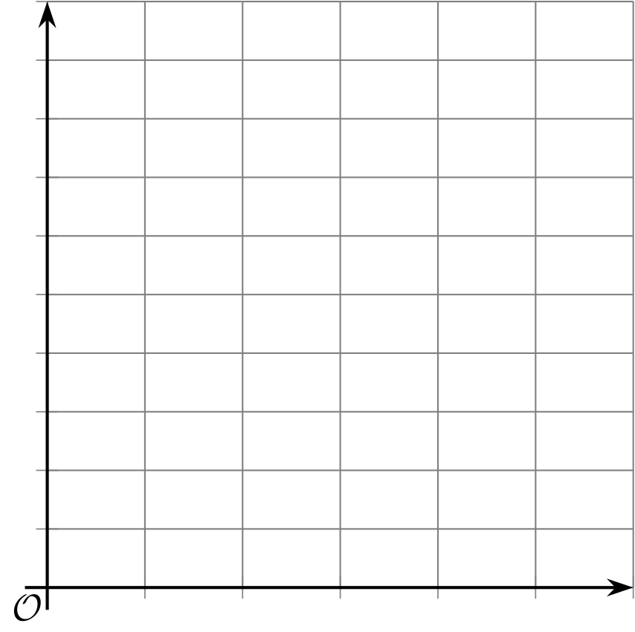
  - ​​​​​
  - What is the vertical intercept of the graph? What does it tell you about the butterfly population?
  - About when does the butterfly population reach 50,000?
- The graph shows the amount of a chemical in a water sample. It is decreasing exponentially.
- Find the coordinates of the points labeled $A$, $B$, and $C$. Explain your reasoning.
- 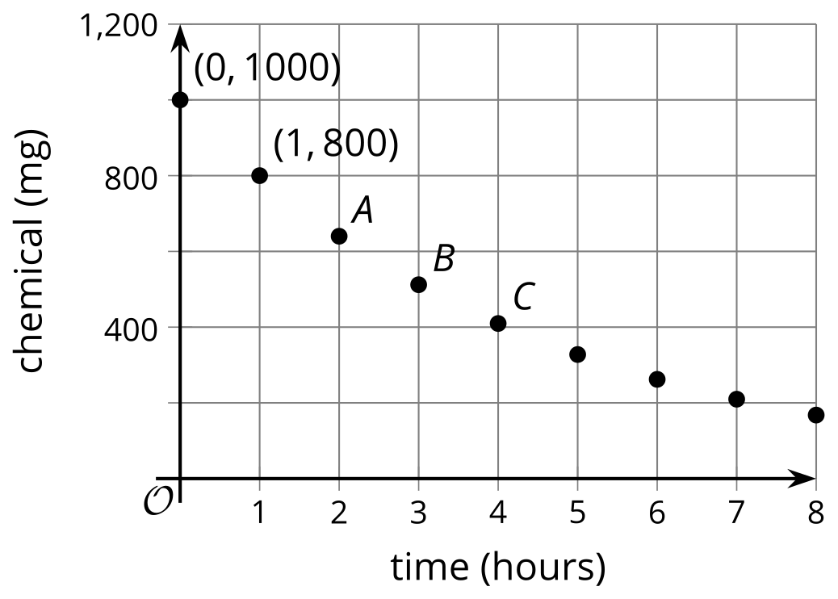
- The graph shows the amount of a chemical in a water sample at different times after it was first measured.
- Select all statements that are true.
- 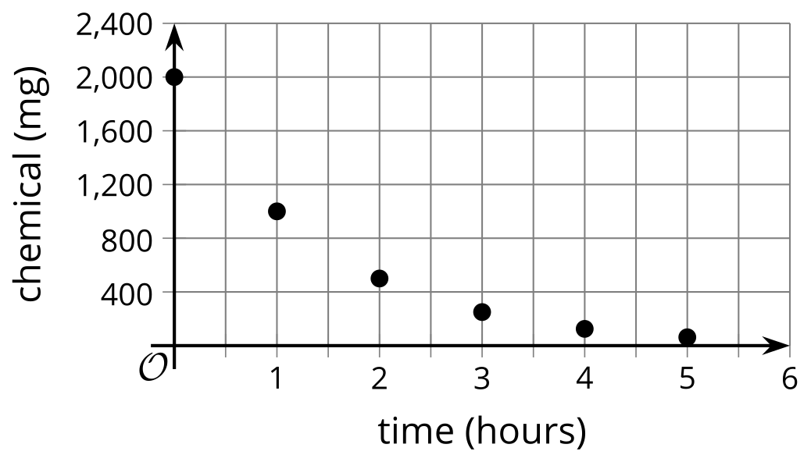
  - The amount of the chemical in the water sample is decreasing exponentially.
  - The amount of the chemical in the water sample is not decreasing exponentially.
  - It is not possible to tell for certain whether or not the amount of the chemical is decreasing exponentially.
  - When it was first measured, there were 2,000 mg of the chemical in the water sample.
  - After 4 hours, there were 100 mg of the chemical in the water.
- The graph shows the amount of a chemical in a patient's body at different times measured in hours since the levels were first checked.
- Could the amount of this chemical in the patient be decaying exponentially? Explain how you know.
- 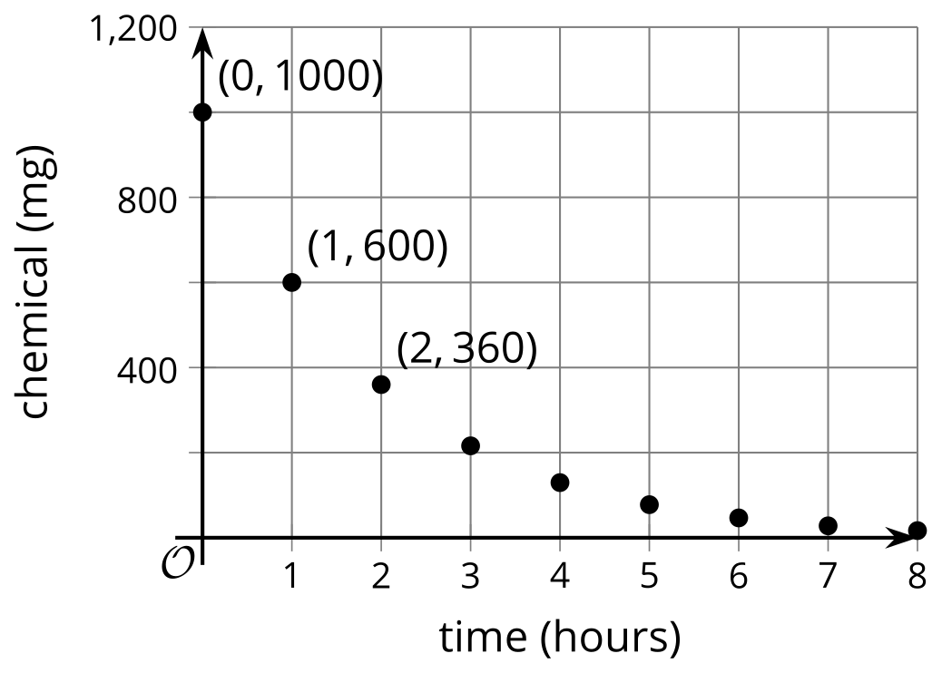
- The height of a plant in mm is 7. It doubles each week. Select all expressions that represent the height of the plant, in mm, after 4 weeks.
  - $7+4⋅2$
  - $7⋅2^{4}$
  - $2+7^{4}$
  - $7⋅2⋅2⋅2⋅2$
  - $7⋅2⋅4$
- (From Unit 5, Lesson 2.)
- The number of people who have read a new book is 300 at the beginning of January. The number of people who have read the book doubles each month.
  - Use this information to complete the table.
- number of months  since January | - number of people who  have read the book
  - 0
  - 1
  - 2
  - 3
  - 4
  - What do you notice about the difference in the number of people who have read the book from month to month?
  - What do you notice about the factor by which the number of people changes each month?
  - At the beginning of a month, $n$ people have read the book. How many people will have read the book at the beginning of the next month?
- (From Unit 5, Lesson 2.)
- Solve each system of equations.
  - $\left\{\begin{matrix}x+y=2 \\ \text{-}3x−y=5\end{matrix}\right.$
  - $\left\{\begin{matrix}\frac{1}{2}x+2y=\text{-}13 \\ x−4y=8\end{matrix}\right.$
- (From Unit 2, Lesson 13.)
© CC BY 2019 by Illustrative Mathematics®

