Lesson 26: Using the Sum
- Let’s calculate some totals.

26.1: Some Interesting Sums
Recall that for any geometric sequence starting at $a$ with a common ratio $r$, the sum $s$ of the first $n$ terms is given by $s=a\frac{1−r^{n}}{1−r}$. Find the approximate sum of the first 50 terms of each sequence:
- $\frac{1}{2}$, $\frac{1}{4}$, $\frac{1}{8}$, $\frac{1}{16}$, . . .
- 1, $\frac{1}{2}$, $\frac{1}{4}$, $\frac{1}{8}$, $\frac{1}{16}$, . . .

26.2: That’s a lot of Houses
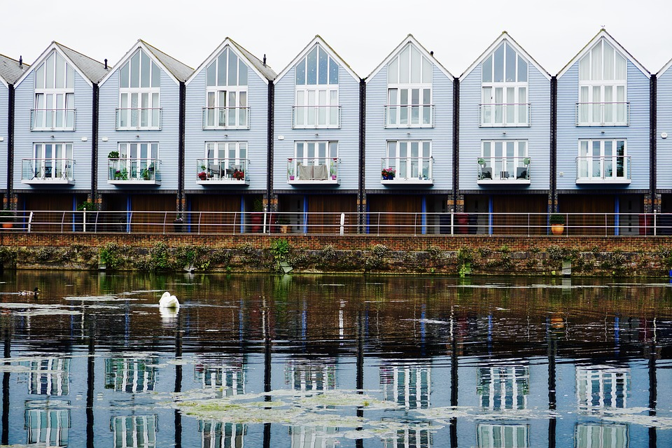
In 2012, about 71 thousand homes were sold in the United Kingdom. For the next 3 years, the number of homes sold increased by about 18% annually. Assuming the sales trend continues,
- How many homes were sold in 2013? In 2014?
- What information does the value of the expression $71\frac{\left(1−{1.18}^{11}\right)}{\left(1−1.18\right)}$ tell us?
- Predict the total number of house sales from 2012 to 2017. Explain your reasoning.
- Do these predictions seem reasonable? Explain your reasoning.

Are you ready for more?
Han and Lin each have a method to calculate $3^{5}+3^{6}+…+3^{n}$. Han says this is $3^{5}\left(1+3+3^{2}+…+3^{n−5}\right)$ and concludes that $3^{5}+…+3^{n}=3^{5}\frac{3^{n−4}−1}{3−1}$. Lin says that this is a difference of terms in 2 geometric sequences and can be written as $\frac{3^{n+1}−1}{3−1}−\frac{3^{5}−1}{3−1}$. Do you agree with either Han or Lin? Explain your reasoning.

26.3: Back to Funding the Future
Let’s say you open a savings account with an interest rate of 5% per year compounded annually and that you plan on contributing the same amount to it at the start of every year.
- Predict how much you need to put into the account at the start of each year to have over $100,000 in it when you turn 70.
- Calculate how much the account would have after the deposit at the start of the 50th year if the amount invested each year were:
  - $100
  - $500
  - $1,000
  - $2,000
- Say you decide to invest $1,000 into the account at the start of each year at the same interest rate. How many years until the account reaches $100,000? How does the amount you invest into the account compare to the amount of interest earned by the account?

Lesson 26 Summary
Let’s say you plan to invest $200 at the start of each year into an account that averages 3% interest compounded annually at the end of the year. How many years until the account has more than $10,000? $20,000?
We know that at the end of year 1 the amount in the account is $206. At the end of year 2 the amount in the account is $418.18 since $200{\left(1.03\right)}^{2}+200\left(1.03\right)=418.18$. At the start of year 30, for example, that original $200 has been compounded a total of 29 times while the last $200 deposited has been compounded 0 times. Figuring out how much is in the account 30 years after the first deposit means adding up $200{\left(1.03\right)}^{29}+200{\left(1.03\right)}^{28}+...+200\left(1.03\right)+200$. We can use the formula for the sum of a geometric sequence, $s=a\frac{\left(1−r^{n}\right)}{\left(1−r\right)}$, to find the total amount in the account. The sequence starts at $a=200$ and increases at a rate of $r=1.03$ each year. After $n$ years, the total $s$ in the account is $s=206\frac{\left(1−{1.03}^{n}\right)}{\left(1−1.03\right)}$. Now we have a simpler expression to evaluate for different $n$ values. It turns out that when $n=31$, the account has about $10,301 in it and when $n=47$, it has about $20,682 in it.
© CC BY 2019 by Illustrative Mathematics®

