Lesson 10: Other Conditions for Triangle Similarity
- Let’s prove more triangles are similar.

10.1: Math Talk: Triangle Congruence
Evaluate mentally. Is there enough information to determine if the pairs of triangles are congruent? If so, what theorem(s) would you use? If not, what additional piece of information could you use?

$\overset{¯}{KM}⊥\overset{¯}{NL},\overset{¯}{KL}≅\overset{¯}{ML}$
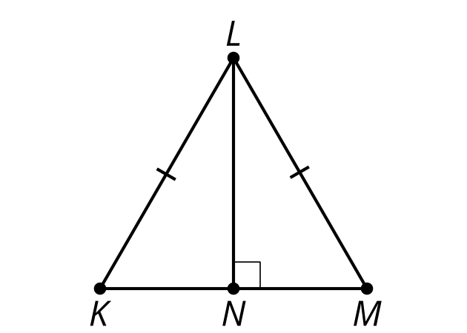

$∠E≅∠D$
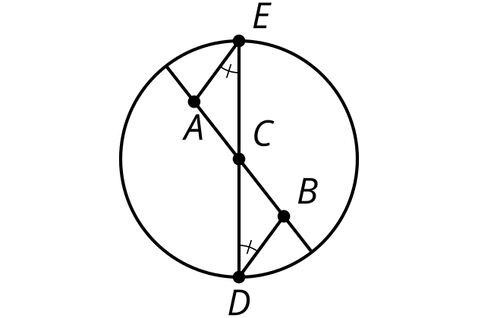

$\overset{¯}{HI}≅\overset{¯}{FG}$
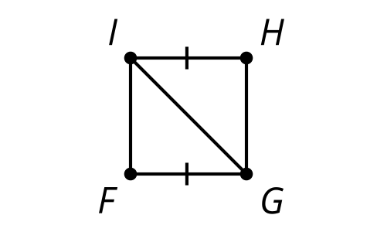

$\overset{↔}{AB}∥\overset{↔}{CD},∠DAC≅∠BCA$
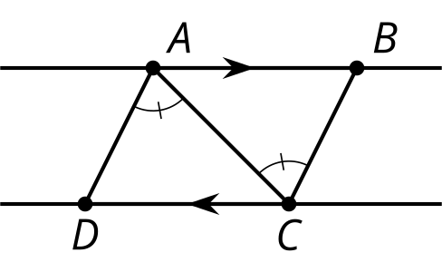

10.2: Side-Angle-Side Triangle Similarity?
Andre remembers lots of ways to prove triangles congruent. He asks Clare, “Can we use Angle-Side-Angle to prove triangles are similar?”
Clare: “Sure, but we don’t need the Side part because Angle-Angle is enough to prove triangles are similar.”
Andre: “Hmm, what about Side-Angle-Side or Side-Side-Side? What if we don’t know 2 angles?”
Clare: “Oh! I don’t know. Let’s draw a picture and see if we can prove it.”
Andre: “Uh-oh. If ‘side’ means corresponding sides with the same length, then we’ll only get congruent triangles.”
- What could ‘side’ stand for to prove triangles similar?
- Draw a diagram that would help you prove the Side-Angle-Side Triangle Similarity Theorem.
- Write a proof.

10.3: Side-Side-Side Triangle Similarity
Prove that these 2 triangles must be similar.
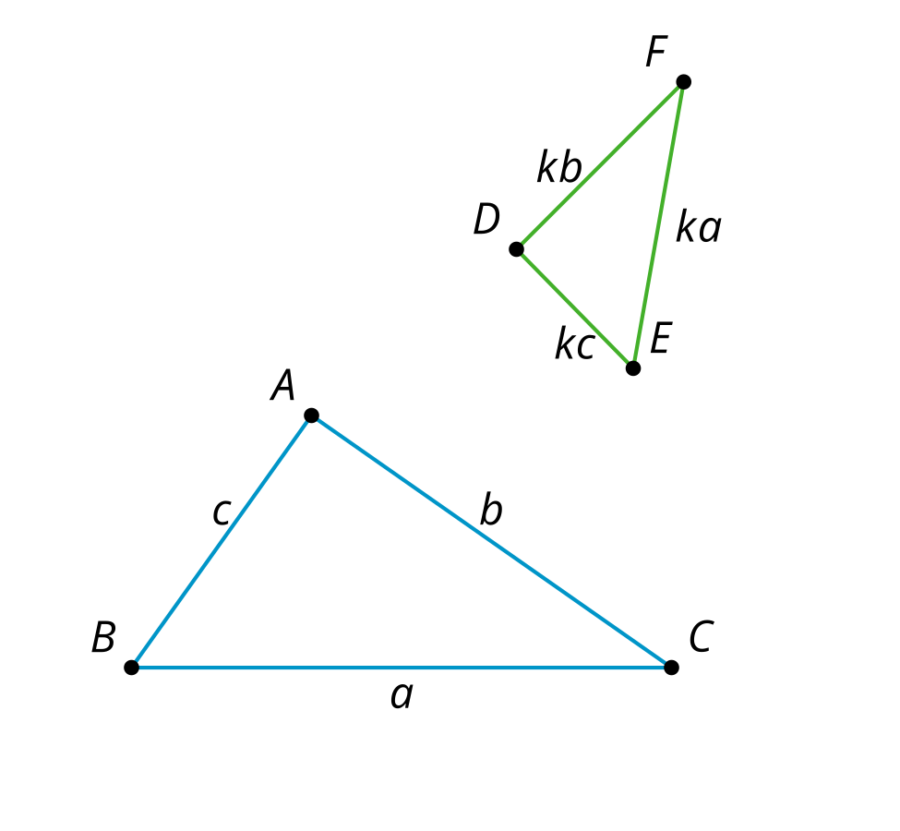

Are you ready for more?
Prove or disprove the Side-Side-Angle Triangle Similarity Theorem.

Lesson 10 Summary
Besides the Angle-Angle Triangle Similarity Theorem, what other criteria are sufficient to prove triangles similar?
When 2 sides of one triangle are proportional to 2 corresponding sides of a second triangle using the same scale factor $k$, and the pair of angles between these sides are congruent, the triangles are similar by the Side-Angle-Side Triangle Similarity Theorem.
For example, angles $EDF$ and $BDC$ are vertical angles and so they are congruent, and there are 2 pairs of corresponding sides with the same scale factor.
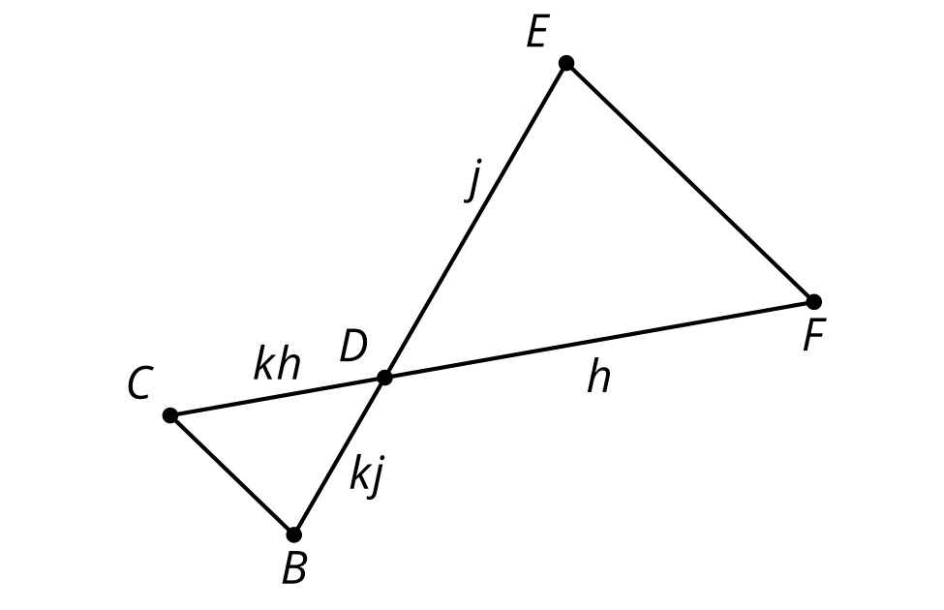
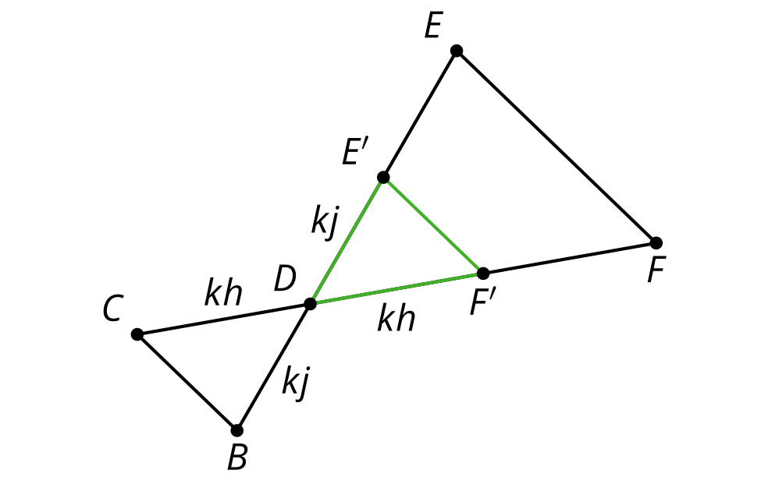
Dilate triangle $DEF$ using center $D$ and scale factor $k$. Since $\frac{BD}{ED}=\frac{CD}{FD}=k$, $BD$ is now congruent to $E^{′}D$, and $CD$ is congruent to $F^{′}D$. The dilation did not change the size of the angles. Therefore, triangle $E^{′}DF^{′}$ is congruent to triangle $BDC$ by the Side-Angle-Side Triangle Congruence Theorem. This means there is a sequence of rigid motions that takes triangle $E^{′}DF^{′}$ to triangle $BDC$. That means triangle $BDC$ is similar to triangle $EDF$ because there is a dilation and a sequence of rigid motions that takes one to the other. There wasn’t anything special about these 2 triangles, therefore, any pair of triangles with 2 pairs of sides whose lengths are in the same proportion and with the angle between them congruent must be similar.
We can also show that if all 3 pairs of corresponding sides are proportional and use the same scale factor $k$, this is sufficient to prove the triangles are similar. We call this the Side-Side-Side Triangle Similarity Theorem.
© CC BY 2019 by Illustrative Mathematics®

