Unit 7 Lesson 2: When and Why Do We Write Quadratic Equations?

1 How Many Tickets? (Warm up)

Student Task Statement
The expression $12t+2.50$ represents the cost to purchase tickets for a play, where $t$ is the number of tickets. Be prepared to explain your response to each question.
- A family paid $62.50 for tickets. How many tickets were bought?
- A teacher paid $278.50 for tickets for her students. How many tickets were bought?

2 The Flying Potato Again

Student Task Statement
The other day, you saw an equation that defines the height of a potato as a function of time after it was launched from a mechanical device. Here is a different function modeling the height of a potato, in feet, $t$ seconds after being fired from a different device:
$f\left(t\right)=\text{-}16t^{2}+80t+64$
- What equation would we solve to find the time at which the potato hits the ground?
- Use any method except graphing to find a solution to this equation.

Activity Synthesis
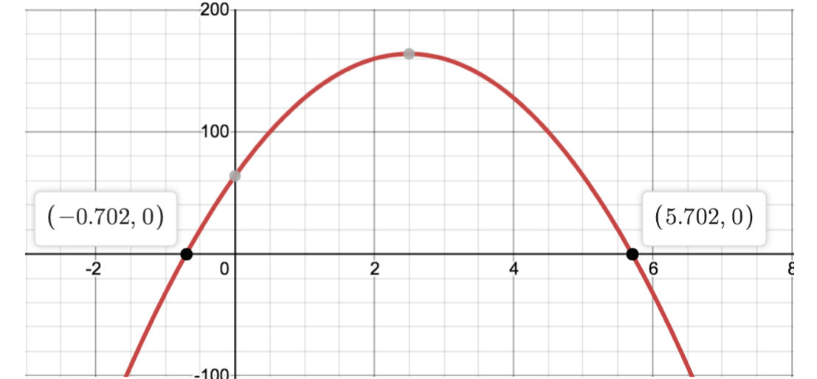

3 Revenue from Ticket Sales

Student Task Statement
The expressions $p\left(200−5p\right)$ and $\text{-}5p^{2}+200p$ define the same function. The function models the revenue a school would earn from selling raffle tickets at $p$ dollars each.
- At what price or prices would the school collect $0 revenue from raffle sales? Explain or show your reasoning.
- The school staff noticed that there are two ticket prices that would both result in a revenue of $500. How would you find out what those two prices are?
© CC BY 2019 by Illustrative Mathematics®

