Lesson 11 Practice Problems

  - Graph these points in the coordinate plane: $\left(\text{-}2,3\right)$, $\left(2,3\right)$, $\left(\text{-}2,\text{-}3\right)$, $\left(2,\text{-}3\right)$.
  - 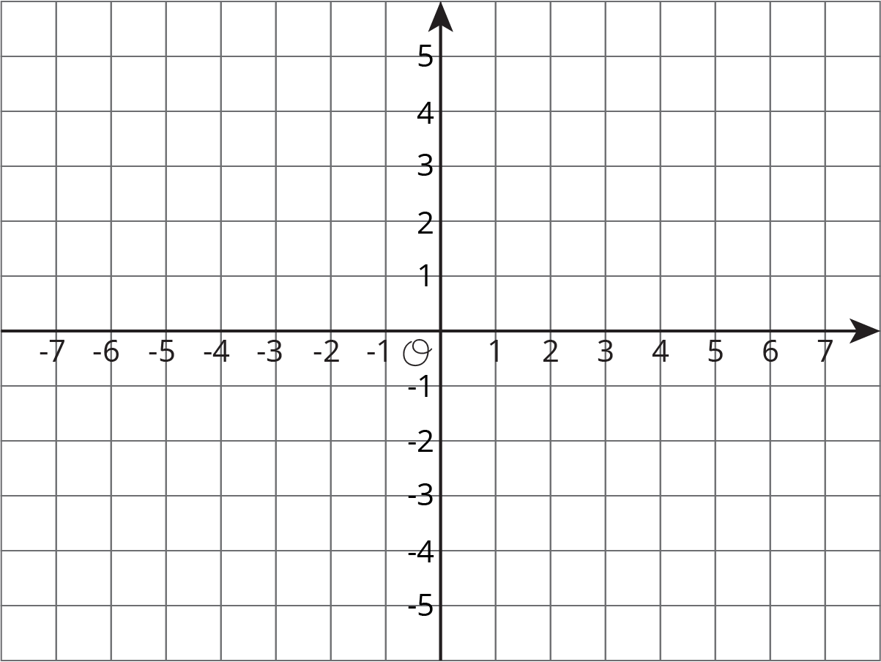
  - Connect all of the points. Describe the figure.
- Diego was asked to plot these points: $\left(\text{-}50,0\right)$, $\left(150,100\right)$, $\left(200,\text{-}100\right)$, $\left(350,50\right)$, $\left(\text{-}250,0\right)$. What interval could he use for each axis? Explain your reasoning.
- Write the coordinates of each point.
- 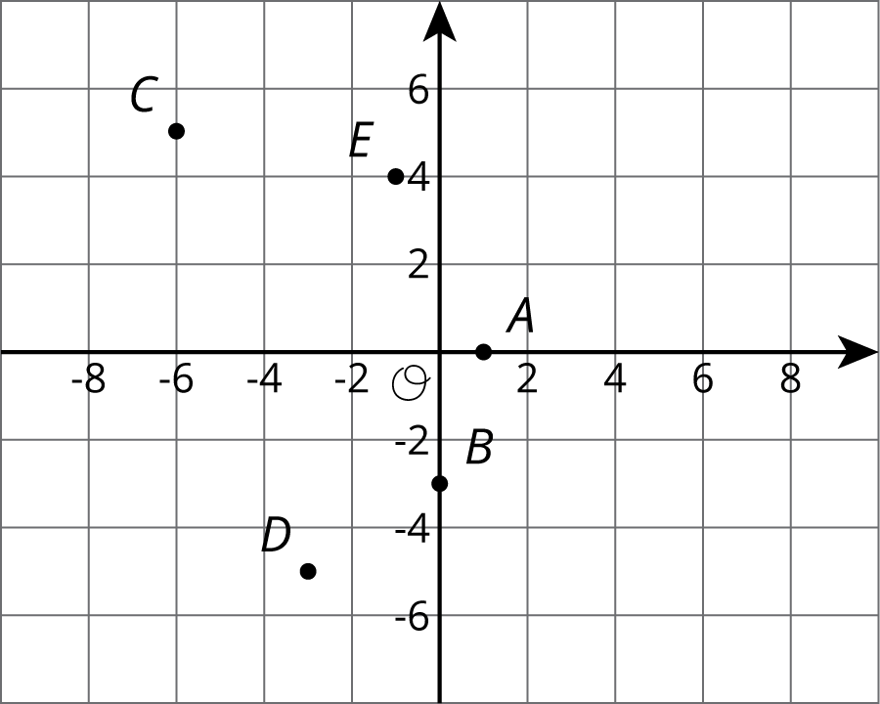
- Find the value of each expression.
  - $16.2+\text{-}8.4$
  - $\frac{2}{5}−\frac{3}{5}$
  - $\text{-}9.2+\text{-}7$
  - $\text{-}4\frac{3}{8}−\left(\text{-}1\frac{1}{4}\right)$
- (From Unit 7, Lesson 10.)
- Lin and Tyler are drawing circles. Tyler's circle has twice the diameter of Lin’s circle. Tyler thinks that his circle will have twice the area of Lin’s circle as well. Do you agree with Tyler?
- (From Unit 5, Lesson 15.)
© CC BY Open Up Resources. Adaptations CC BY IM.

