Lesson 19 Practice Problems
- Use long division to show that the fraction and decimal in each pair are equal.
- $\frac{3}{4}$ and 0.75
- $\frac{3}{50}$ and 0.06
- $\frac{7}{25}$ and 0.28

- Mai walked $\frac{1}{8}$ of a 30-mile walking trail. How many miles did Mai walk? Explain or show your reasoning.
- Use long division to find each quotient. Write your answer as a decimal.
  - $99÷12$
  - $216÷5$
  - $1,​988÷8$
- Here is a diagram representing a base-ten number. The large rectangle represents a unit that is 10 times the value of the square. The square represents a unit that is 10 times the value of the small rectangle.
- Here is a diagram showing the number being divided into 5 equal groups.
- 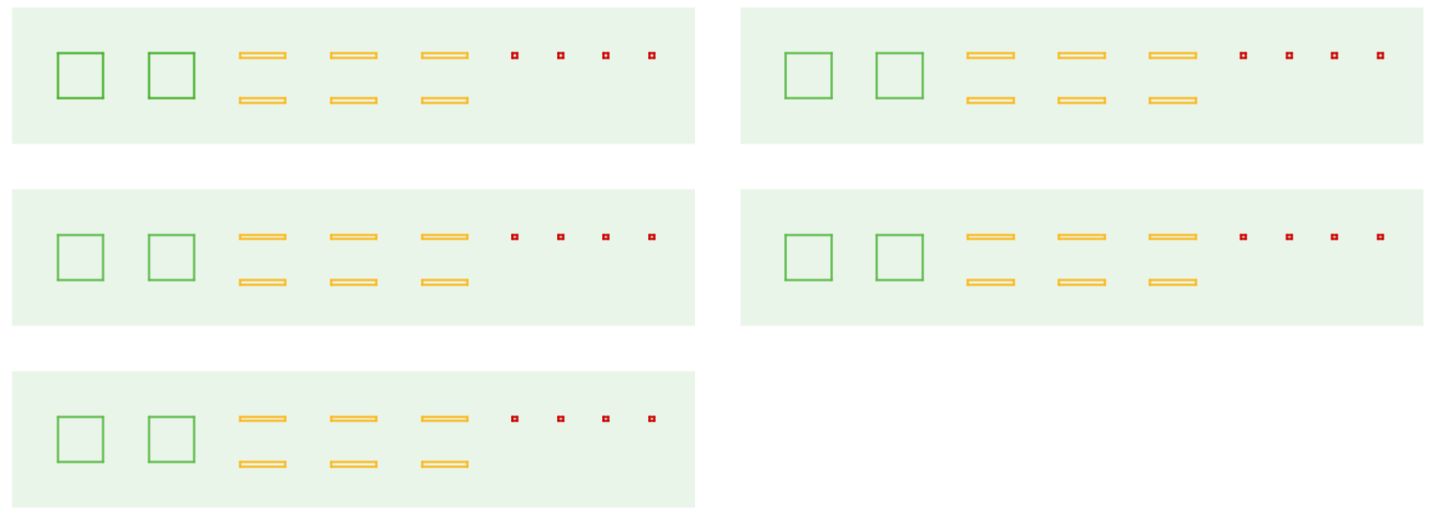
  - If a large rectangle represents 1,000, what division problem did the second diagram show? What is its answer?
  - If a large rectangle represents 100, what division problem did the second diagram show? What is its answer?
  - If a large rectangle represents 10, what division problem did the second diagram show? What is its answer?
- (From Unit 3, Lesson 20.)
- Complete the calculations so that each shows the correct difference.
- 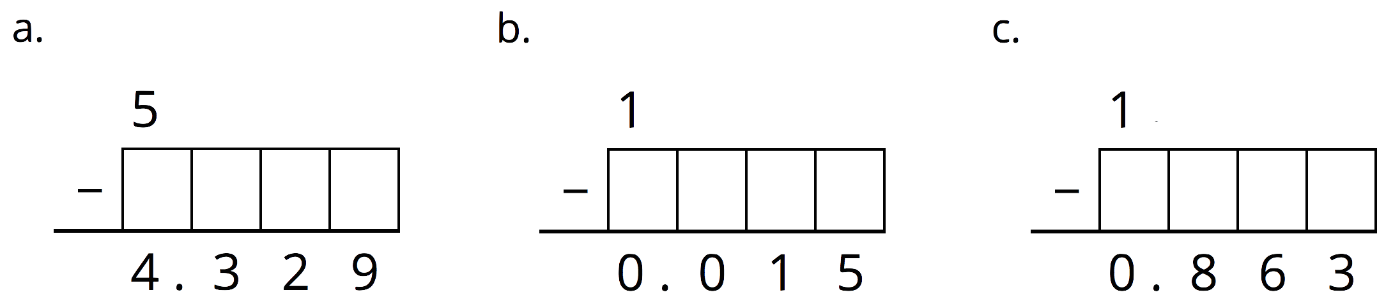
- (From Unit 3, Lesson 15.)
- Use the equation $124⋅15=1,​860$ and what you know about fractions, decimals, and place value to explain how to place the decimal point when you compute $\left(1.24\right)⋅\left(0.15\right)$.
- (From Unit 3, Lesson 16.)
© CC BY Open Up Resources. Adaptations CC BY IM.

