Unit 5 Lesson 8: Using Graphs to Compare Relationships

1 Number Talk: Fraction Multiplication and Division (Warm up)

Student Task Statement
Find each product or quotient mentally.
$\frac{2}{3}⋅\frac{1}{2}$
$\frac{4}{3}⋅\frac{1}{4}$
$4÷\frac{1}{5}$
$\frac{9}{6}÷\frac{1}{2}$

2 Race to the Bumper Cars

Student Task Statement
Diego, Lin, and Mai went from the ticket booth to the bumper cars.
- Use each description to complete the table representing that person’s journey.
  - Diego left the ticket booth at the same time as Tyler. Diego jogged ahead at a steady pace and reached the bumper cars in 30 seconds.
  - Lin left the ticket booth at the same time as Tyler. She ran at a steady pace and arrived at the bumper cars in 20 seconds.
  - Mai left the booth 10 seconds later than Tyler. Her steady jog enabled her to catch up with Tyler just as he arrived at the bumper cars.
- Diego’s  time  (seconds) | - Diego’s  distance  (meters)
- 0
- 15
- 30 | - 50
- 1

- Lin’s  time  (seconds) | - Lin’s  distance  (meters)
 | - 0
 | - 25
- 20 | - 50
- 1

- Mai’s  time  (seconds) | - Mai’s  distance  (meters)
 | - 0
 | - 25
- 40 | - 50
- 1
- Using a different color for each person, draw a graph of all four people’s journeys (including Tyler's from the other day).
- 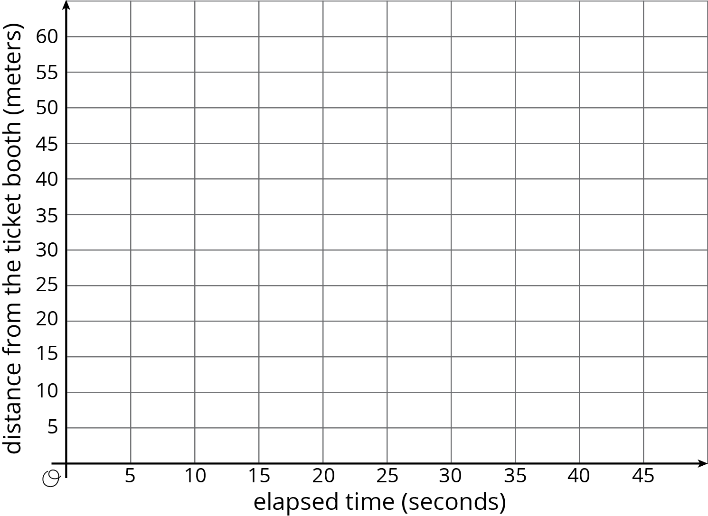
- Which person is moving the most quickly? How is that reflected in the graph?

3 Space Rocks and the Price of Rope

Student Task Statement
- Meteoroid Perseid 245 and Asteroid x travel through the solar system. The graph shows the distance each traveled after a given point in time.
- 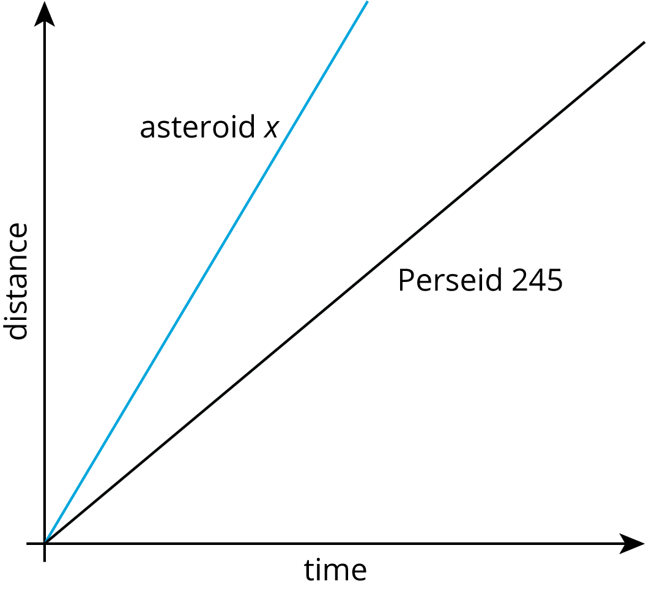
- Is Asteroid x traveling faster or slower than Perseid 245? Explain how you know.
- The graph shows the price of different lengths of two types of rope.
- 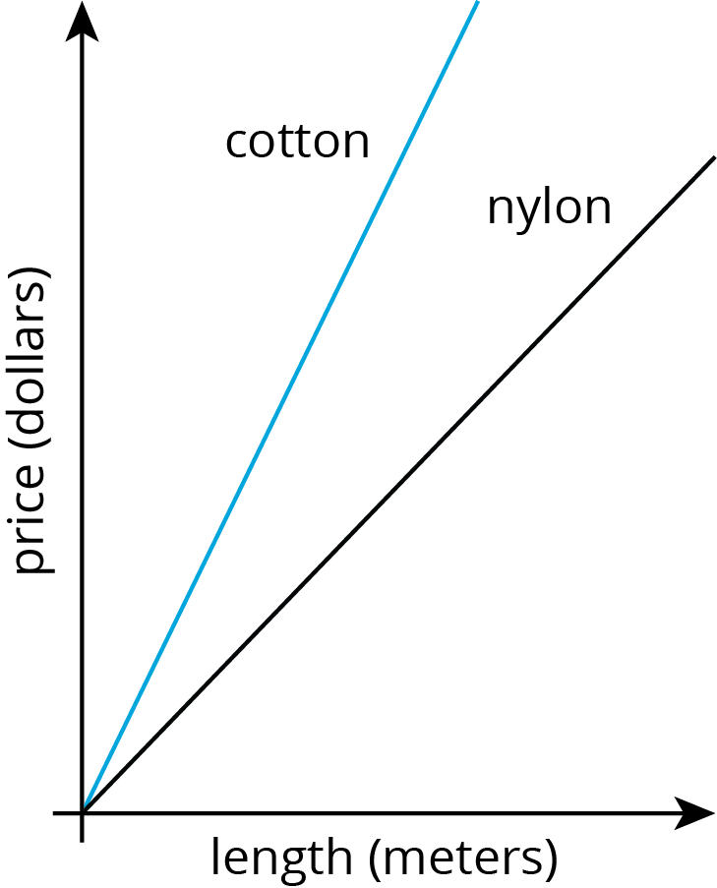
- If you buy $1.00 of each kind of rope, which one will be longer? Explain how you know.

© CC BY Open Up Resources. Adaptations CC BY IM.

