Unit 2 Lesson 2: Scale Factors and Making Scaled Copies

1 Number Talk: Multiplying by a Unit Fraction (Warm up)

Student Task Statement
Find each product mentally.
$\frac{1}{4}⋅32$
$\left(7.2\right)⋅\frac{1}{9}$
$\frac{1}{4}⋅\left(5.6\right)$

2 Scaled Triangles

Student Task Statement
Here is Triangle O, followed by a number of other triangles.
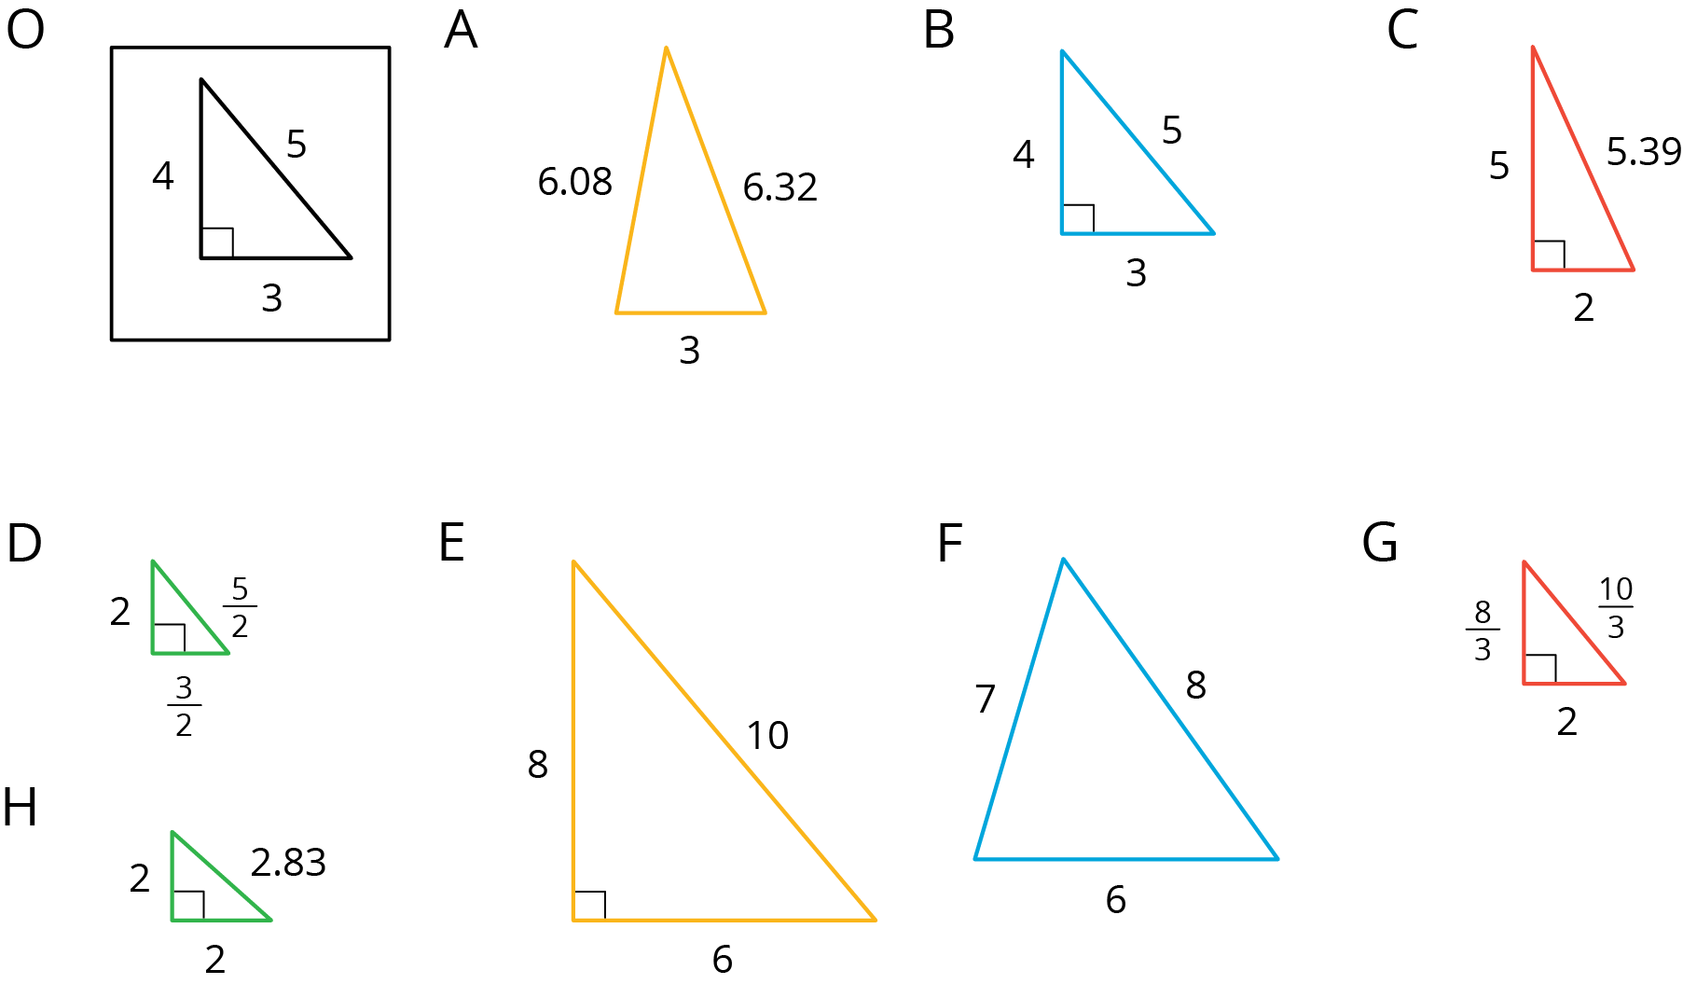
Your teacher will assign you two of the triangles to look at.
- For each of your assigned triangles, is it a scaled copy of Triangle O? Be prepared to explain your reasoning.
- As a group, identify all the scaled copies of Triangle O in the collection. Discuss your thinking. If you disagree, work to reach an agreement.
- List all the triangles that are scaled copies in the table. Record the side lengths that correspond to the side lengths of Triangle O listed in each column.
- Triangle O | - 3 | - 4 | - 5
- Explain or show how each copy has been scaled from the original (Triangle O).

Activity Synthesis
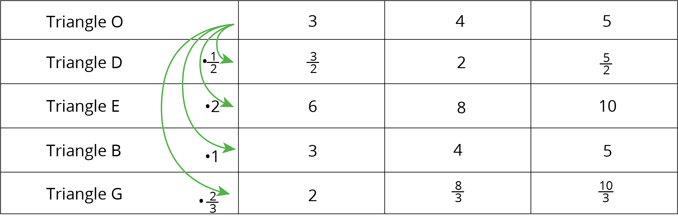

3 Which Operations? (Part 1)

Student Task Statement
Diego and Jada want to scale this polygon so the side that corresponds to 15 units in the original is 5 units in the scaled copy.
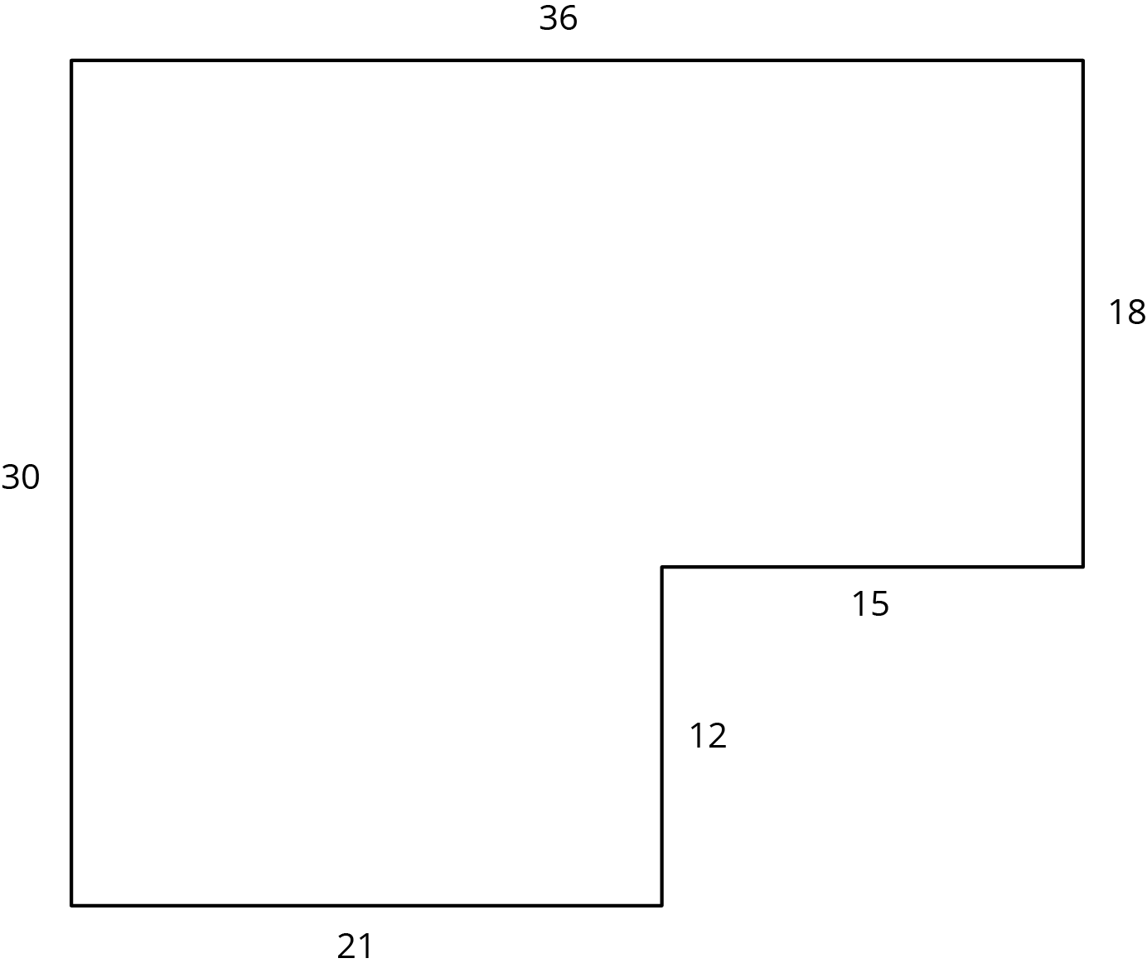
Diego and Jada each use a different operation to find the new side lengths. Here are their finished drawings.
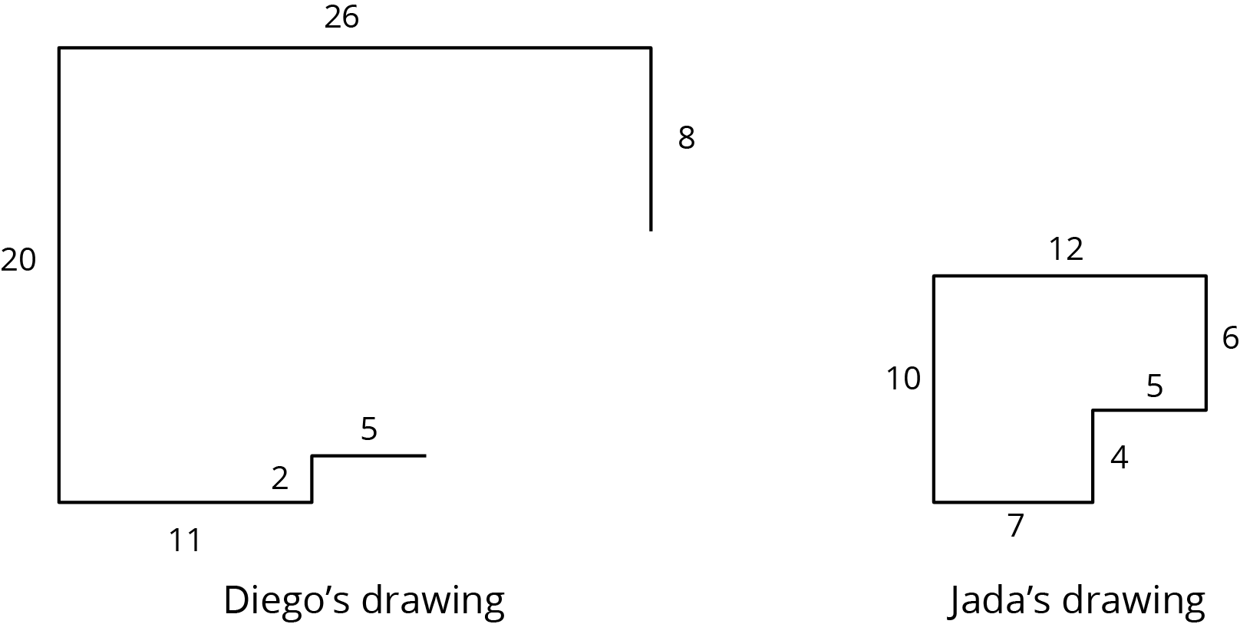
- What operation do you think Diego used to calculate the lengths for his drawing?
- What operation do you think Jada used to calculate the lengths for her drawing?
- Did each method produce a scaled copy of the polygon? Explain your reasoning.

4 Which Operations? (Part 2)

Student Task Statement
Andre wants to make a scaled copy of Jada's drawing so the side that corresponds to 4 units in Jada’s polygon is 8 units in his scaled copy.
- Andre says “I wonder if I should add 4 units to the lengths of all of the segments?” What would you say in response to Andre? Explain or show your reasoning.
- Create the scaled copy that Andre wants. If you get stuck, consider using the edge of an index card or paper to measure the lengths needed to draw the copy.
- 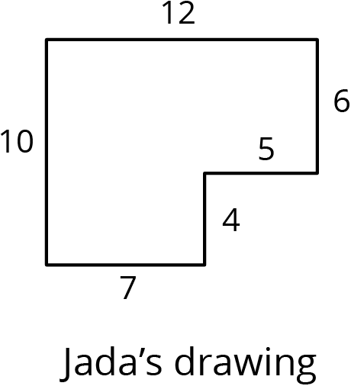
© CC BY Open Up Resources. Adaptations CC BY IM.

